**TEKNOWLEDGE SHARED SERVICES (PVT) LTD**

**OPR for Observing and assigning indoor and outdoor work task to office assistance**

|  |  |
| --- | --- |
| **SUBJECT** | Observing and assigning indoor and outdoor work task to office assistance. |
| **RECORDER (Name Designation)** | Ajith Wasantha |
| **APPROVED BY (Name Designation)** | Chalani Maduwanthi |
| **CREATED DATE** | 06/10/2016 |
| **NO. OF PAGES INCLUDING THIS PAGE** | 02 |

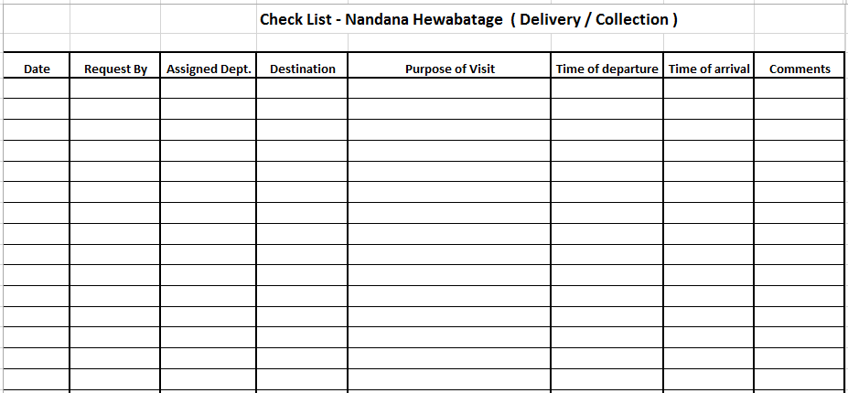According to daily requirements of other departments used our office assistant for indoor and outdoor work tasks. Go to bank for deposit money, deposit cheques, go to post office for post letters are some of the tasks make by office assistance. Every day departmental wise collect daily needs on orally and prioritize them.

For this task use above format for record it.

This list weekly send to HR department for their requirement.