|  |  |
| --- | --- |
| **SUBJECT** | Supervise kitchen items daily and update check list once a week ( Friday) |
| **RECORDER (Name Designation)** | Nipuna Madumal |
| **APPROVED BY (Name Designation)** | Chalani Maduwanthi |
| **CREATED DATE** | 06/03/2016 |
| **NO. OF PAGES INCLUDING THIS PAGE** | 01 |

**TEKNOWLEDGE SHARED SERVICES (PVT) LTD**

**OPR for Supervise kitchen items daily and update check list once a week ( Friday)**

The purpose of the update check list is determine the stocks in the kitchen are available for usage. And also keep the continuation of the cooking process.

Daily supervise the usage of the kitchen items and get information from Rekha and update check list. Based on the information update the check list put quantities and amounts in every Friday.

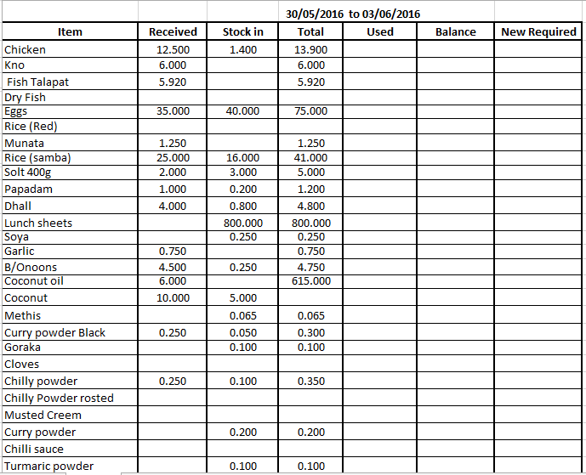

After create the report send through ETF and also send Lahiru Dharmasena, Accountant.