**TEKNOWLEDGE SHARED SERVICES (PVT) LTD**

**Preparing weekly vehicle maintence report and lunch expenses report**

|  |  |
| --- | --- |
| **SUBJECT** | Preparing weekly vehicle maintence report and lunch expenses report |
| **Department** | Admin Operation / Administrator |
| **RECORDER (Name Designation)** | Ajith Wasantha |
| **APPROVED BY (Name Designation)** | Chalani Maduwanthi |
| **CREATED DATE** | 06/03/2016 |
| **NO. OF PAGES INCLUDING THIS PAGE** | 04 |

**Vehicle Maintenance Report**

The purpose of this report is to identify the fuel consumption of the company vehicles and update records accordingly.

The vehicles in head office details are taken by ETF. GO to SL vehicle maintenance and select vehicle maintenance report as you can see following screenshot.

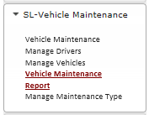

According to the screenshot select the vehicle type and date of the relevant week.

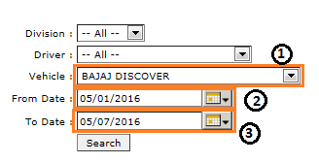

1 – Type of the vehicle.

2 – Start date of the week

3 – End date of the week.

After select the details we can see below result as the following screenshot.

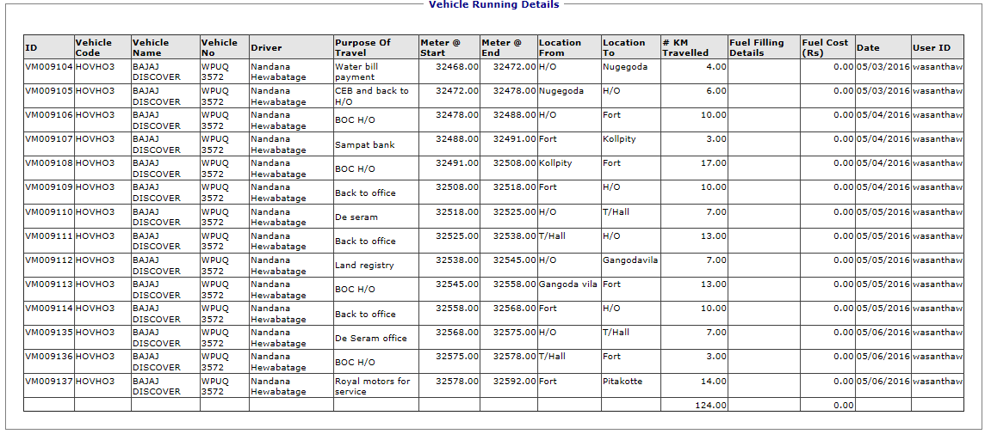

The vehicles in the farm details are taken by Kloud IP.

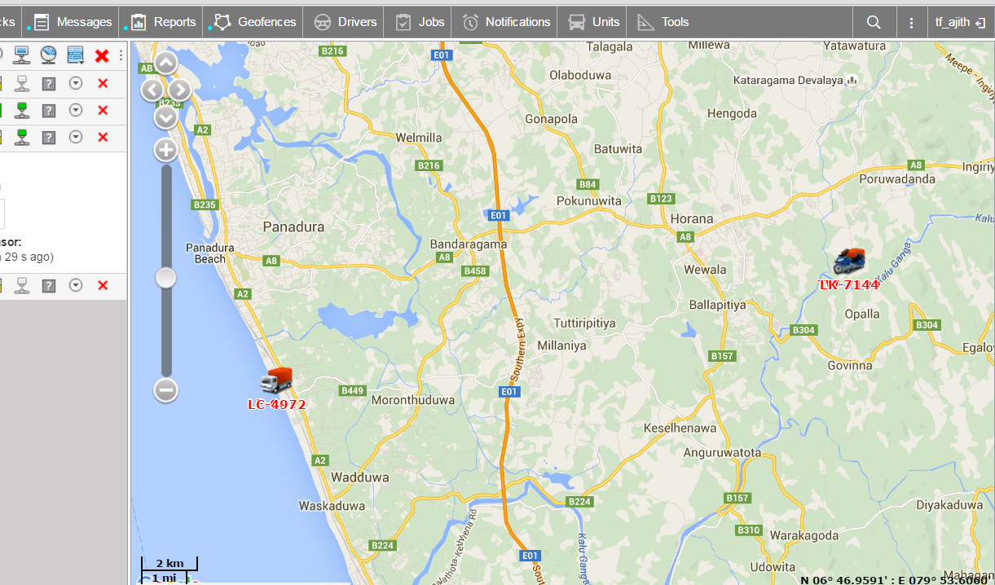

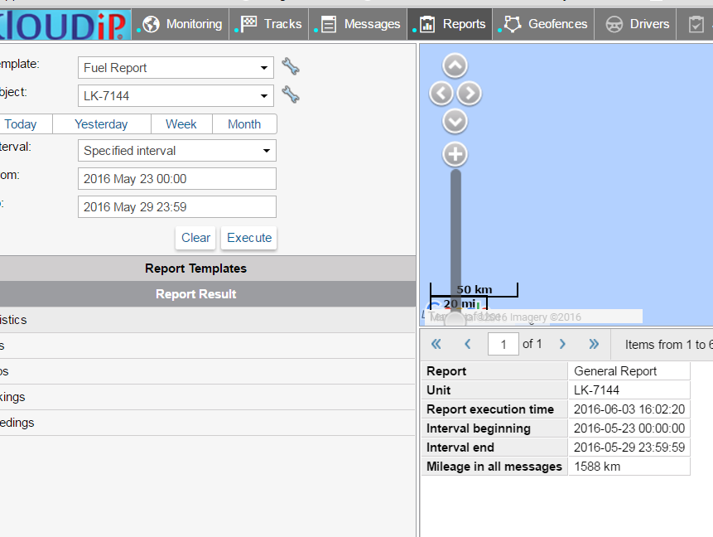

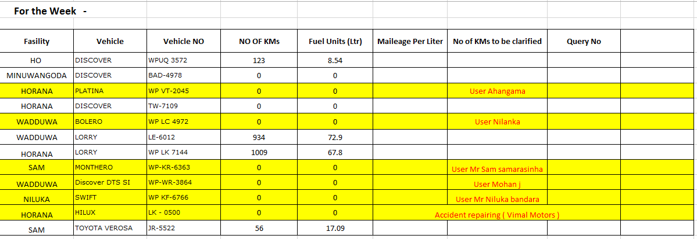After the get details the report is create as flowingly.

After create the report send through ETF and also send Lahiru Darmasena, Accountant.

**Lunch Expense Report**

The purpose of the update check list is determine the stocks in the kitchen are available for usage. And also keep the continuation of the cooking process.

Daily supervise the usage of the kitchen items and get information from Rekha and update check list. Based on the information update the check list put quantities and amounts in every Friday.

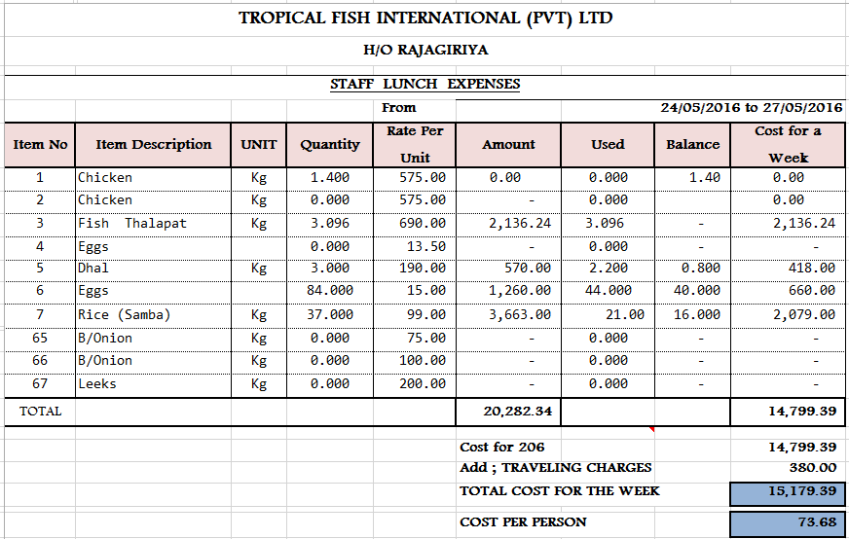After create the report send through ETF and also send Lahiru Darmasena, Accountant.