|  |  |
| --- | --- |
| **SUBJECT** | Updating and maintaining asset forms H/O & Farms |
| **RECORDER (Name Designation)** | Nipuna Madumal |
| **APPROVED BY (Name Designation)** | Chalani Maduwanthi |
| **CREATED DATE** | 06/16/2016 |
| **NO. OF PAGES INCLUDING THIS PAGE** | 03 |

**TEKNOWLEDGE SHARED SERVICES (PVT) LTD**

**Updating and maintaining asset forms H/O & Farms**

When new employee come, according to the mail received from HR department we have to provide laptop, mobile phone, dongle and sim. Lap is provide by IT support. And according to the information provided by IT support serial number and other details are fill. For sim (phone & dongle) need approval from the Head of Admin Operation.

After provide equipment for employees take sing from employee and keep a record from each employees.

For this task use following type of document.

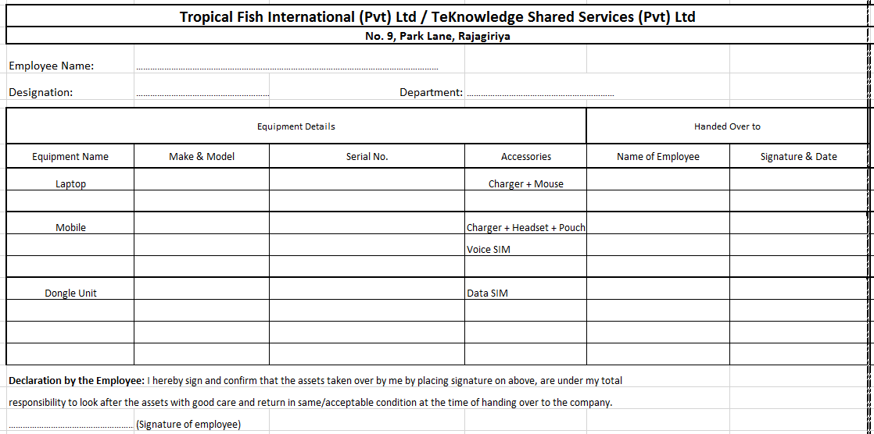

When an employee resign from the organization check them weather they are in proper manner and use another document for that process. When resigned employee hand over laptop it is checked by IT support and they make appropriate clearance process. Also mobile phone and dongle checked by Admin Operation department. After clearance all the equipment take a signature from employee and give him to copy as well.

