**Teknowledge Shared Services Pvt Ltd  
  
OPR for Sending Calendar Invites for meetings for CEO & Director**

|  |  |
| --- | --- |
| **SUBJECT** | Contacting CEO (Sam) & DIRECTOR (Varuni) while they are in a different time zone |
| **DEPARTMENT** | ExecAdmin (EA) |
| **RECORDER (Name & Designation)** | Zuhara Careem – Project Coordinator |
| **APPROVED BY (Name & Designation)** |  |
| **CREATED DATE** | 29-May-2016 |
| **LAST UPDATED** | - |
| **PATH ON NETWORK FOLDER** | - |
| **NO. OF PAGES INCLUDING THIS PAGE** | 1 |

**Objective**:

1. Sending calendar invites / reminders to Sam & Varuni to ensure they get appropriate reminders

**Introduction:**

In the event where Sam & OR Varuni are required for the meeting, please send an invite via outlook email so they know their schedule for the day.

Booking the outlook calendar also helps them & the Assistant to check their availability for the rest of the week/month.

You can use the calendar as a reminder alert too!

How to send calendar invites from your outlook;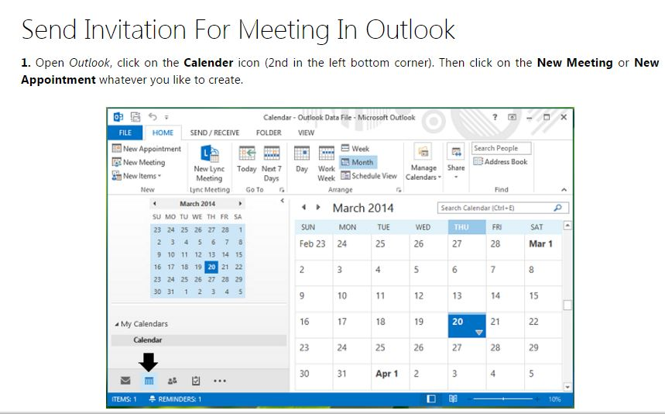

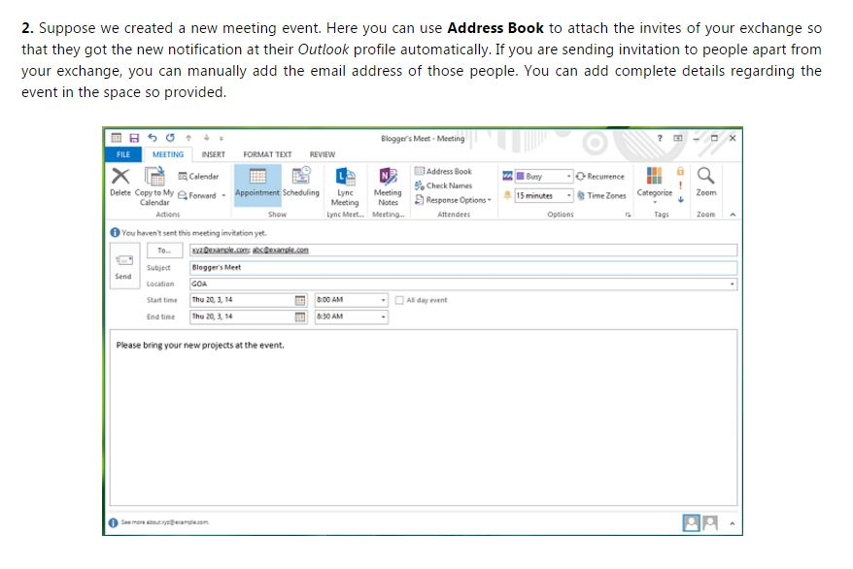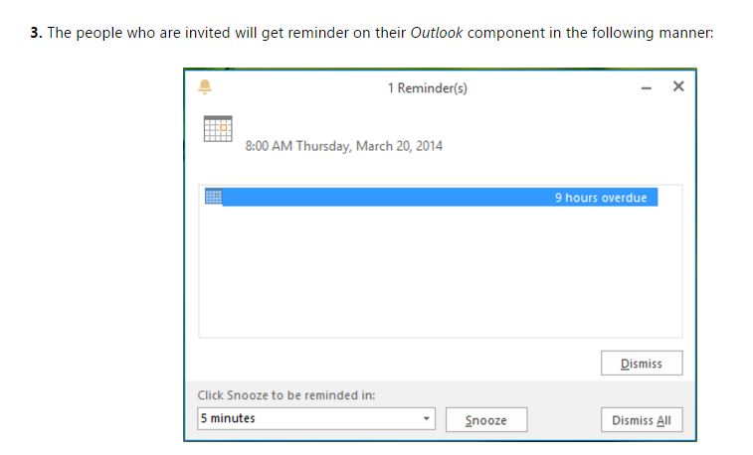

Strictly adhered to;

1. **Do NOT send calendar invites to Sam/Varuni to meetings that are taking place local time UNLESS requested to do so.**
2. If you are sending to a group, make sure Sam/Varuni are not members as their mobile gets alarmed at US early am time.
3. Please do not send them meeting requests if they are not participants
   1. When sending meeting requests to groups, make sure all members are required for the meeting.