|  |  |
| --- | --- |
| **SUBJECT** | OPR for Update PMS |
| **RECORDER (Name Designation)** | Chalani Maduwanthi / Assistant Manager System Admin |
| **APPROVED BY (Name Designation)** |  |
| **CREATED DATE** | 05/04/16 |
| **NO. OF PAGES INCLUDING THIS PAGE** | 05 |

**OPR for Update PMS**

**PMS**

1. **Login to the PMS account**

PMS Link - <http://69.63.218.233:86/pms/index.php>

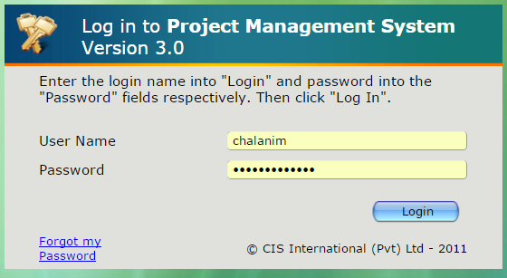

PMS home screen

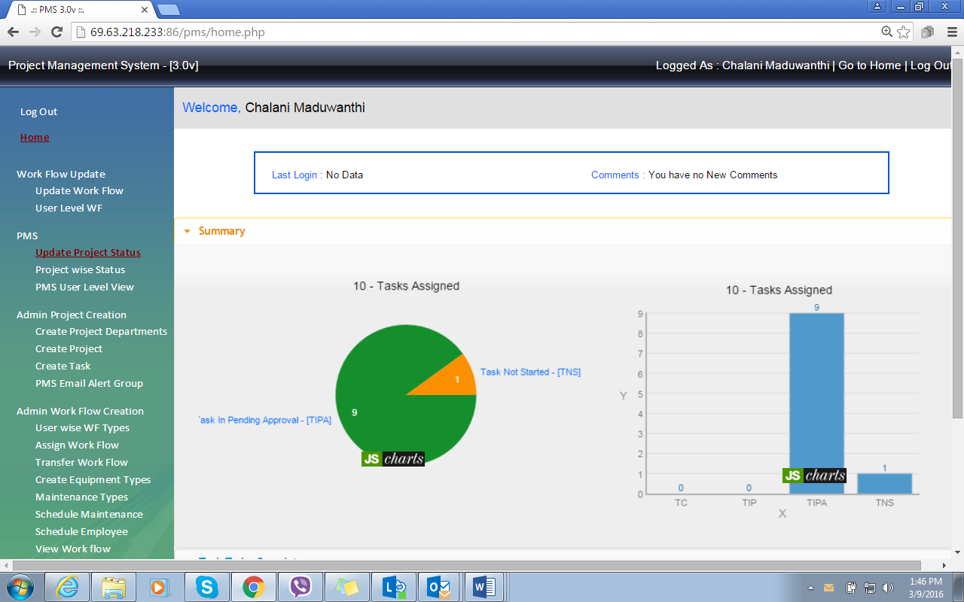

1. **PMS Update**

2.1 Select project status

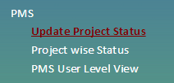

2.2 Task to be complete – To check all the projects and task that come under employee account

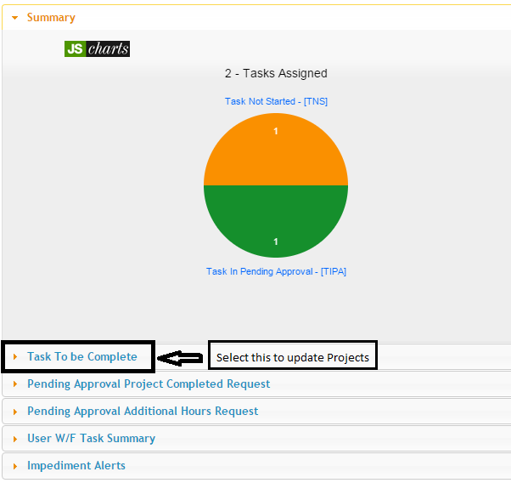

Go to Task to be complete – then select show “100” **(1)** to show all the project in once page/click status **(2)** to sort all the completed and pending project separate/ go to search **(4)** if you want to search by name or project no / select and view project by selecting view **(3)**

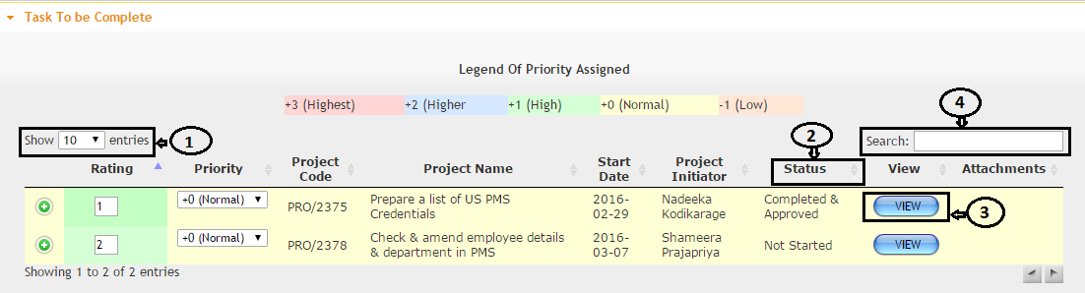

Select the project by view



Select the task and click  to update project task

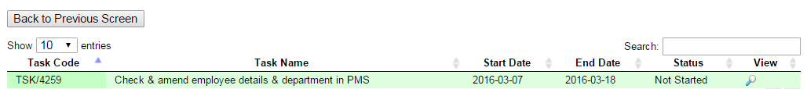

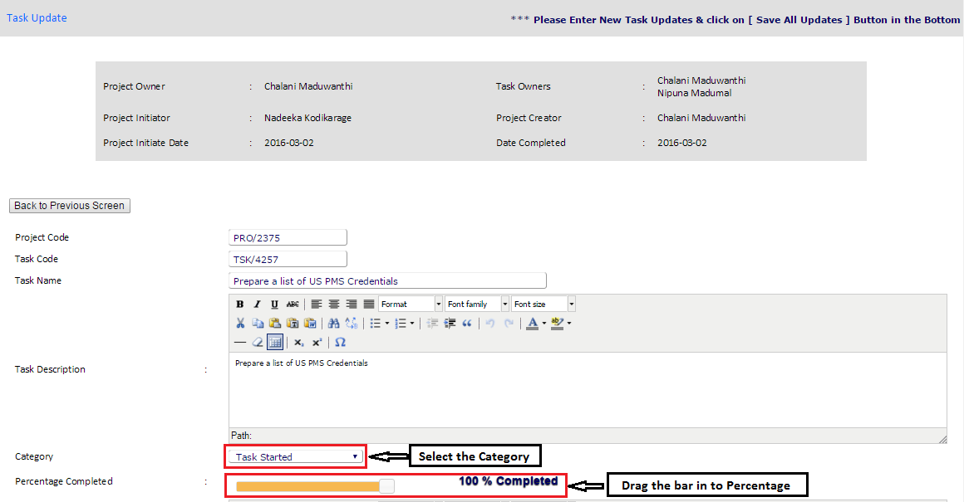Update project status

