|  |  |
| --- | --- |
| **SUBJECT** | PMS & ETF User level |
| **RECORDER (Name Designation)** | Chalani Maduwanthi / Assistant Manager System Admin |
| **APPROVED BY (Name Designation)** |  |
| **CREATED DATE** |  |
| **NO. OF PAGES INCLUDING THIS PAGE** |  |

**OPR for PMS & ETF user level**

**Content**

**PMS**

1. Login to the PMS account
2. PMS Update
3. Workflow Update

**ETF**

1. ETF Login
2. Report document calendar
3. Report Upload
4. Report review panel
5. Meeting calendar
   1. Add meeting minutes
   2. Add non schedule meeting minutes

**PMS**

1. **Login to the PMS account**

PMS Link - <http://69.63.218.233:86/pms/index.php>

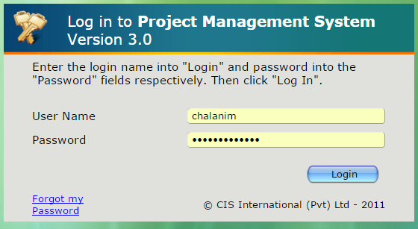

PMS home screen

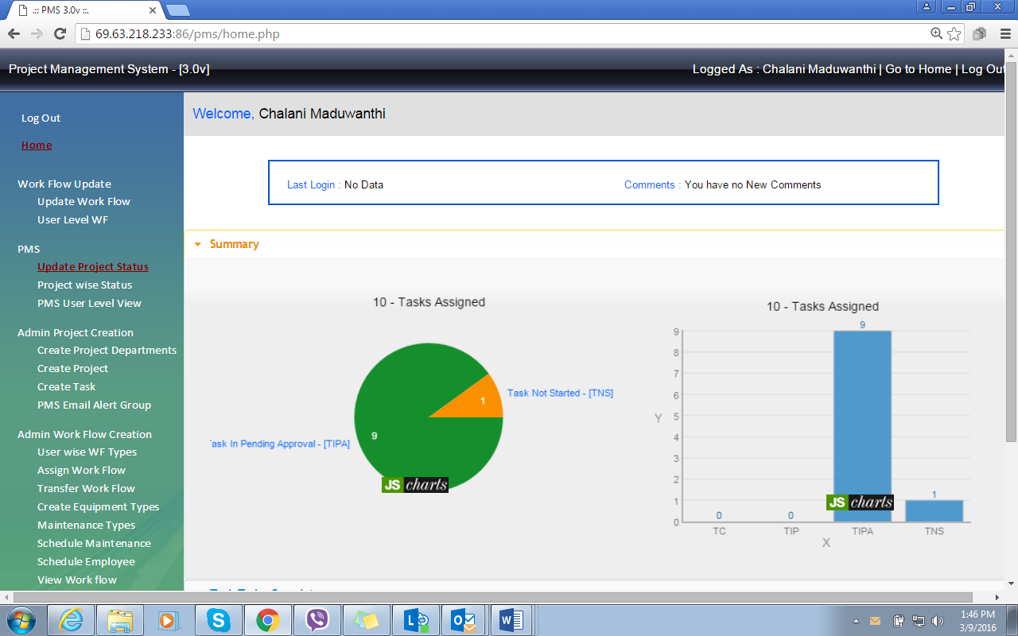

1. **PMS Update**

2.1 Select project status

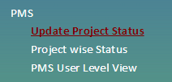

2.2 Task to be complete – To check all the projects and task that come under employee account

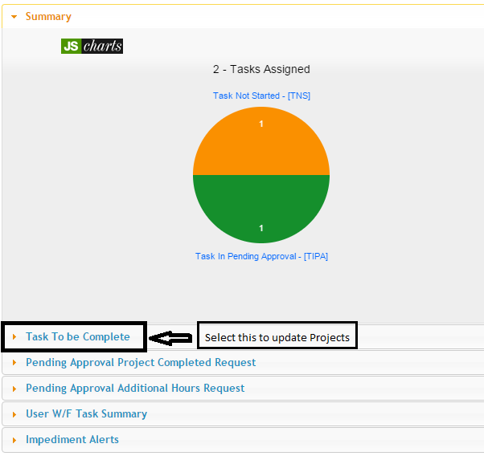

Go to Task to be complete – then select show “100” **(1)** to show all the project in once page/click status **(2)** to sort all the completed and pending project separate/ go to search **(4)** if you want to search by name or project no / select and view project by selecting view **(3)**

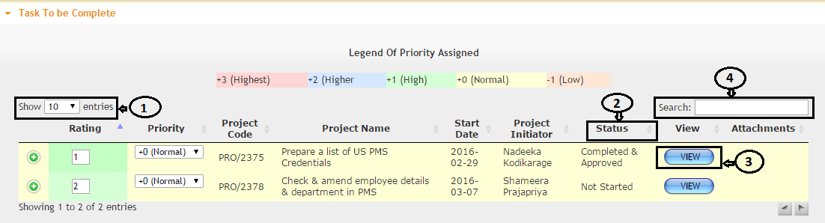

Select the project by view



Select the task and click  to update project task

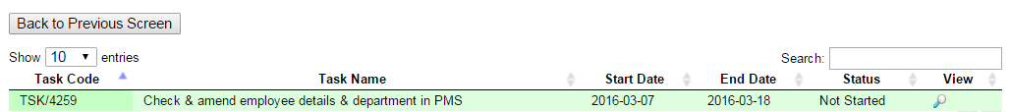

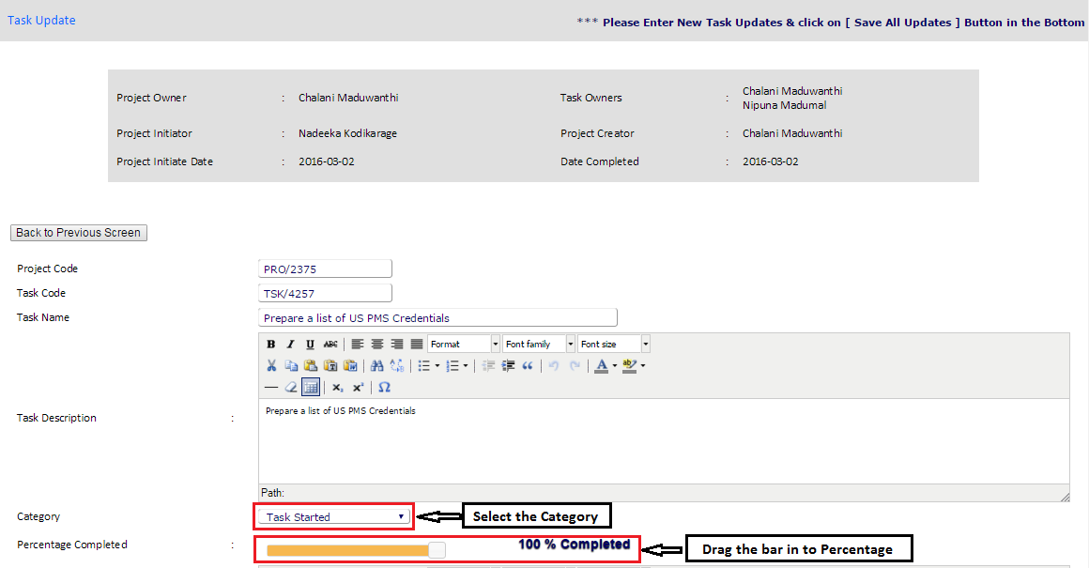Update project status

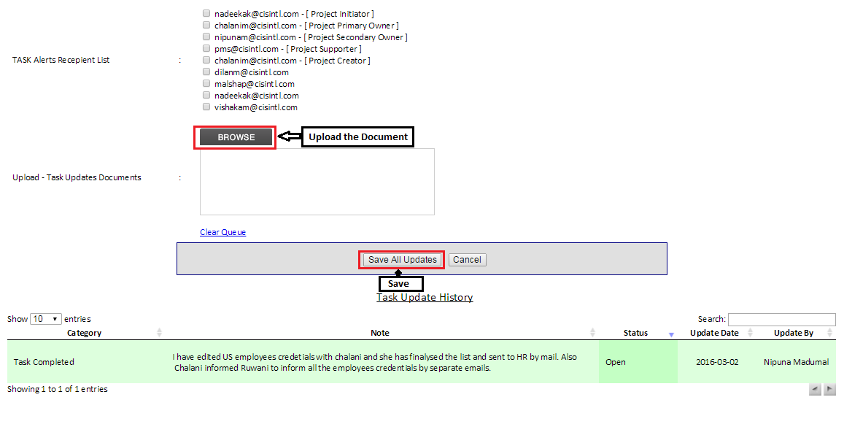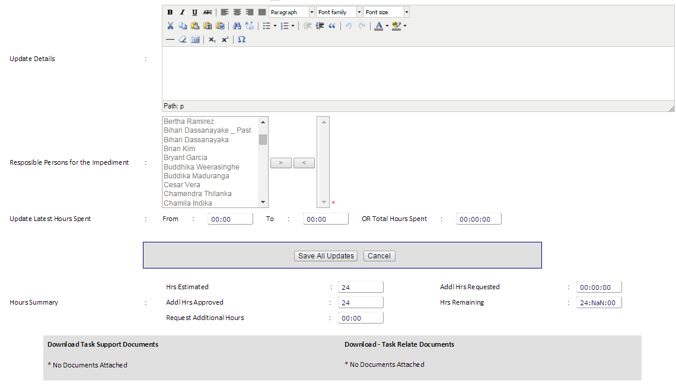

1. **Workflow Update**
2. Initial training is arranged by HR, for all newcomers on how to update workflows.
3. Workflows should be updated before 11:00pm on each day. There are NO EXCUSES for not updating the workflows.
4. System Admin department follows up with workflow updates and if not updated, System Admin will send an email requesting explanations for not performing. This inquiry should be addressed properly and CANNOT be ignored.

If you miss your workflow updates consecutively for more than three days. HODs are responsible for taking necessary actions as per our company policy.

When an employee is resigned/ terminated, the supervisor/HOD of that department should send an email to Admin Dept. asking to remove / transfer workflows of that employee to another employee.

System admin will do the needful and confirm by a retuned email for the same.

**3.1 Update workflow**

Select Update workflow

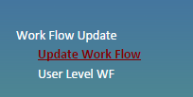

Update workflow – go the each task and mentioned tick “Yes” if the work done, tick “No” if the work is not done and tick “N/A” if the data is not available or any other reason.

Please note to mention time actual **time** duration and **user review note**.

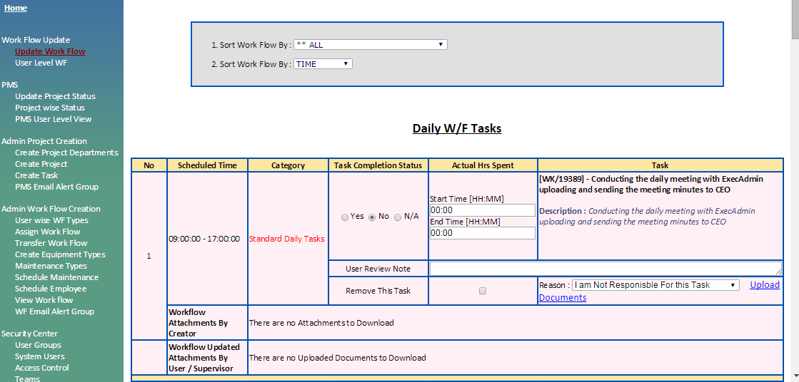

Once you done the tasks you can keep on save and end of the day once you complete all the task click **save** and **Send mail**.

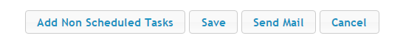

**3.2 Non schedule workflow**

If the employee is doing task which is not related to workflow or not under PMS/ if the employee is doing somebody else workflow task need to be recorded in add nonscheduled tasks.

Click **Add nonscheduled** tasks and fill the form as mentioned below.

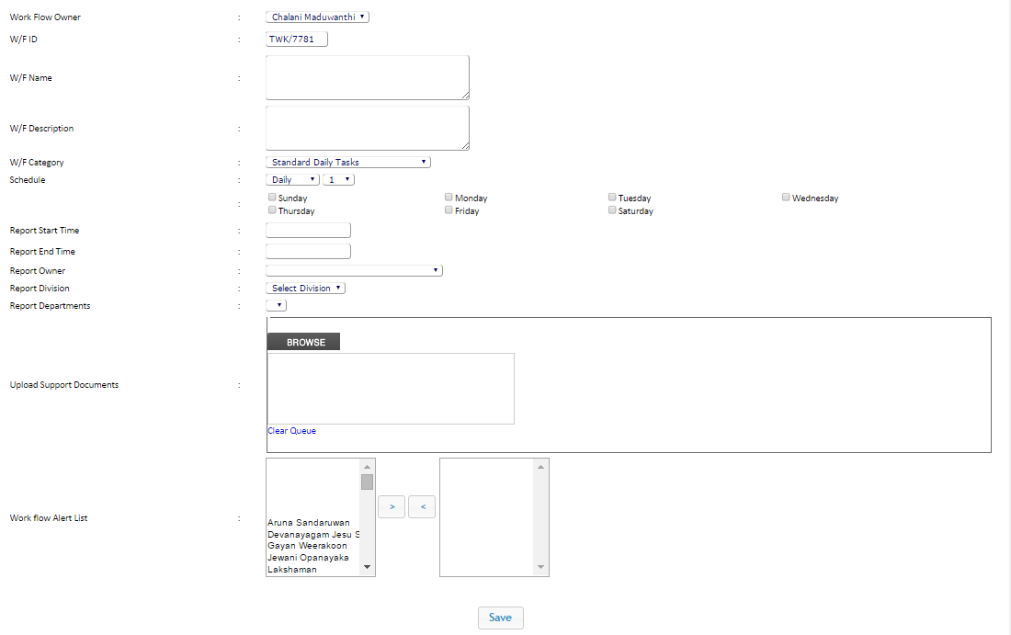

Click “Save”

Once you save you will get an individual summary and Department summary will goes to system admin and HOD of the department.

**ETF**

ETF is a system developed for the use of managing meeting and reports for all the staff members of TFI and TEKSS.

It is a place to refer scheduled/ non-scheduled meetings/meeting minutes. It is a place to review /upload reports on monthly/daily basis. All the relevant documents could be uploaded along with where it works as a store also for these two categories.

1. **ETF Login**

ETF Link - <http://etropicalfish.com/>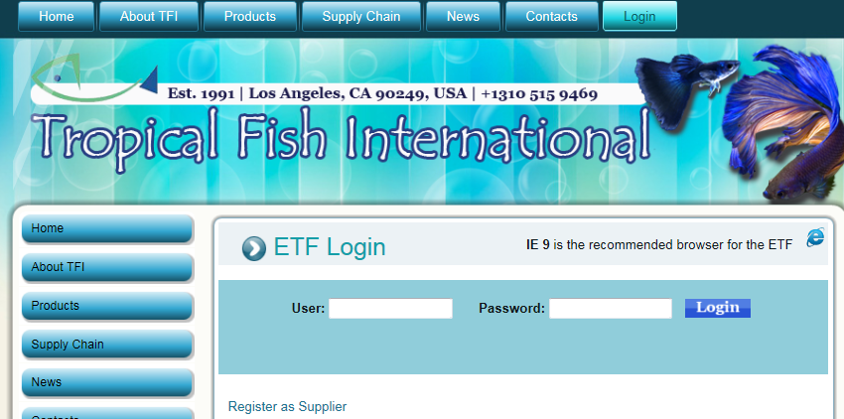

1. **Report document calendar** 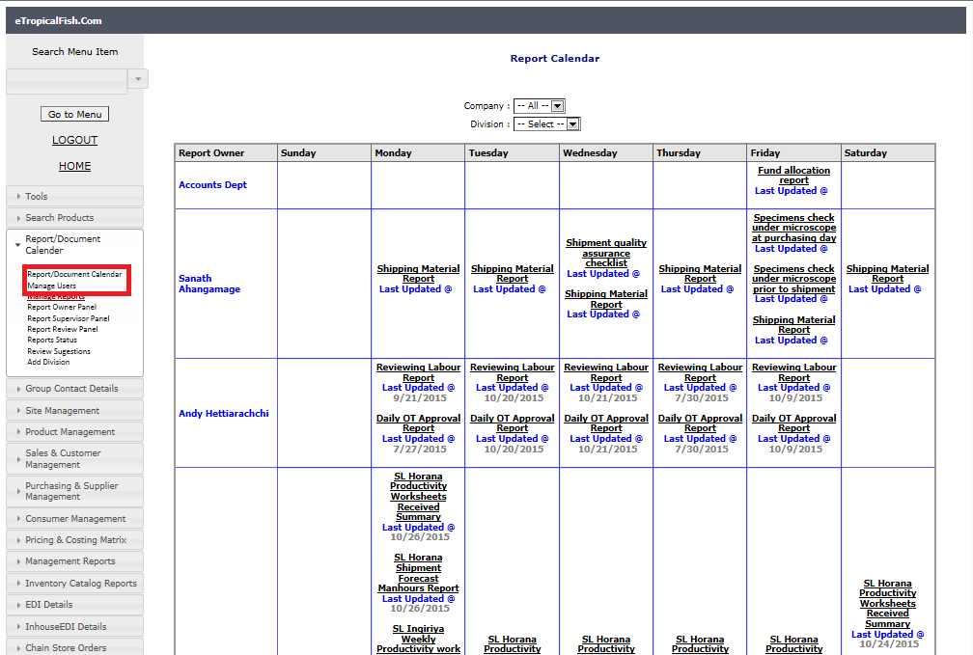
2. **Report Upload**

Report calendar -Update report – report owner panel

1. Go to report/ document calendar – report owner panel – then select the report date – then current week and if you want to add the previous week select the previous week.

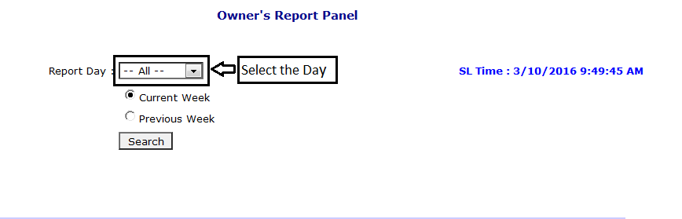

1. If you want select all and check search then you will see you’re all the reports. Then select as mentioned red and also check the report date.

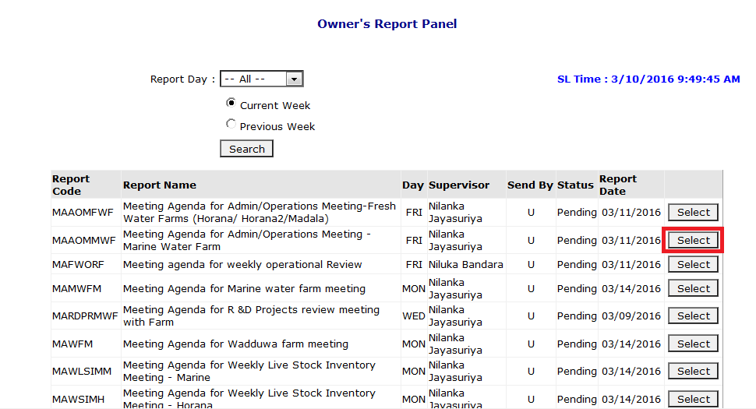

1. Browse your document (1) - tick the box (2) – write on email body (3) as our company policy you need copy and paste email body whatever in the attachment

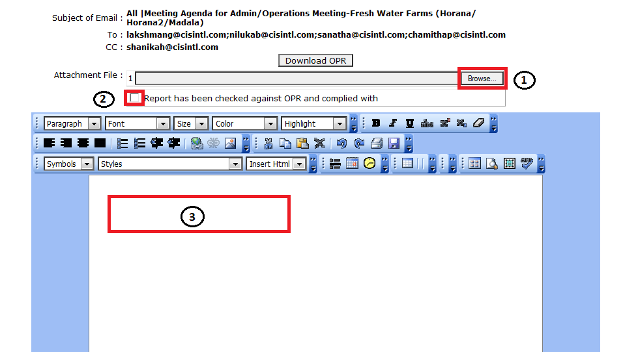

1. Click send report mail to proceed

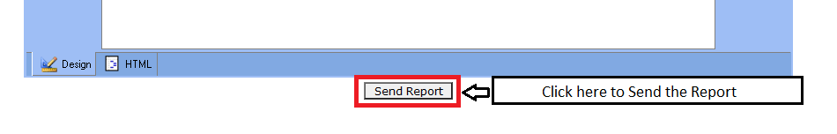

Then system will generate email to all the recipient on behalf of you.

1. **Report review panel**

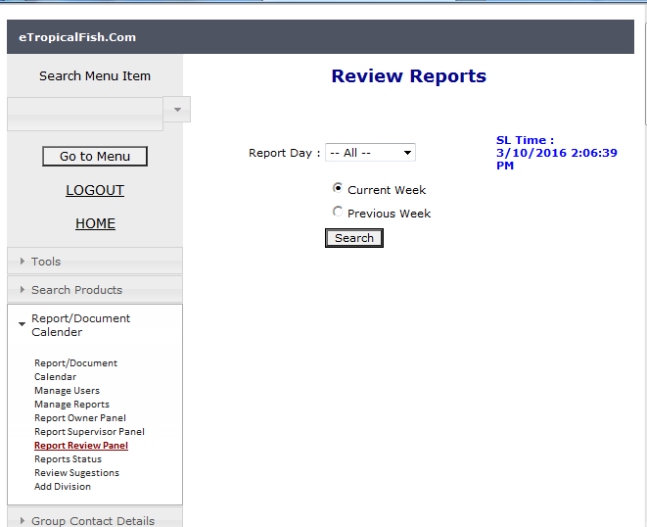

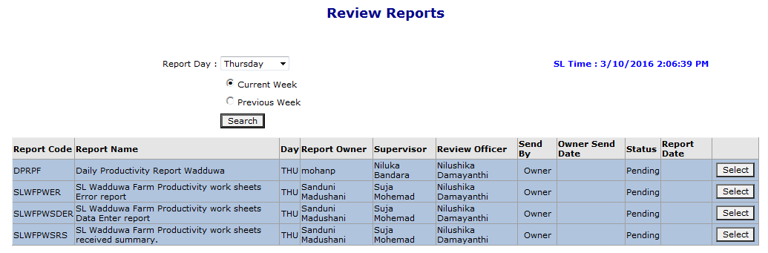

c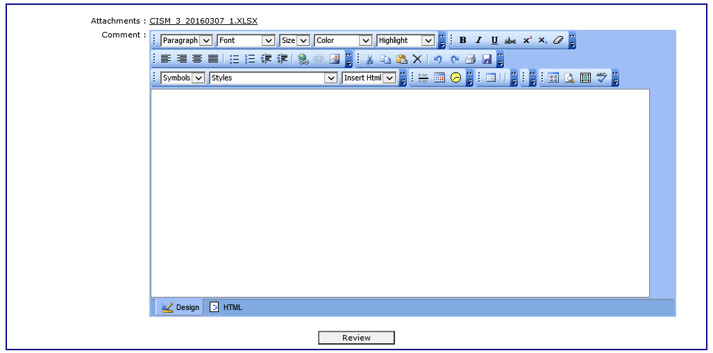

C:\Users\Chalani2\AppData\Local\Microsoft\Windows\Temporary Internet Files\Content.Outlook\3AKI11RC\Capture 3333.PNG

1. **Meeting calendar**

After completing the meeting, one of the participants have to upload meeting minutes in to the system. This is not necessary to add by system admins.

To add meeting minutes, you have to “search” for the meeting and “select” the meeting and follow steps as in the screen shots.

**5.1 Add meeting minutes**

Select the company – select the day – tick the current week if you going to update current week and tick the previous week to update the previous week meeting minutes.

Please note that before select the meeting need to check the meeting

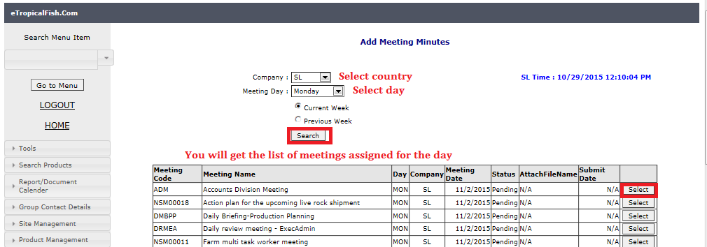

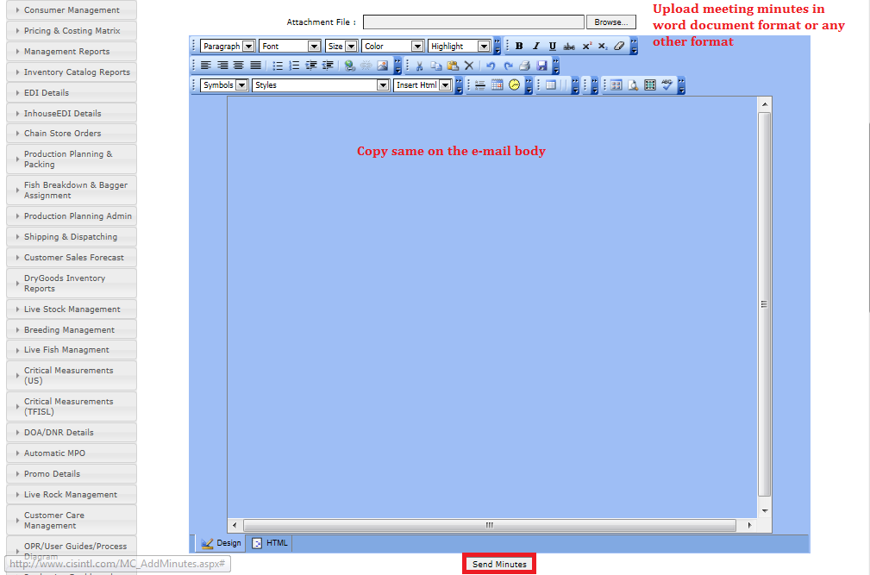

**5.2 Add non schedule meeting minutes**

