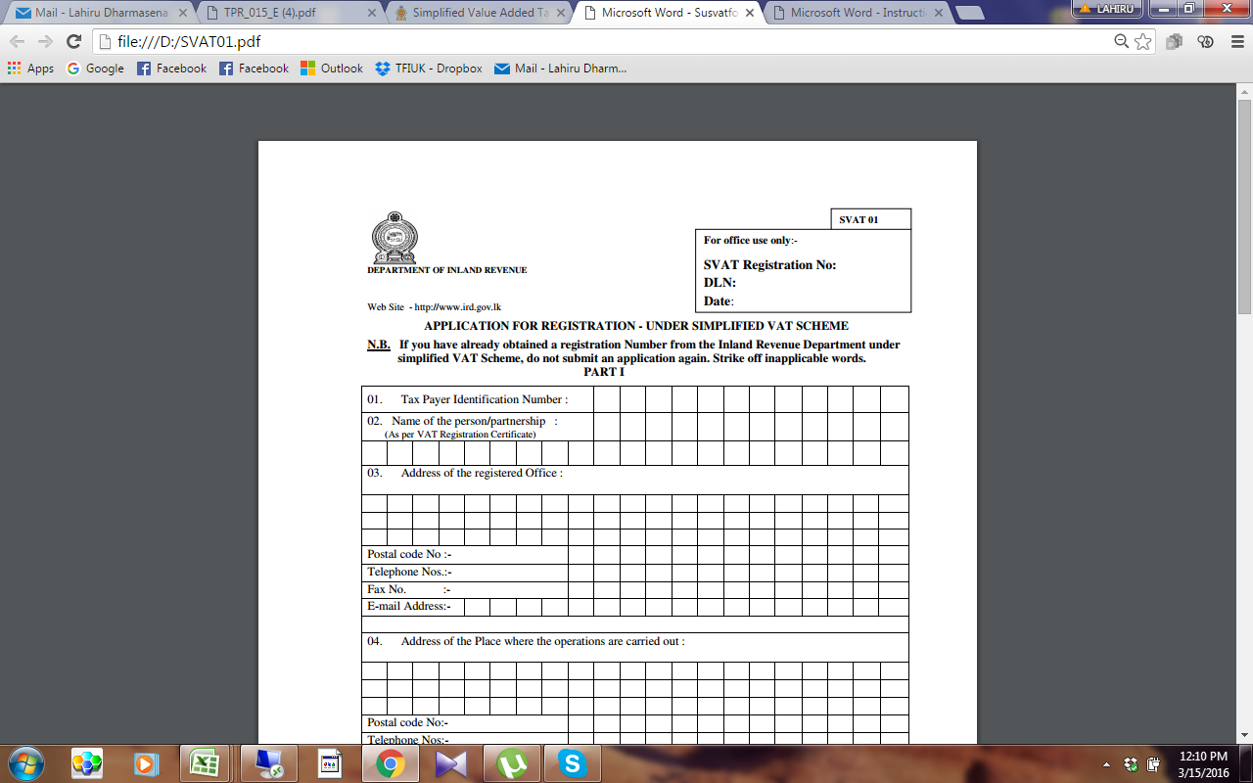

**SVAT FORM 01** [**Application For Registration (SVAT 01)**](http://www.ird.gov.lk/en/Type%20of%20Taxes/SVAT_The%20forms%20specified%20for%20the%20purposes%20of%20this/SVAT01.pdf)

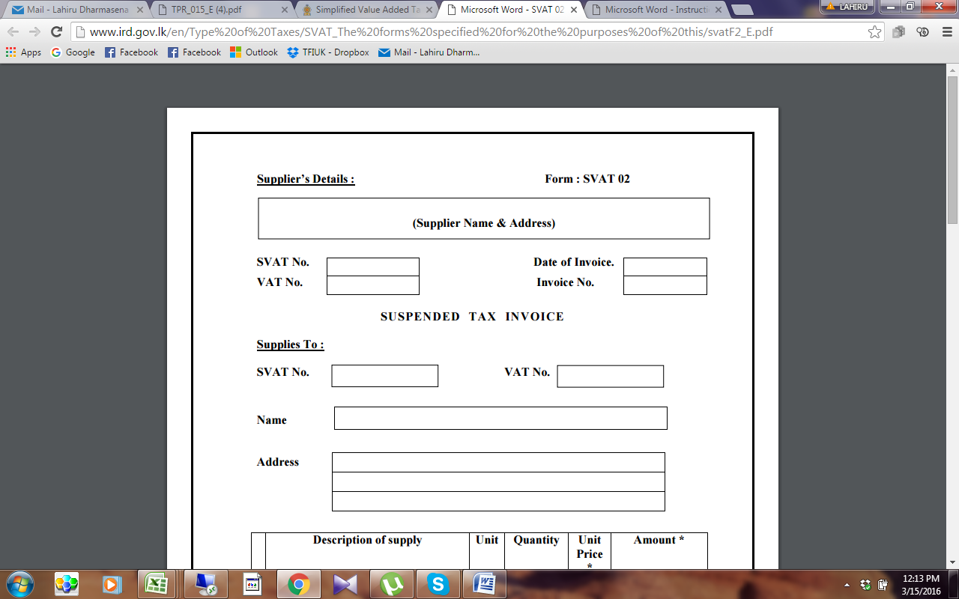

SVAT FORM 02 [Suspended VAT Invoice (SVAT 02) used for supplies without charging VAT](http://www.ird.gov.lk/en/Type%20of%20Taxes/SVAT_The%20forms%20specified%20for%20the%20purposes%20of%20this/svatF2_E.pdf).

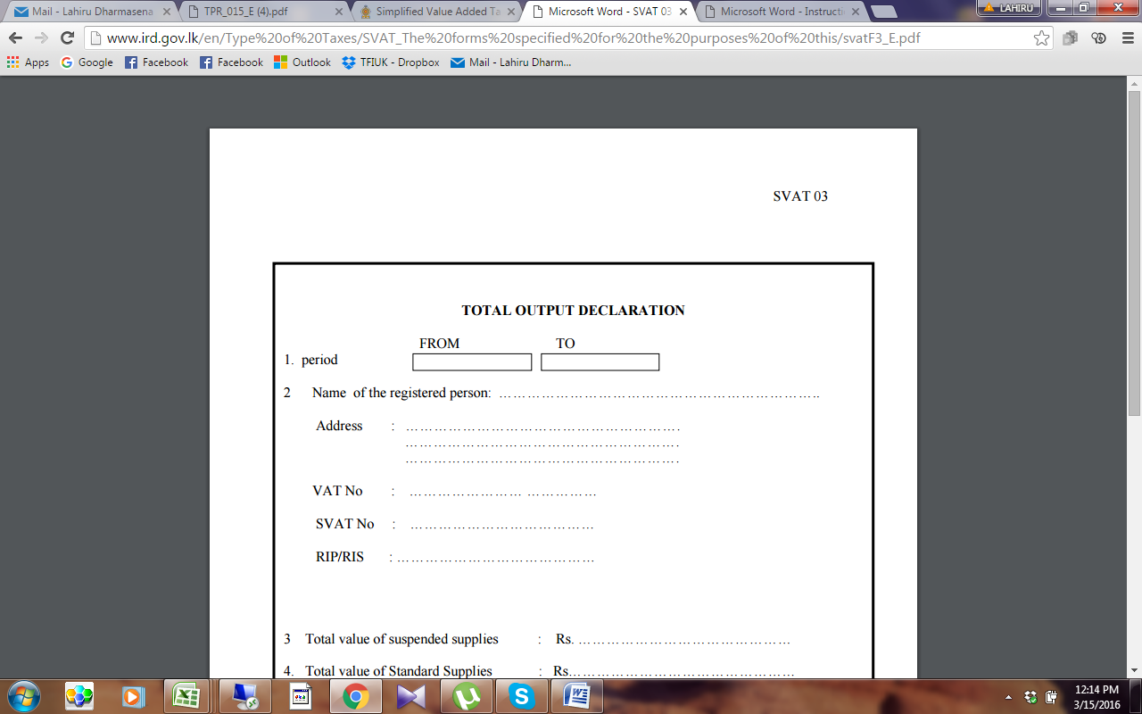

SVAT FORM 03-[Total Output Declaration (SVAT 03) is required to be submitted by Purchasers and Suppliers](http://www.ird.gov.lk/en/Type%20of%20Taxes/SVAT_The%20forms%20specified%20for%20the%20purposes%20of%20this/svatF3_E.pdf).

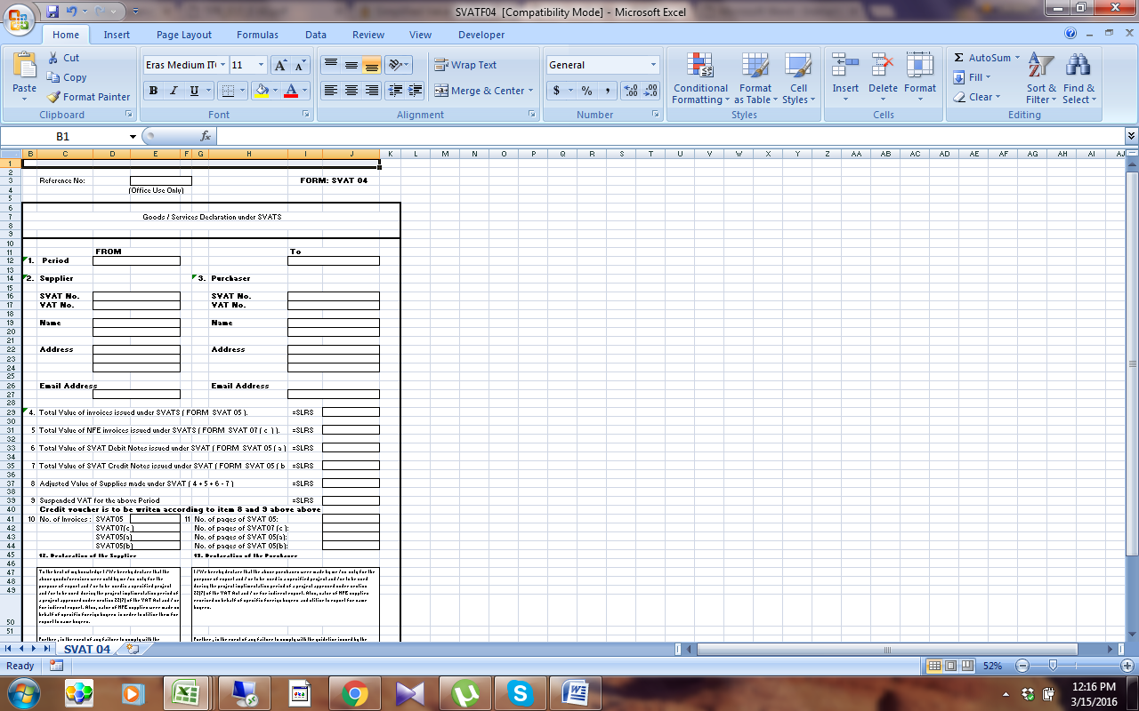

SVAT FORM 04 [Confirmation of the Supply from both parties. (SVAT 04) This is to be submitted by Suppliers - both party document](http://www.ird.gov.lk/en/Type%20of%20Taxes/SVAT_The%20forms%20specified%20for%20the%20purposes%20of%20this/SVATF04.xls).

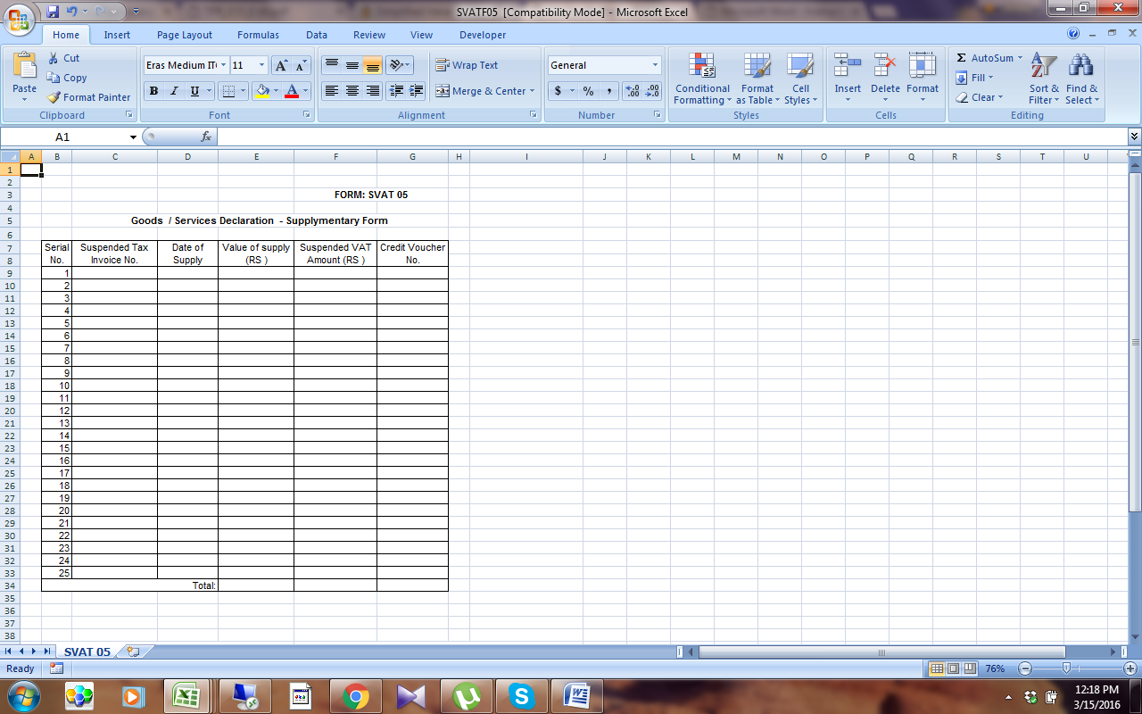

SVAT FORM 05 [Monthly Supplementary Declaration Form (SVAT 05) – This is a summary of Supplies.  The suppliers are required to submit this form with SVAT 04. – both party document](http://www.ird.gov.lk/en/Type%20of%20Taxes/SVAT_The%20forms%20specified%20for%20the%20purposes%20of%20this/SVATF05.xls).

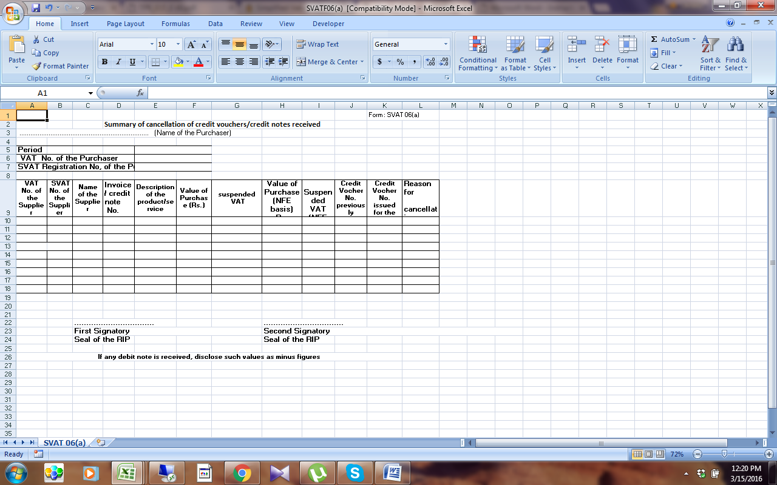

SVAT 06 [Reconciliation of Cancellation of Credit Vouchers And Purchases Returned During The Month or In A Subsequent Month.  - [SVAT 06(a)]- This documentation is required to be submitted by the purchaser](http://www.ird.gov.lk/en/Type%20of%20Taxes/SVAT_The%20forms%20specified%20for%20the%20purposes%20of%20this/SVATF06(a).xls).

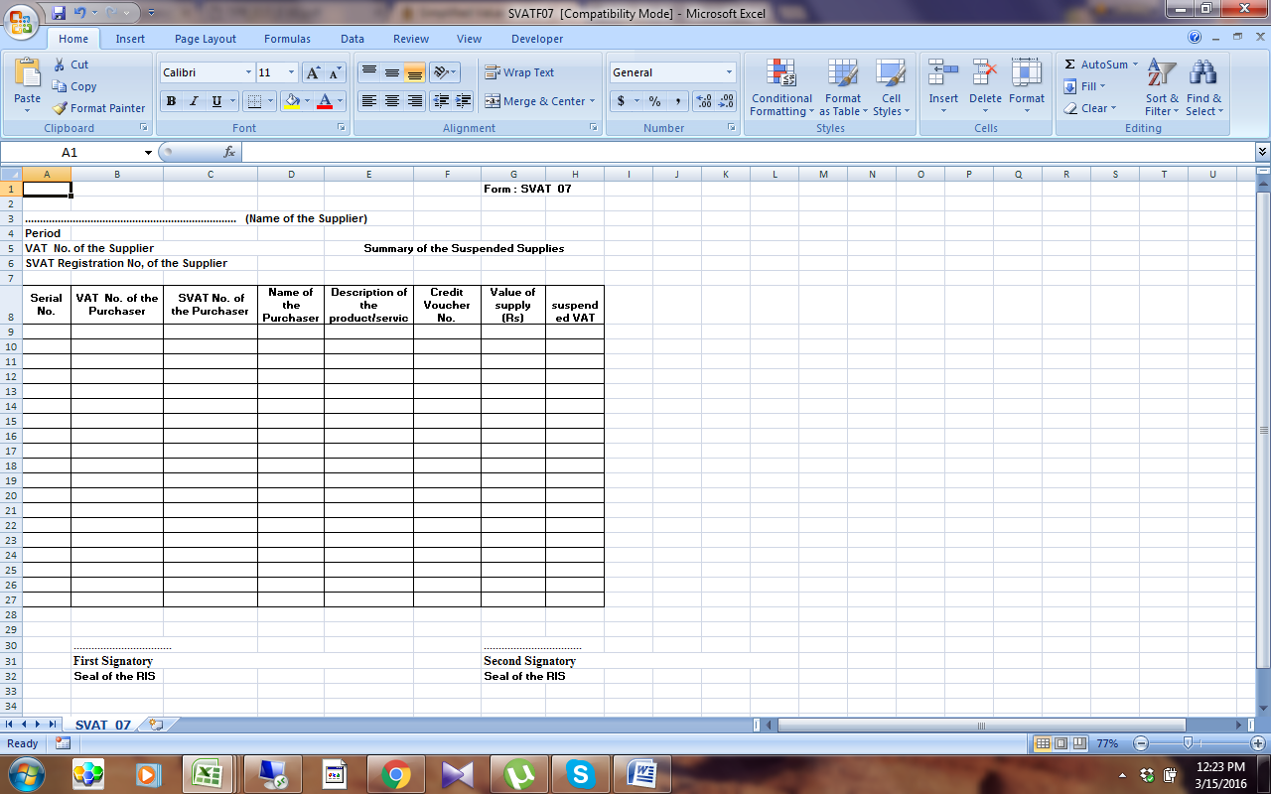

SVAT Form 07 [Summary of the Suspended Supplies - (SVAT 07) - This documentation is required to be submitted by the supplier](http://www.ird.gov.lk/en/Type%20of%20Taxes/SVAT_The%20forms%20specified%20for%20the%20purposes%20of%20this/SVATF07.xls)