**OPR for Hardcopies of all farm Bills and filing in payable file**

|  |  |
| --- | --- |
| **SUBJECT** | OPR for Hardcopies of all farm Bills and filing in payable file |
| **RECORDER (Name Designation)** | Sajith Asanka – Accounts Executive |
| **APPROVED BY (Name Designation)** | Stanley Samidas – Senior Accountant |
| **CREATED DATE** | 03/08/2016 |
| **NO. OF PAGES INCLUDING THIS PAGE** | 02 |

1. Get the hardcopies of Bills by curio from Wadduwa & Horana farms

2. Check whether the Scan Images save to the Network Folder of those invoices according to supplier wise (Start button/ My Computer/ SL Farm Folder/TFISL)

3. Check the PO rates, Invoice amounts and GRN amounts is in order and agree with QB records.

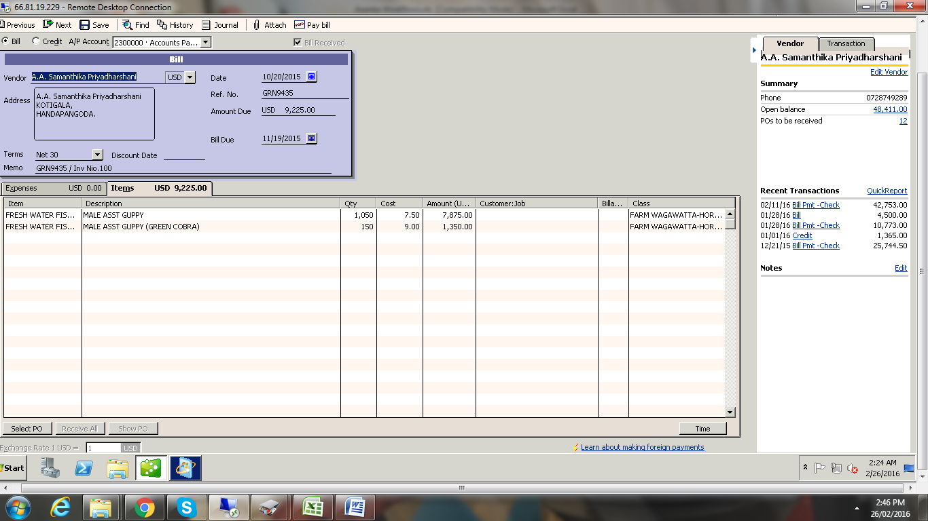

4. Check those bills under farm managers authorized with signature.

5. All hard copies filing supplier wisein payable file for once the payment arranged attached to cheque payment voucher.