**OPR for Supplier negotiation Payment Request & get Approval**

|  |  |
| --- | --- |
| **SUBJECT** | OPR for Supplier negotiation Payment Request & get Approval |
| **RECORDER (Name Designation)** | Sajith Asanka – Accounts Executive |
| **APPROVED BY (Name Designation)** | Stanley Samidas – Senior Accountant |
| **CREATED DATE** | 03/08/2016 |
| **NO. OF PAGES INCLUDING THIS PAGE** | 03 |

1. Answer supplier Calls and other related parties calls

2. Discussed with suppliers and inform to them when we are going to settle their bills

3. If already settle their bills provide the payment details (Cheque Date/ Amount/ Cheque Number)

4. If we not settle due bills, get from unpaid bills details report and sent due bills details for Finance Manager approval to arrange payment via email and get approval code

Path - Log in to TFI QB File/ Report/Vender and Payable / unpaid bills details

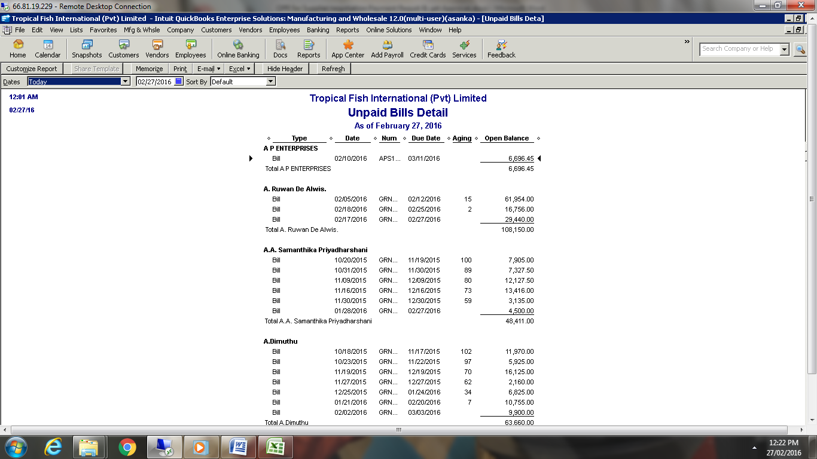

Example for e-mail

Dominic,

Suplier call and asking following payments, Please approval for arrange pyment

|  |  |  |  |  |  |  |  |
| --- | --- | --- | --- | --- | --- | --- | --- |
| **Onetma Solutions** | | |  |  |  |  |  |
|  |  | Bill | 10/05/2015 | ON20151005-01 | 10/20/2015 | 121 | 1,554.00 |
|  |  | Bill | 10/16/2015 | ON20151016-01 | 10/31/2015 | 110 | 23,300.00 |
| Total Onetma Solutions | | | |  |  |  | 24,854.00 |

5. After arrange payments via call/Skype/email need to inform collect the cheques to Supplier or relevant division (Admin /HR/Logistic)

6. After handover cheques according to our bank funds situation ( Bank reconciliation/Advise by senior Officer ) need to inform supplier not bank on cheque date and give them to another date.