**OPR for Update Details of Cheques to be cut in QB (TFI/TKKS/CTF)**

|  |  |
| --- | --- |
| **SUBJECT** | OPR for Update Details of Cheques to be cut in QB (TFI/TKKS/CTF ) |
| **RECORDER (Name Designation)** | Sajith Asanka – Accounts Executive |
| **APPROVED BY (Name Designation)** | Stanley Samidas – Senior Accountant |
| **CREATED DATE** | 03/08/2016 |
| **NO. OF PAGES INCLUDING THIS PAGE** | 02 |

To make a payment through a cheques for Supplies or any other payment

1. **If it is Bill payment**

Path - Log in to CTF/TFI/TKKS QB File/Vendors/Bill Payment / Select the bill/Pay selected Bills/Put the Cheque Date / Put the Cheque No/OK

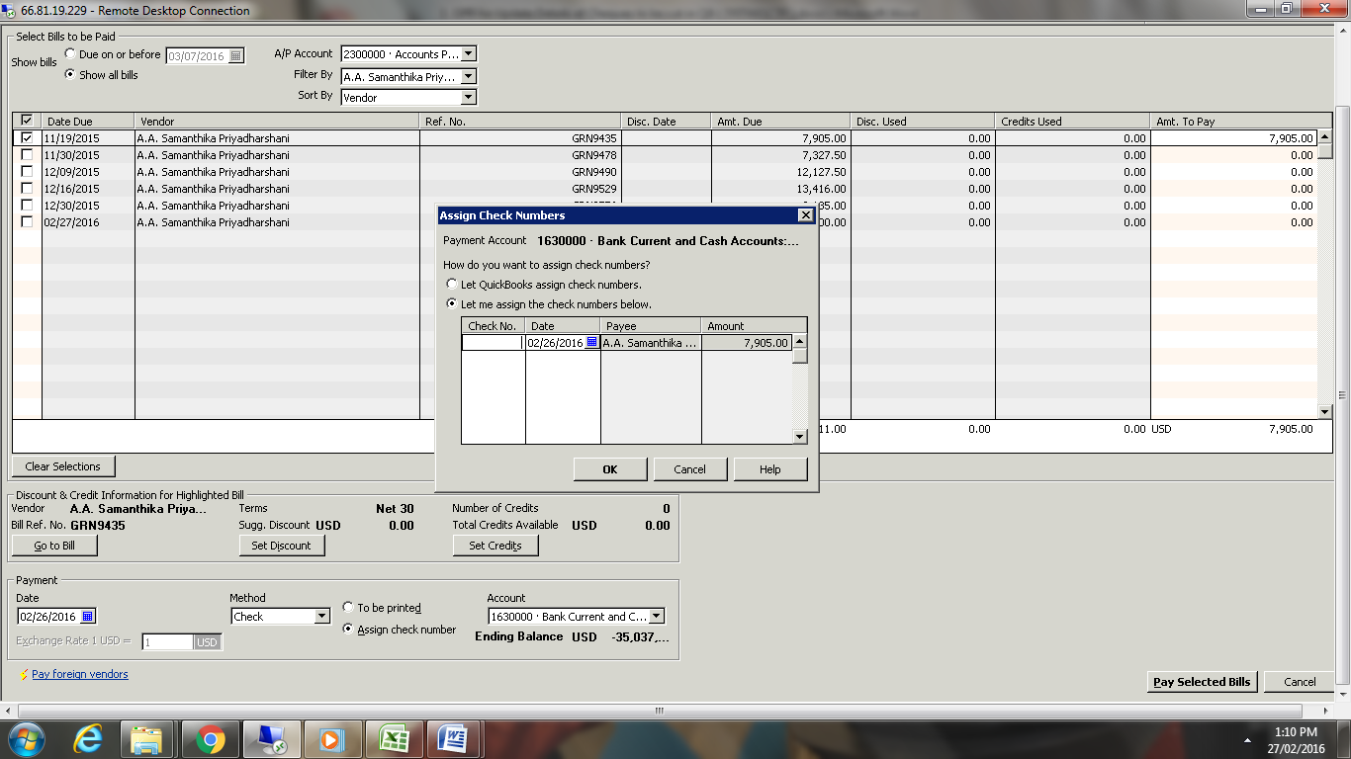

**2. If it is Not Bill payment**

Path - Log in to CTF/TFI/TKKS QB File/Banking/Write Check/ Save

We have to include following details arrange a cheque

1. Select the Bank account
2. Enter cheque number
3. Select Date
4. Enter Amount
5. Enter Memo to be print on Voucher

