OPR for Export to Acc-soft Cheque Printing Software & Cheque & Voucher Printing

|  |  |
| --- | --- |
| **SUBJECT** | OPR for Export to Acc-soft Cheque Printing Software & Cheque & Voucher Printing |
| **RECORDER (Name Designation)** | Sajith Asanka – Accounts Executive |
| **APPROVED BY (Name Designation)** | Stanley Samidas – Senior Accountant |
| **CREATED DATE** | 03/08/2016 |
| **NO. OF PAGES INCLUDING THIS PAGE** | 03 |

*After wrote a cheque it should be Print using following paths,*

Cheques Print

Reports/ Memorized Report/ Cheque & Voucher Printing/ Modify the Date Range/ Press "Print" Button/ Create Disk File Window select "Computer"/ Select "C on ASANKA-PC"/ Open "Text File"/ Select "Journal"/ Press "Save" Button

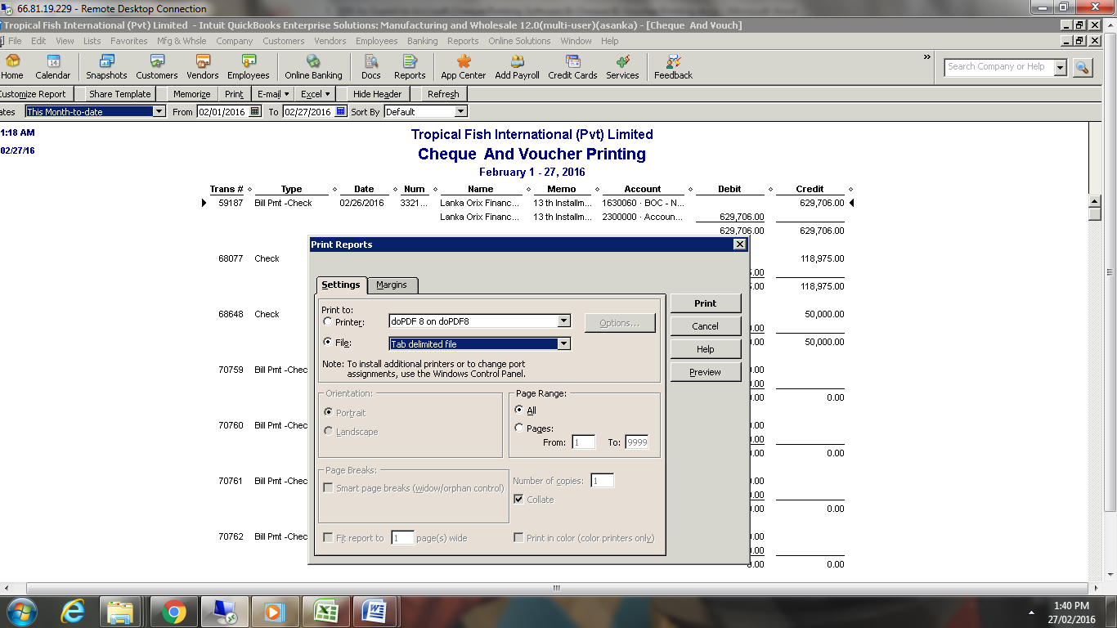

Voucher Print

1. **If it is Bill payment**

Reports/ Memorized Report/ Bill/ Modify the Date Range/ Press "Print" Button/ Create Disk File Window select "Computer"/ Select "C on ASANKA-PC"/ Open "Text File"/ Select "Bill"/ Press "Save" Button

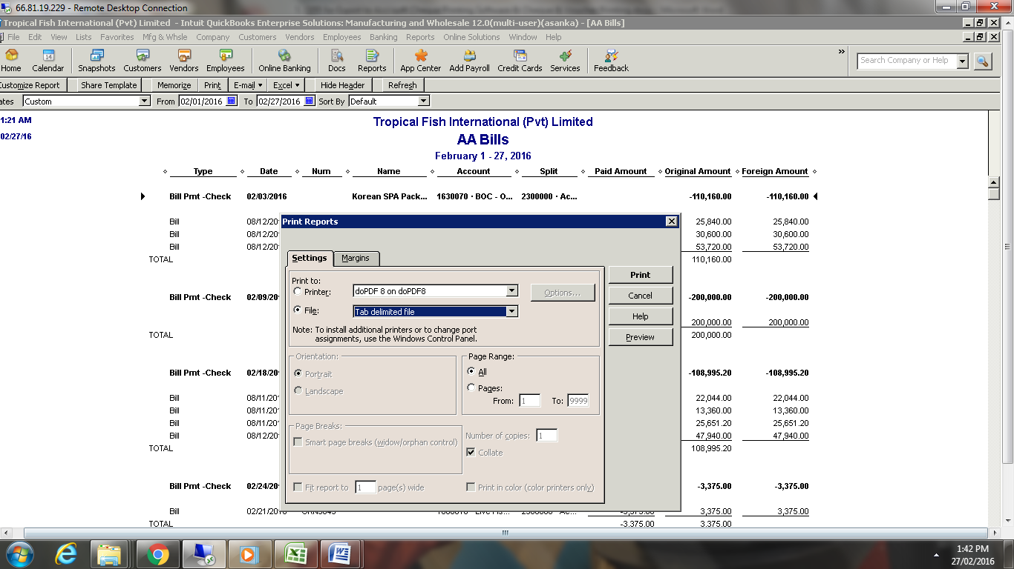

**2. 2. If it is Not Bill payment**

Reports/ Memorized Report/ Cheque & Voucher Printing/ Modify the Date Range/ Press "Print" Button/ Create Disk File Window select "Computer"/ Select "C on ASANKA-PC"/ Open "Text File"/ Select "Journal"/ Press "Save" Button

