**Maintaining Trade Payable Ledger**

|  |  |
| --- | --- |
| **SUBJECT** | Maintaining Trade Payable Ledger |
| **RECORDER (Name Designation)** | Sajith Asanka – Accounts Executive |
| **APPROVED BY (Name Designation)** | Stanley Samidas – Senior Accountant |
| **CREATED DATE** | 03/08/2016 |
| **NO. OF PAGES INCLUDING THIS PAGE** | 01 |

**TFI QB FILE/Report/Unpaid Bills**

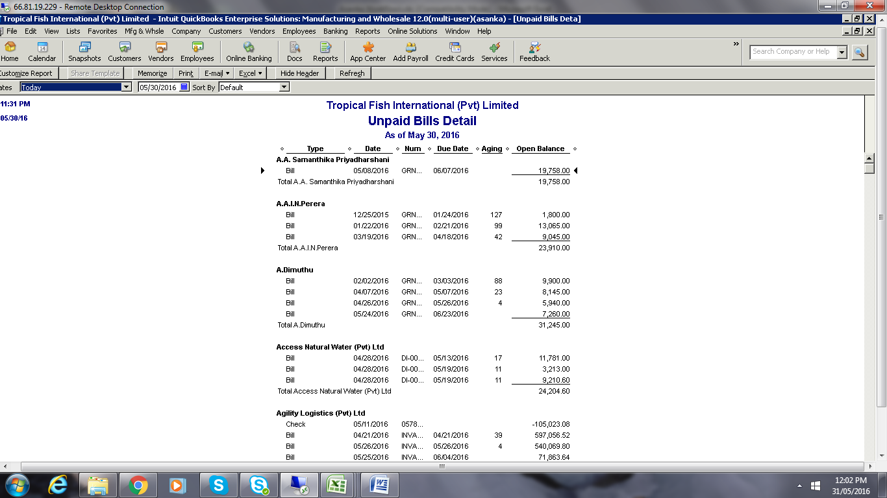

Check before arrange payment all bills book to QB

Supplier payment advance payment / (-) balance on time settlement after received bills