**Check the company all utility biils settlement**

|  |  |
| --- | --- |
| **SUBJECT** | Check the company all utility biils settlement |
| **RECORDER (Name Designation)** | Sajith Asanka – Accounts Executive |
| **APPROVED BY (Name Designation)** | Stanley Samidas – Senior Accountant |
| **CREATED DATE** | 03/08/2016 |
| **NO. OF PAGES INCLUDING THIS PAGE** | 02 |

Check the bill file for all utility bills received to accounts department (Electricity, Water)

Check QB Unpaid bill report for all utility bills entered to the system

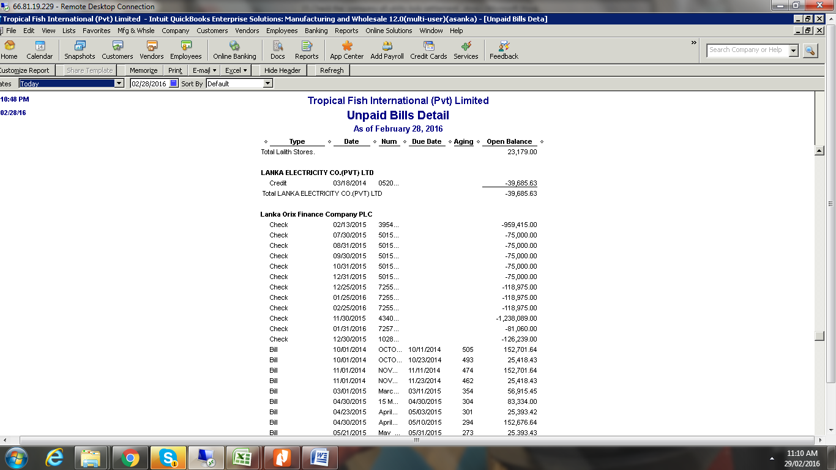

If not bills entered to system check what the reason.

If not bill still received accounts department need to coordinate with admin department and get the bills and follow up enter bill to the QB.

Arrange payment and settlement the during the period for avoid the unnecessary disconnection of service.