**Tropical Fish International (Pvt) Ltd**

Exception Report

|  |  |
| --- | --- |
| **SUBJECT** | EXCEPTION REPORT |
| **DEPARTMENT** | Marketing – Payroll |
| **RECORDER (Name Designation)** | Saroad Gunarathne : Payroll Executive |
| **APPROVED BY (Name Designation)** |  |
| **LAST UPDATE** | 29/03/2016 |
| **PATH ON NETWORK FOLDER** |  |
| **NO. OF PAGES INCLUDING THIS**  **PAGE** | 04 |

**Objective : Send exceptions for Labors.**

**Note : Still Not received a training for generate Exception report in New Uattend system**

* Exception report send in every day without Saturday & Sunday (Monday to Friday)
* Daily update the punchers & get the report From QQEST
* Select All Employees Before get the Report
* 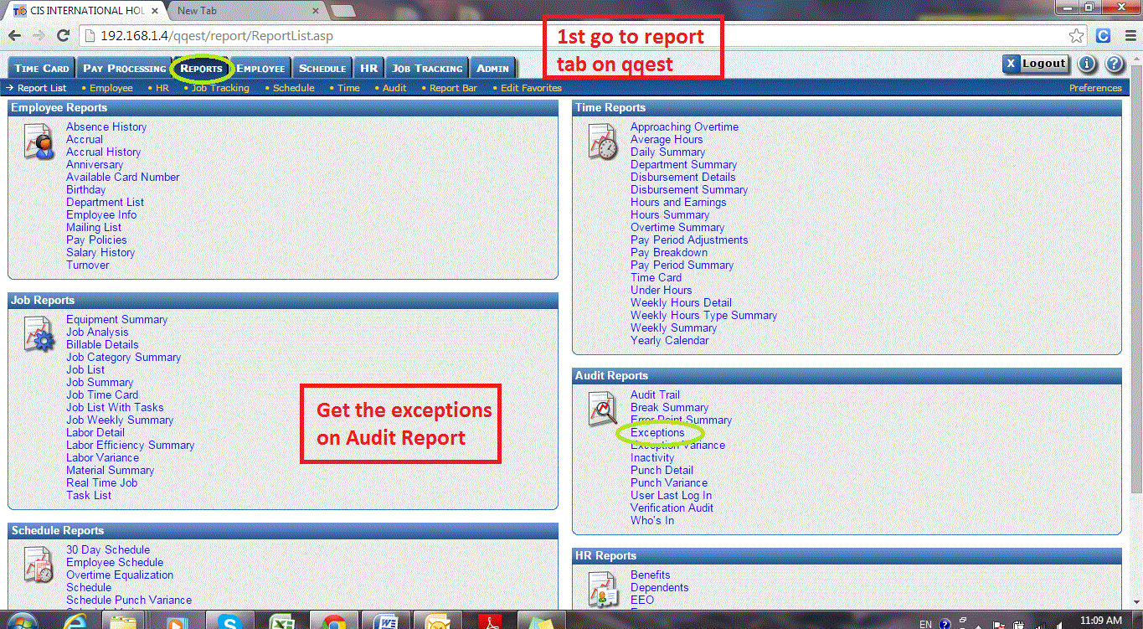On the Exception Report Select The Production date & uncheck the Followings & get the Report
  + Job Mismatch
  + Task Mismatch
  + Not Allowed On Job
  + Not Allowed On Task
  + Job Completed

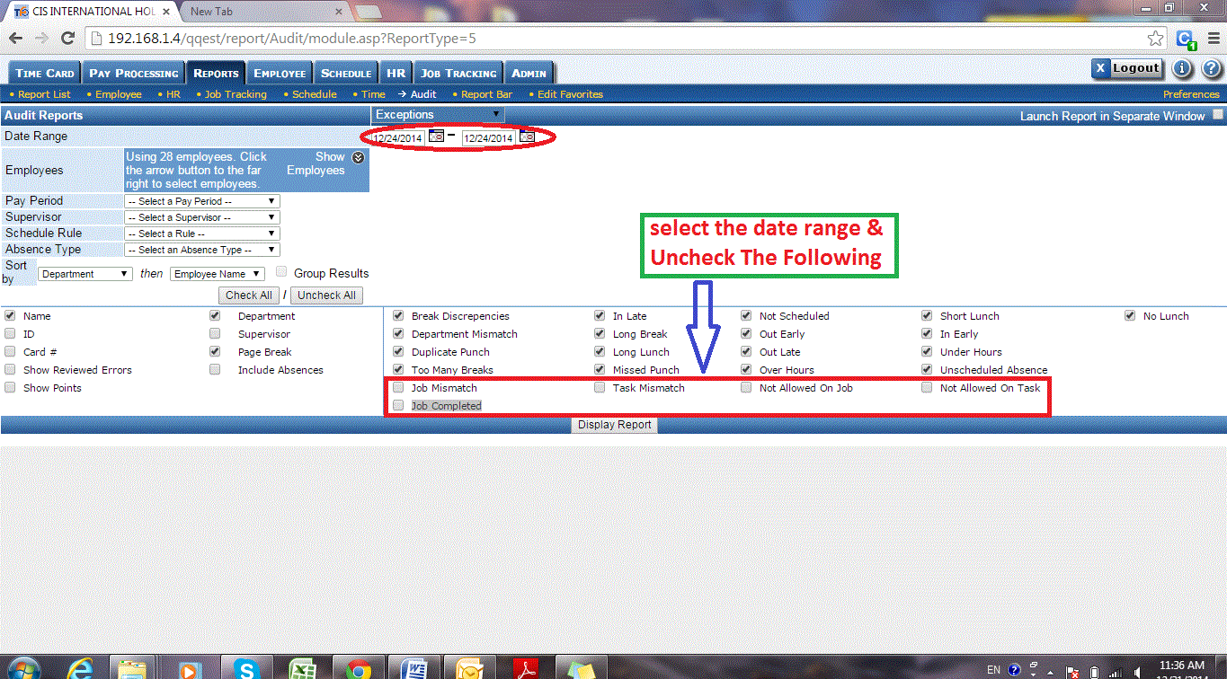

* 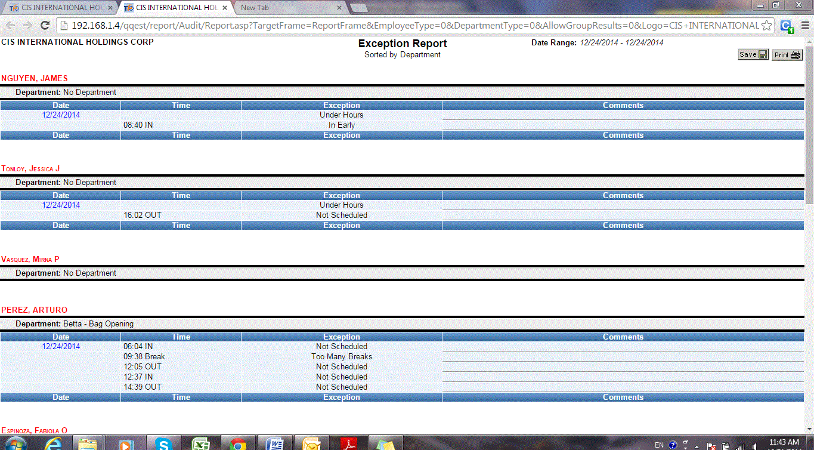Copy the data to Excel exception Report