|  |  |
| --- | --- |
| **SUBJECT** | Payroll Summary Report |
| **DEPARTMENT** | Marketing – Payroll |
| **RECORDER (Name Designation)** | Saroad Gunarathne : Payroll Executive |
| **APPROVED BY (Name Designation)** |  |
| **LAST UPDATE** | 29/03/2016 |
| **PATH ON NETWORK FOLDER** |  |
| **NO. OF PAGES INCLUDING THIS**  **PAGE** | 05 |

Payroll summary report is prepared once a week (On Wednsday) for the last pay week from Friday to Thusday.

1. Get weekly regular hours and OT hours from uAttend system.

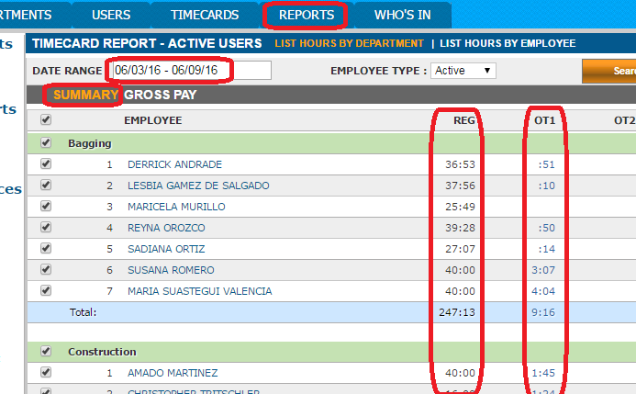

1. Enter those weekly regular and OT hours to the payrall summary report.

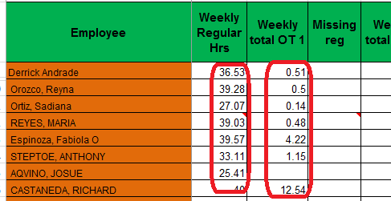

1. Get total approved OT hours from approved and unapproved OT summary report and enter them in to the approved OT column of payroll summary report.

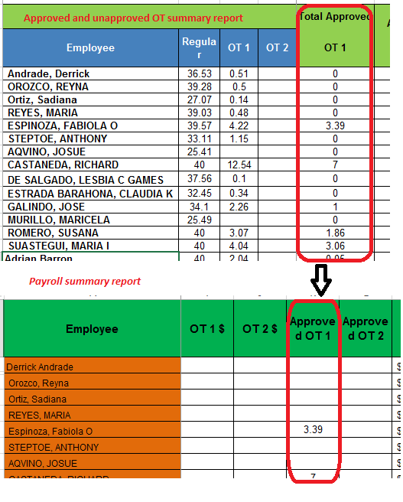

1. Fill the Bonus column of payroll summary report by getting total bonus values from weekly productivity bonus summary report.

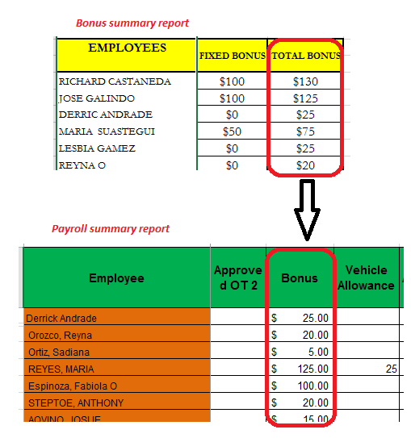

1. If there are missing OT hours, enter them to the missing OT hours column.

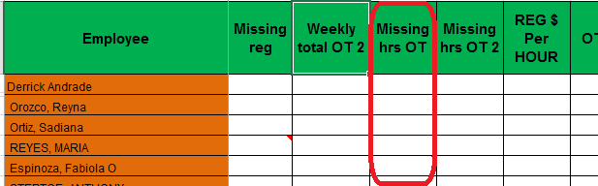

1. If allowances, commissions and salary advances are there, enter them into the relevant columns.

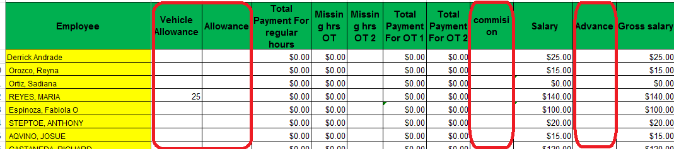

1. Following columns of the payroll summary report are used to process weekly payroll.

