**Tropical Fish International (Pvt) Ltd**

SET DIRECT DEPOSIT

|  |  |
| --- | --- |
| **SUBJECT** | SET DIRECT DEPOSIT |
| **DEPARTMENT** | Marketing – Payroll |
| **RECORDER (Name Designation)** | Saroad Gunarathne : Payroll Executive |
| **APPROVED BY (Name Designation)** |  |
| **LAST UPDATE** | 29/03/2016 |
| **PATH ON NETWORK FOLDER** |  |
| **NO. OF PAGES INCLUDING THIS**  **PAGE** | 02 |

**Objective : Pay employees direct to their bank.**

**Log in to iop.intuit web site by using your login details.**

**Select “Pay day” tab**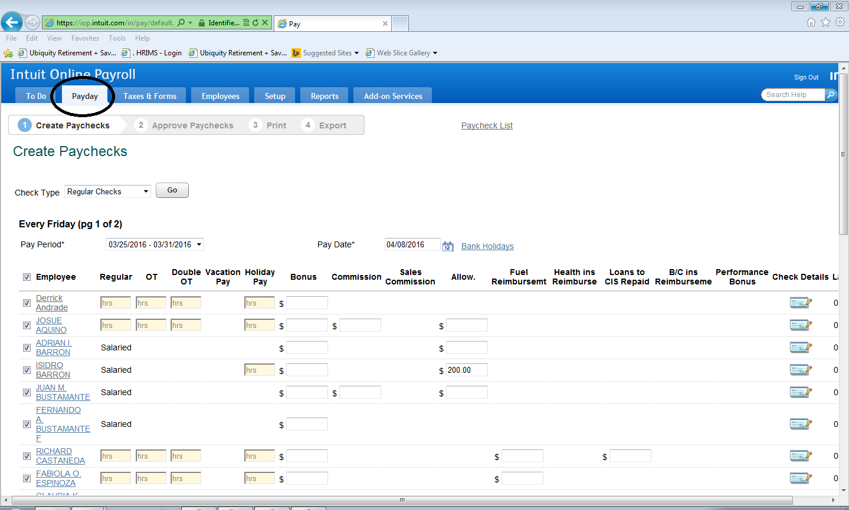

* **Select pay period**
* **check employees who need to put direct deposit, uncheck other employees & process**

**Approve pay checks.**