|  |  |
| --- | --- |
| **SUBJECT** | Bonus Summary Report |
| **DEPARTMENT** | Marketing – Payroll |
| **RECORDER (Name Designation)** | Saroad Gunarathne : Payroll Executive |
| **APPROVED BY (Name Designation)** |  |
| **LAST UPDATE** | 29/03/2016 |
| **PATH ON NETWORK FOLDER** |  |
| **NO. OF PAGES INCLUDING THIS**  **PAGE** | 02 |

Bonus Summary report is prepared once a week (Tuesday) for the last production week of Friday to Saturday.

1. Open the weekly productivity worksheets submission report received from the labor planning department via e-mail.

This report shows the number of productivity work sheets submitted by each employee and submitted dates.

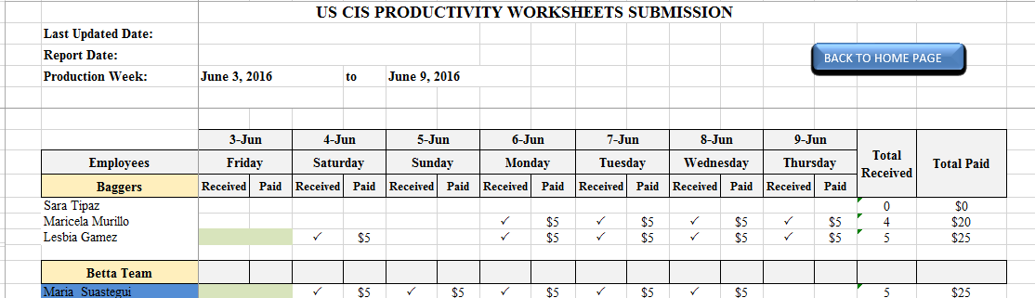

1. Employees are paid five dollars for each submitted productivity worksheet. Enter five dollars into the column under the submitted date.
2. Enter total number of productivity worksheets submitted for the relevant week under the column named as PWS SUBMIT.

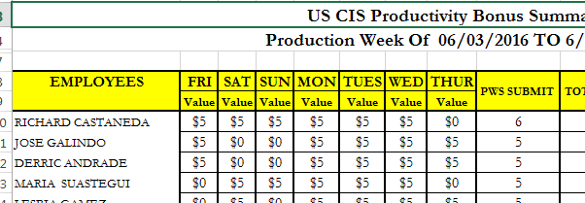

1. Put a copy of productivity worksheet submission report (shown in 1) to the general staff tab of bonus summary report.
2. Fixed bonus values should be included to fixed bonus column.

Fixed bonus values are sent by the management. Fixed bonuses should be included after management inform and that values should be remain until changes are informed by the management.

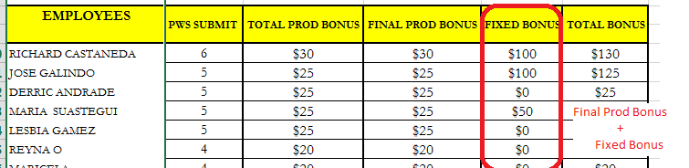

1. Total bonus value is the summation of final productivity bonus value and fixed bonus value.