|  |  |
| --- | --- |
| **SUBJECT** | Approved Unapproved OT Summary |
| **DEPARTMENT** | Marketing – Payroll |
| **RECORDER (Name Designation)** | Saroad Gunarathne : Payroll Executive |
| **APPROVED BY (Name Designation)** |  |
| **LAST UPDATE** | 29/03/2016 |
| **PATH ON NETWORK FOLDER** |  |
| **NO. OF PAGES INCLUDING THIS**  **PAGE** | 05 |

Approved unapproved OT summary report is prepared once a week for the last production week of Friday to Thursday.

1. Get total regular, OT1 and OT2 hours from reports in uAttend. Date range should be the relevant production week as shown as follow.

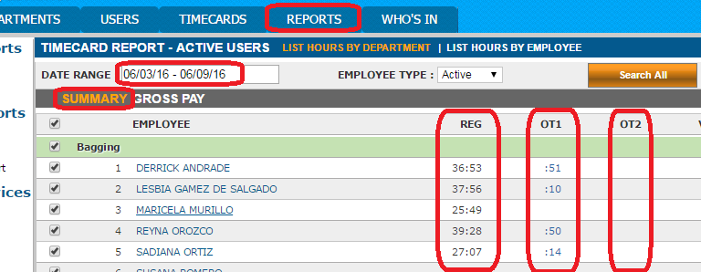

1. Enter those times in to the relevant columns of the report

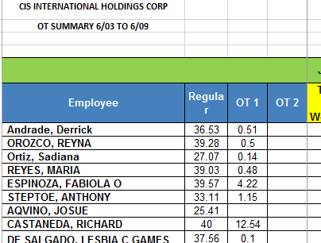

1. Go to the uAttend again and get the reports for each day of the week

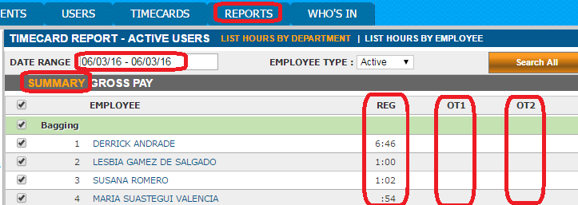

1. Enter the regular and OT hours of employees for each day of the week

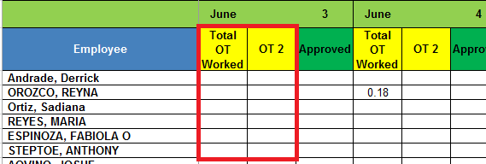

1. Log in to the remote desktop and go to the OT approval sheets from OT Approval file (use the path highlighted below)

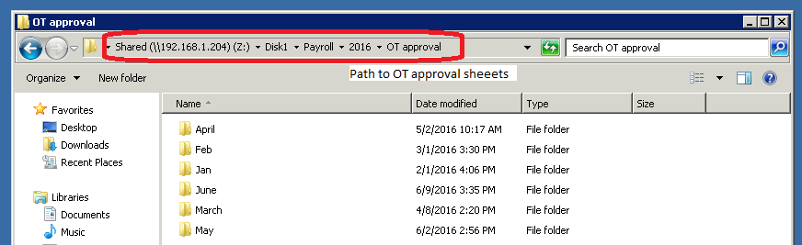

Then you can get OT approval sheet as shown below

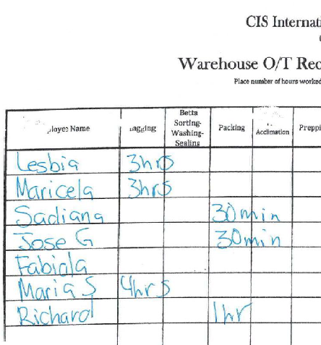

1. Enter the number of approved OT hours to the approved OT column of the report.

If hours of approved OT is higher than the number of actual OT hours of work, then approved OT should be the actual number of OT hours. Otherwise entered value is same to the approved value.

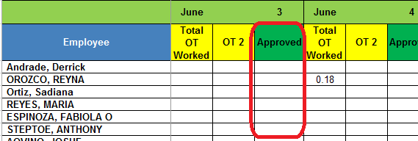

1. If an employee’s regular hours of the week is 40 then go to uAttend and get that employee’s time card of the relevant week.

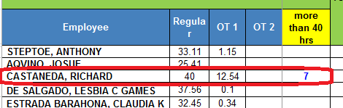

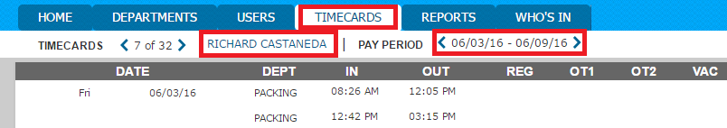

1. Check whether there is weekly over time which appears in the bottom of the time card and enter weekly over time to the more than 40 hours column.

* Weekly over time is payable without any approval

