**Tropical Fish International (Pvt) Ltd**

SALES VS LABOR REPORT FOR LAST PAYROLL WEEK

|  |  |
| --- | --- |
| **SUBJECT** | SALES VS LABOR REPORT LAST PAYROLL WEEK |
| **DEPARTMENT** | Marketing – Payroll |
| **RECORDER (Name Designation)** | Saroad Gunarathne : Payroll Executive |
| **APPROVED BY (Name Designation)** |  |
| **LAST UPDATE** | 29/03/2016 |
| **PATH ON NETWORK FOLDER** |  |
| **NO. OF PAGES INCLUDING THIS**  **PAGE** | 07 |

**Objective : TO get deep idea about Sales and Labor cost for previous week.**

* Sales vs. Labor Report send in every Monday (Report Create For Labor Week Friday to Thursday)
* First update The day to day sales (getting the data from ETF – EDI DETAILS – INVOICE SUMMARY REPORT)
* 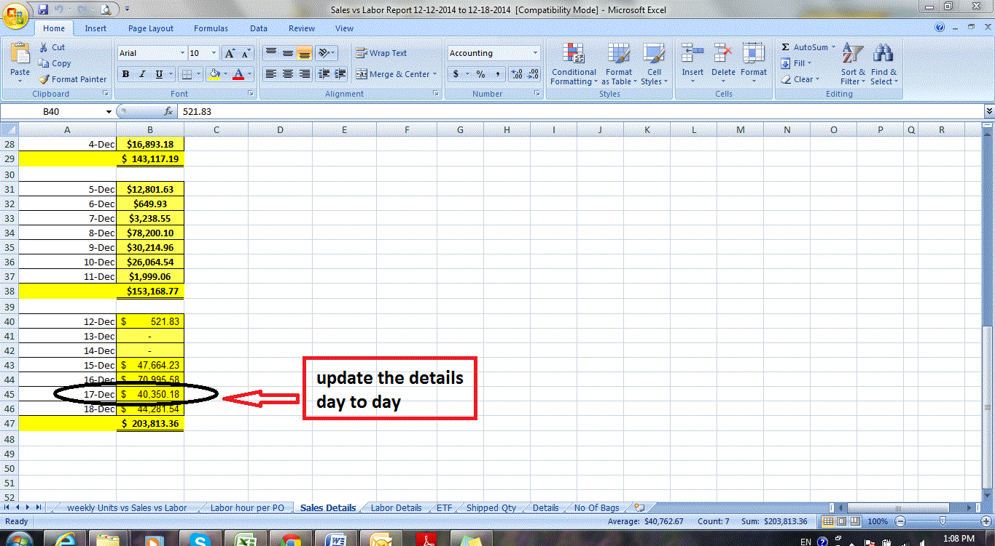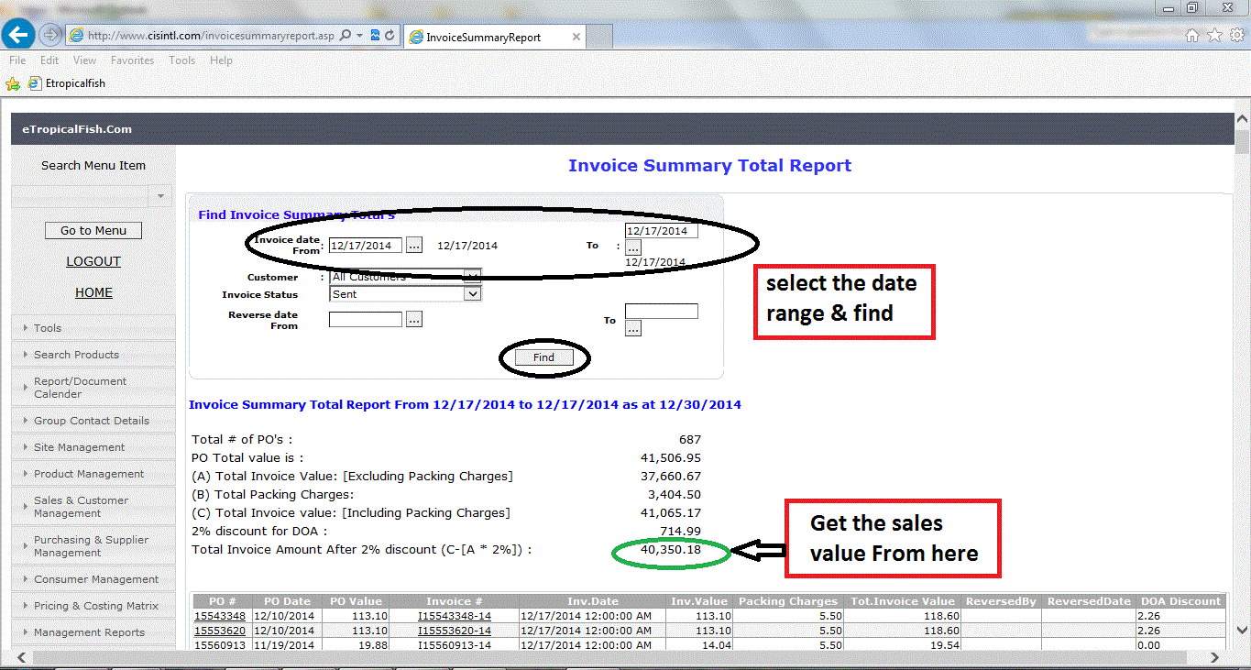Update The sales detail
* Get the labor Details From Uattend (labor cost , regular & Double OT Record seporatly)
* Update the Labor Details

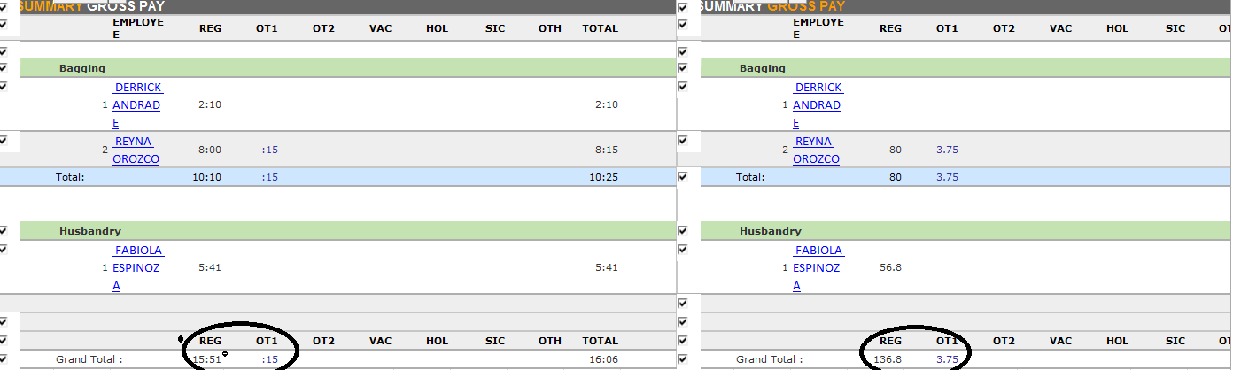

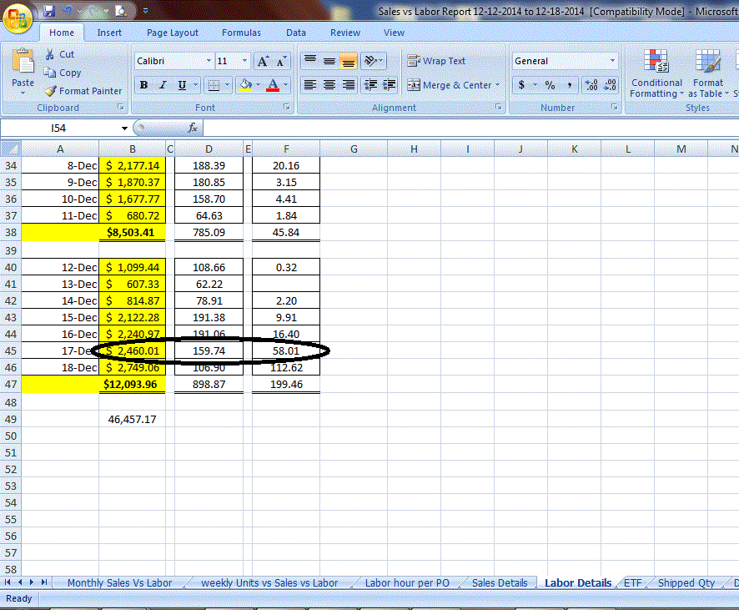

* To the ETF Tab ON excel sheet paste the Screen Shot Of Invoice Summary Report (Friday to Thursday)

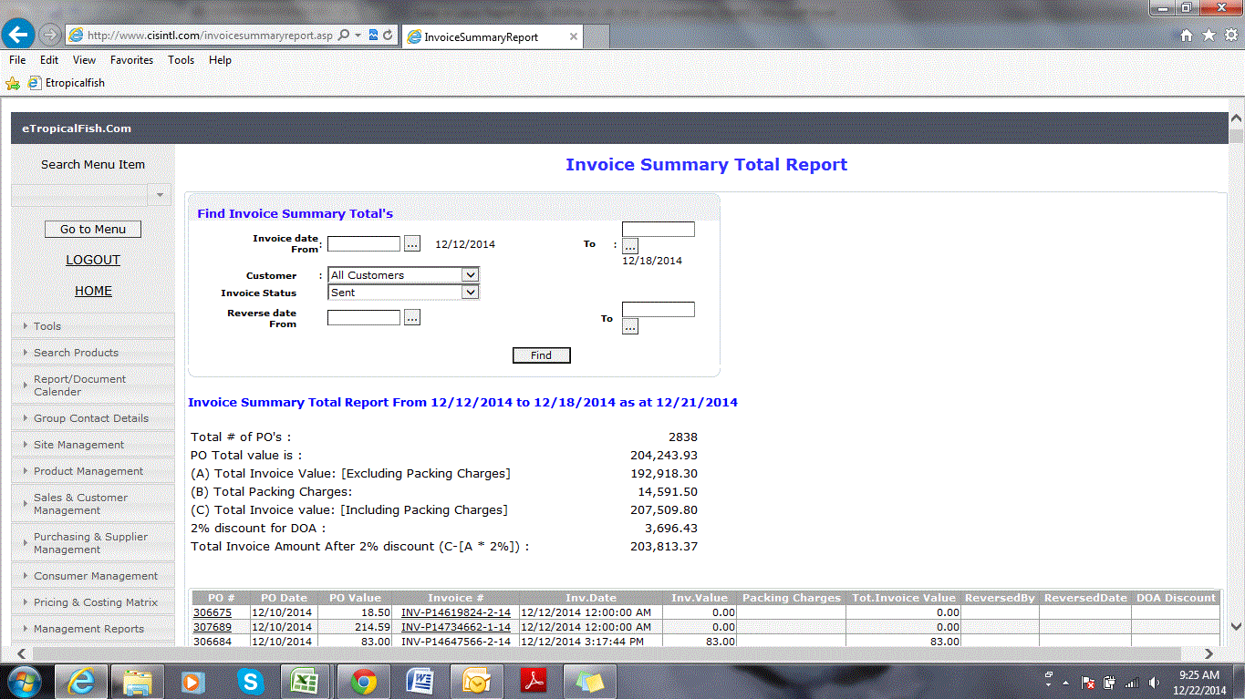

* To the Shipped Qty tab on Excel sheet paste the Shipped Qty Report With EOQ Bags& get the details (customer must be selected as All Customers), from this report get the Total shipped Fish Qty

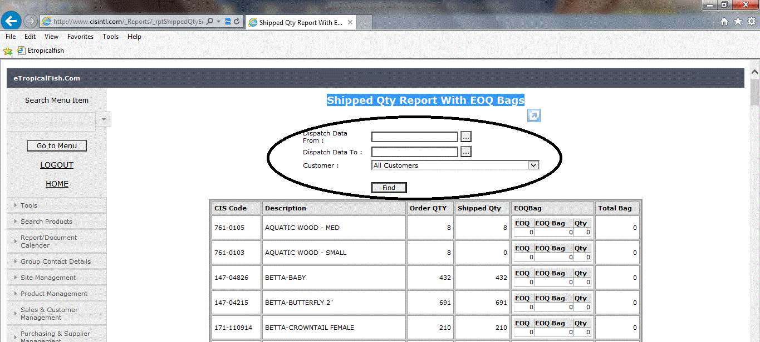

* Update the details to weekly Units vs. Sales vs. Labor tab

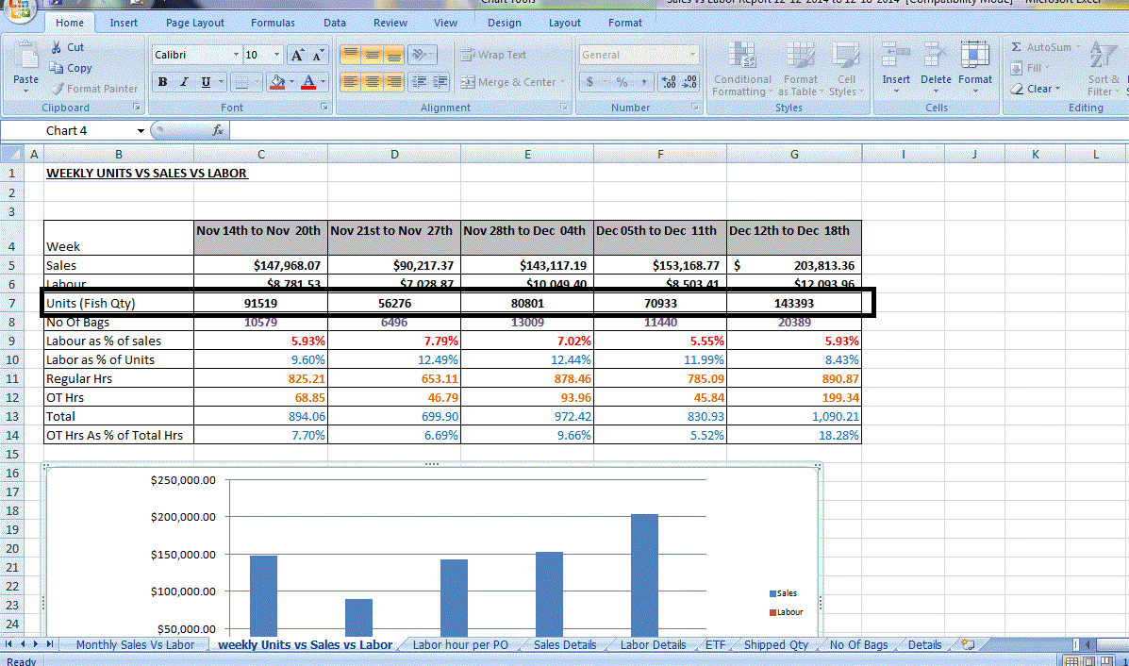

* 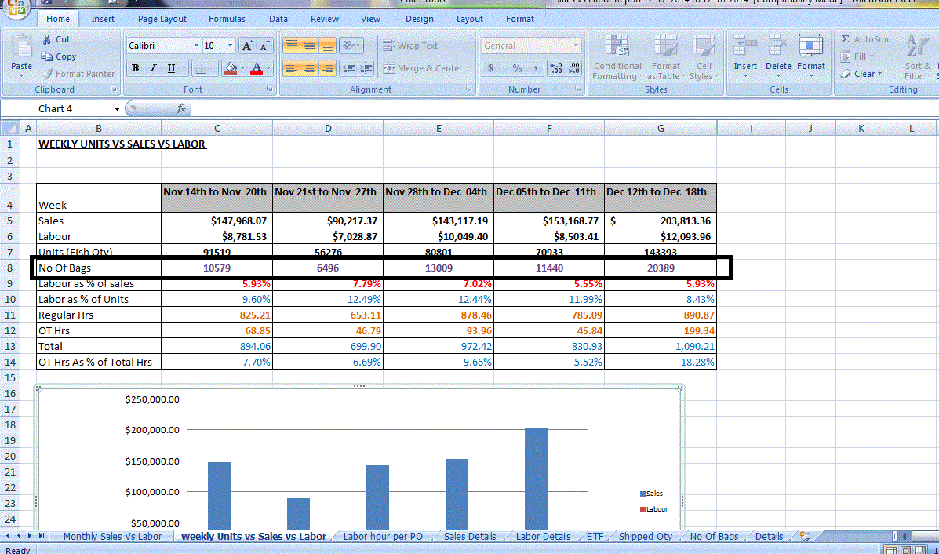To the No Of Bags tab on Excel sheet paste the Shipped Qty Report With EOQ Bags & get the details Separately (customer must be selected as petco & petco.com), from this report get the Total shipped No of Bags Qty
* In the detail tab we show Labor Hrs Separately, get the data from QQEST

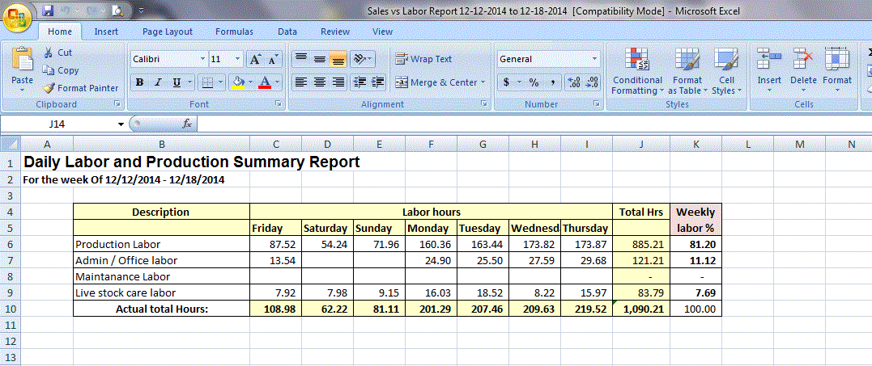

* On Labor hour per PO tab get the details from EFT—Shipping & Dispatching—Dispatch Report
* From this report get No of PO s Dispatched For The Week

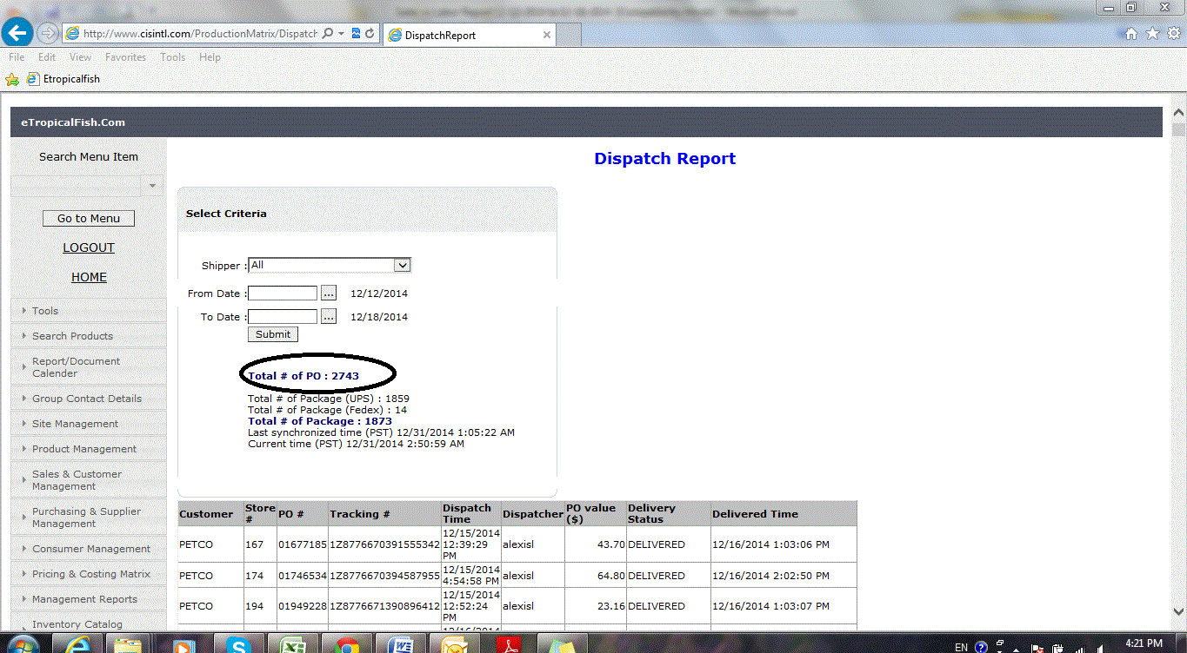

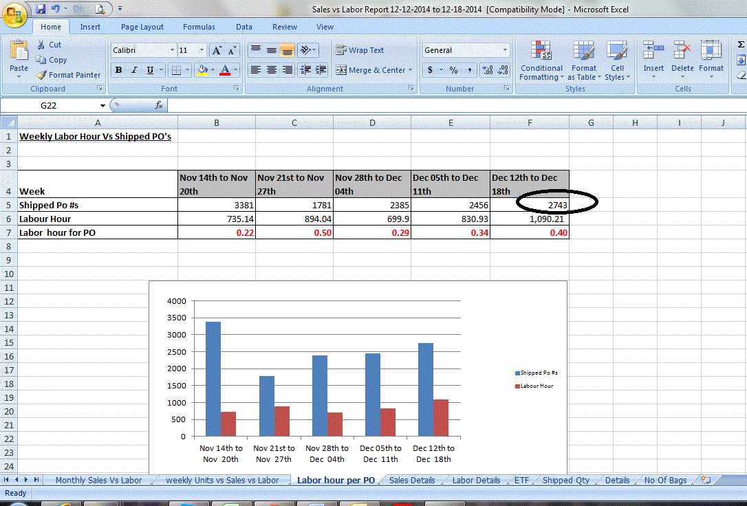

* From Monthly Sales Vs Labor Tab Showing monthly sales , labor cost & % of labor as Sales

