**Tropical Fish International (Pvt) Ltd**

WEEKLY TIME SHEETS

|  |  |
| --- | --- |
| **SUBJECT** | WEEKLY TIME SHEETS |
| **DEPARTMENT** | Marketing – Payroll |
| **RECORDER (Name Designation)** | Saroad Gunarathne : Payroll Executive |
| **APPROVED BY (Name Designation)** |  |
| **LAST UPDATE** | 29/03/2016 |
| **PATH ON NETWORK FOLDER** |  |
| **NO. OF PAGES INCLUDING THIS**  **PAGE** | 02 |

**Objective : Check Employee worked times are correct / not.**

1. **Log into Uattend website by using the user name & password**
2. **Go to "Time card" Tab**

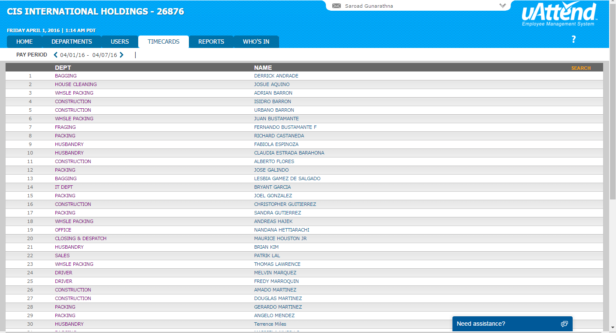

1. **Look up employee name**
2. **Below the screen press download option**

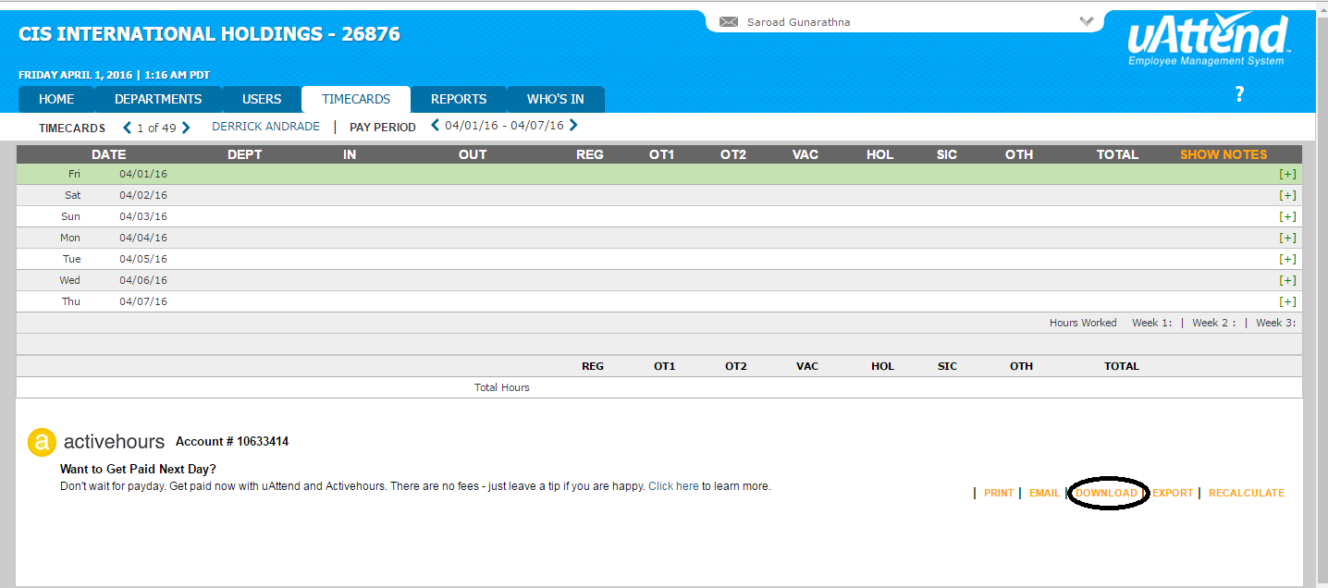

1. **Take one time card for each employee by selecting date range for relavent pay week.**