|  |  |
| --- | --- |
| **SUBJECT** |  |
| **DEPARTMENT** | Marketing – Payroll |
| **RECORDER (Name Designation)** | Saroad Gunarathne : Payroll Executive |
| **APPROVED BY (Name Designation)** |  |
| **LAST UPDATE** | 29/03/2016 |
| **PATH ON NETWORK FOLDER** |  |
| **NO. OF PAGES INCLUDING THIS**  **PAGE** | 03 |

Payroll process is done weekly (Thursday) for the last pay week of Friday to Thursday.

1. Sign in to intuit and go to pay day tab.

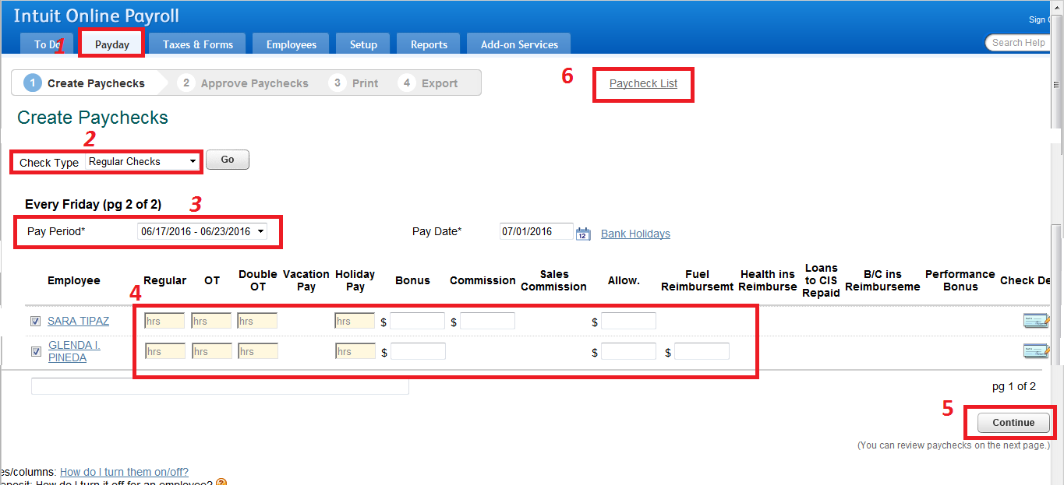

* Check type should be Regular checks – No. 2
* Select the relevant pay period – No. 3
* Enter regular hours, OT hours, bonuses, etc. – No. 4
* Click on continue to go to net page – No. 5

1. Click on pay check list (No. 6) to enter check numbers.

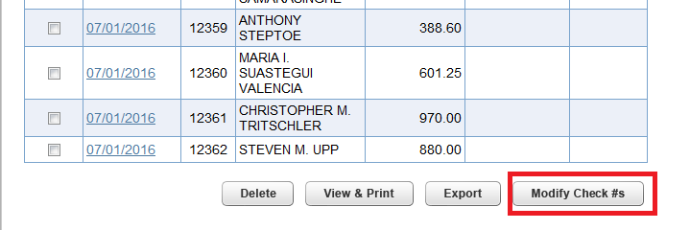

Click on Modify Check button and then you will get following window.

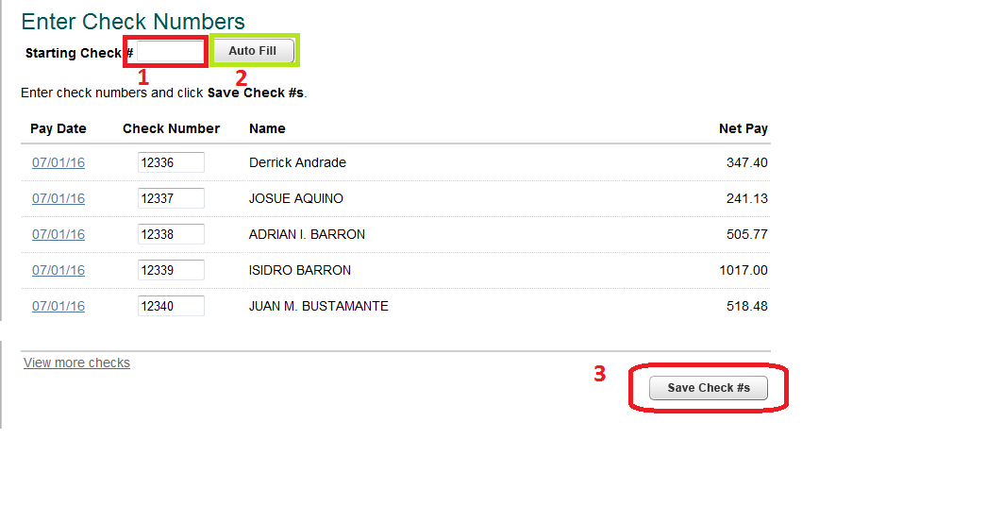

* Enter starting check number into the box (No. 1) – Starting check number is informed by the US management through an e-mail.
* Click on auto fit button (No. 2). Then check numbers will enter automatically by the system.
* Click on Save check #s button (No. 3)

1. Go to approve check page and approve checks.

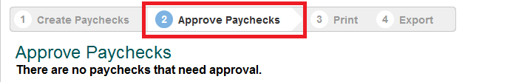

1. Finally go to the print page (No. 1) to save the checks.

Click on View & Print button (No. 2) and save the document.

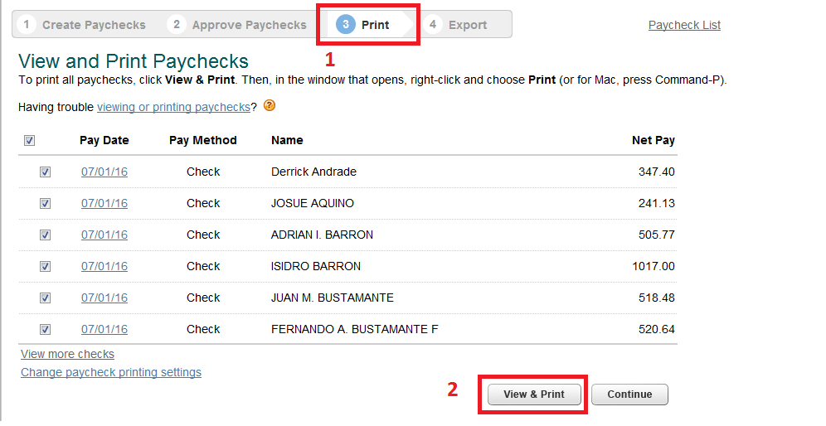

1. Send an e-mail by attaching saved document to the US management.