|  |  |
| --- | --- |
| **SUBJECT** |  |
| **DEPARTMENT** | Marketing – Payroll |
| **RECORDER (Name Designation)** | Saroad Gunarathne : Payroll Executive |
| **APPROVED BY (Name Designation)** |  |
| **LAST UPDATE** | 29/03/2016 |
| **PATH ON NETWORK FOLDER** |  |
| **NO. OF PAGES INCLUDING THIS**  **PAGE** | 02 |

Tax payment

1. Log in to intuit and go to the Taxes & forms tab.

* click on Pay Taxes
* click on Skip and go to Pay Taxes

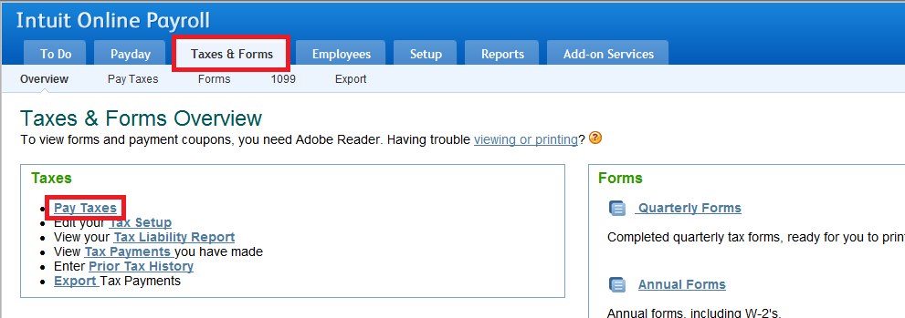

1. Click on the Create Payment button of the relevant tax which supposed to pay (check the tax due date carefully).

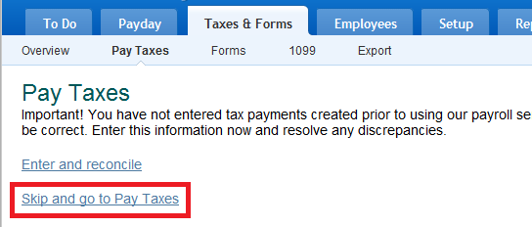

1. 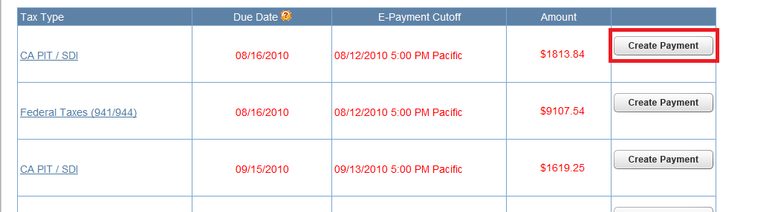Finally approve the tax payment.