**Tropical Fish International (Pvt) Ltd**

COMPLETE PAYROLL

|  |  |
| --- | --- |
| **SUBJECT** | COMPLETE PAYROLL |
| **DEPARTMENT** | Marketing – Payroll |
| **RECORDER (Name Designation)** | Saroad Gunarathne : Payroll Executive |
| **APPROVED BY (Name Designation)** |  |
| **LAST UPDATE** | 29/03/2016 |
| **PATH ON NETWORK FOLDER** |  |
| **NO. OF PAGES INCLUDING THIS**  **PAGE** | 02 |

**Objective : Pay employees weekly.**

Notes: Payroll week - runs from Friday to Thurs

* Log into UATTEND web site by using the user name & password
* 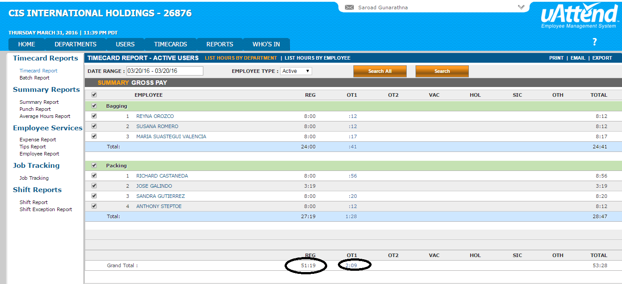Click on “Reports” tab,
* Select the date range for which you have to completed payroll.
* Click download button to download the report.
* 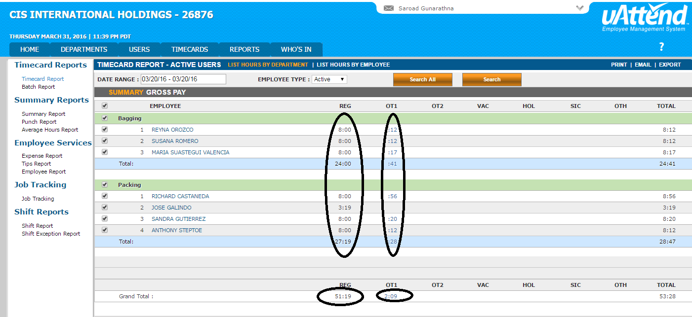Find regular hours, OT 1 hours &OT 2 hours for each employee daily basis and weekly
* 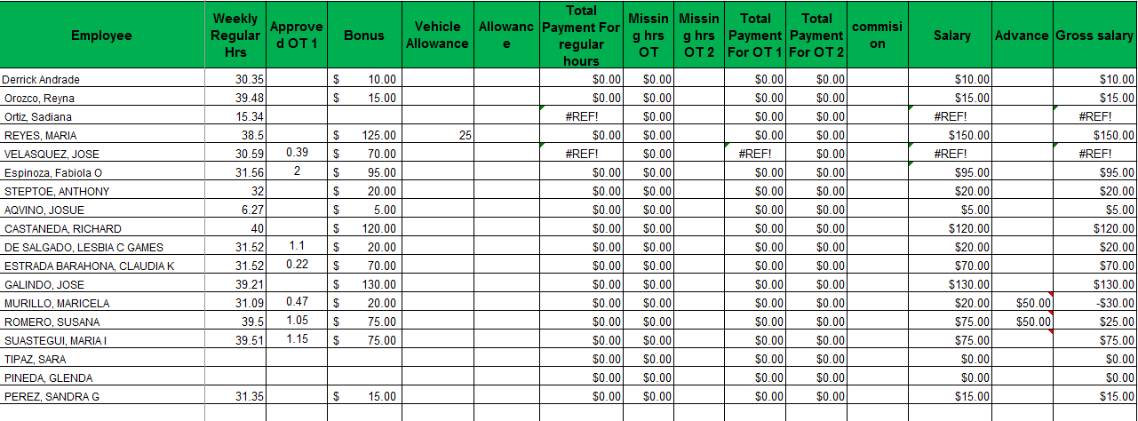According to regular hour rate, OT 1& OT 2 rate (Payroll) calculate check amount for each employee, if they earn bourns add bonus also for check amount.
* Who earn salary basis calculate check for offices worker salary.
* Analysis Payroll summary report.