**Tropical Fish International (Pvt) Ltd**

ENTER OT APPROVAL FOR OT SUMMARY

|  |  |
| --- | --- |
| **SUBJECT** | ENTER OT APPROVAL FOR OT SUMMARY |
| **DEPARTMENT** | Marketing – Payroll |
| **RECORDER (Name Designation)** | Sarodh Gunarathne : Payroll Executive |
| **APPROVED BY (Name Designation)** |  |
| **LAST UPDATE** | 29/03/2016 |
| **PATH ON NETWORK FOLDER** |  |
| **NO. OF PAGES INCLUDING THIS**  **PAGE** | 01 |

**Objective : Managing OT payments.**

* 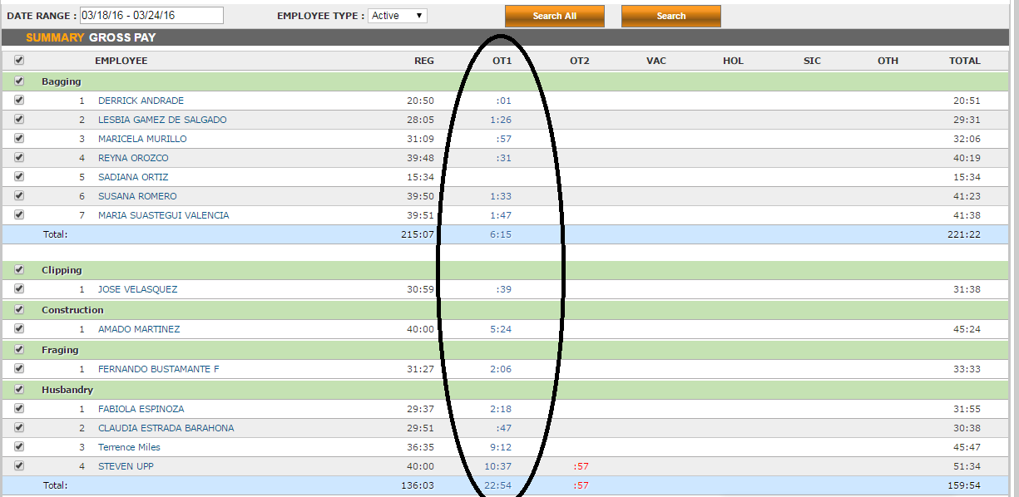Log in to Uattend and download reports daily.
* Take OT hours to excel sheet.
* Take approved OT sheets from network folder
* Approve Actual OT according to Approved OT sheets day by day.