|  |  |
| --- | --- |
| **SUBJECT** | Check Employee Attendance |
| **DEPARTMENT** | Marketing – Payroll |
| **RECORDER (Name Designation)** | Saroad Gunarathne : Payroll Executive |
| **APPROVED BY (Name Designation)** |  |
| **LAST UPDATE** | 29/03/2016 |
| **PATH ON NETWORK FOLDER** |  |
| **NO. OF PAGES INCLUDING THIS**  **PAGE** | 02 |

Employees’ attendance should be checked every day by comparing daily sign out sheet and in and out times in uAttend system.

1. Log in to remote desktop and get the sign out sheet in the master daily folder of payroll document (use the following highlighted path).

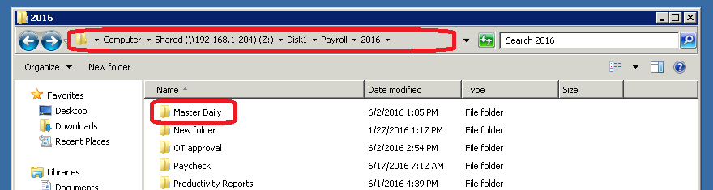

1. Log in to uAttend system and go to time cards tab.

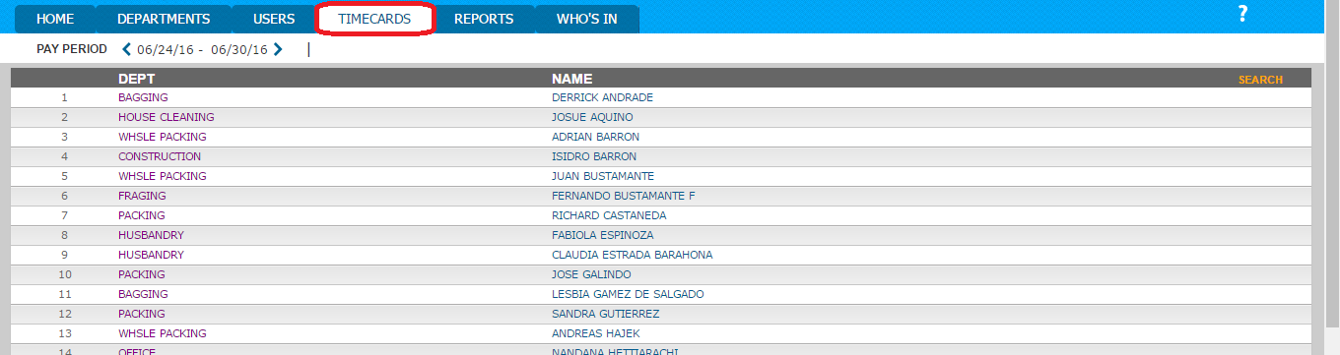

1. Go to time card of each employee by clicking on the employees name.

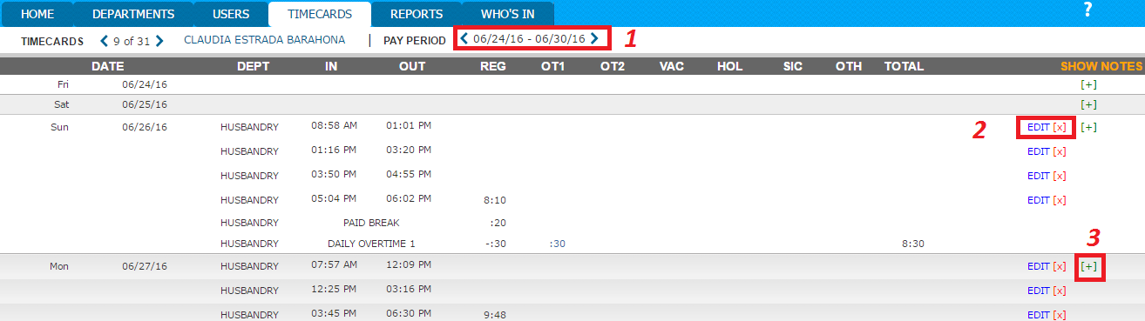

* Select the relevant time period by clicking on arrows – No. 1
* If there is a need of change in time period do it using edit button – No. 2
* If there is a need of adding new in/out time click [+] mark – No. 3