**Teknowledge Shared Services (PVT) LTD.**

**OPR for Prepare budget for farm dry goods requirements or Maldives requirement**

|  |  |
| --- | --- |
| **SUBJECT** | OPR for prepare budget for farm dry goods requirements or Maldives requirement |
| **RECORDER (Name Designation)** | Dishan Malaweera / Admin Operation |
| **APPROVED BY (Name Designation)** |  |
| **CREATED DATE** | 06/03/2016 |
| **NO. OF PAGES INCLUDING THIS PAGE** |  |

1. Introduction

Check on recent and pending procurements of all farms (Horana, Wadduwa & Maldives ) related to all monthly dry goods requirements and urgent requirements.

Prepare assumed budget for the requested items as per updated prices & collected quotations.

1. Contents

* Horana Farm Monthly or Urgent Requirements.
* Wadduwa Farm Monthly or Urgent Requirements.
* Maldives Farm Monthly or Urgent Requirements.
* Styrofoam + Corrugated Boxes Requirement for US/UK Warehouse shipments.

1. Process

* Check for all pending procurements related all farms for the month. ( As in OPR 2 )
* Check any balances of the monthly dry goods requirements sent by all farms.(As in OPR 2)
* Check any special requirements requested by Horana/Wadduwa and Maldives (As in OPR 2)
* Check any Urgent requirements requested by all farms.(As in OPR 2)
* Prepare separate budgets for relevant farm dry goods requirements.
* Separate budget as cash and credit. 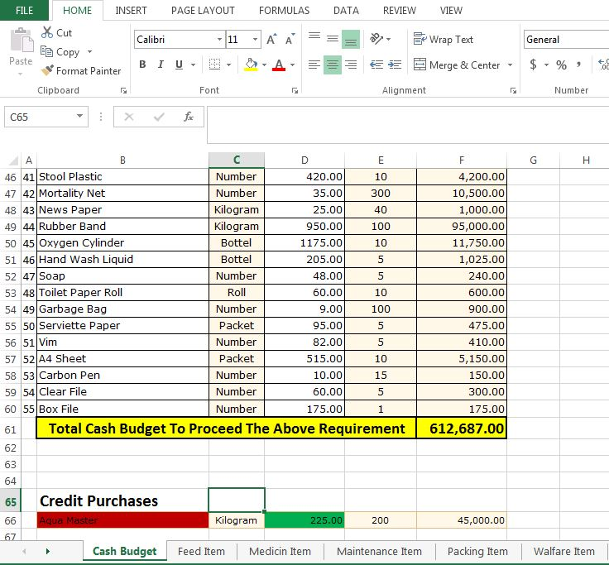
* Negotiate prices with suppliers for any bulk orders/large quantities.
* Send budget via mail to supervisor/HOD for approvals.

