**Teknowledge Shared Services (PVT) LTD.**

**OPR for Find new suppliers , Go out for procurement related work and Update “Supplier Register”.**

|  |  |
| --- | --- |
| **SUBJECT** | OPR for Find new suppliers , go out for procurement related work and update "Supplier Register" |
| **RECORDER (Name Designation)** | Dishan Malaweera / Admin Operation |
| **APPROVED BY (Name Designation)** |  |
| **CREATED DATE** | 06/03/2016 |
| **NO. OF PAGES INCLUDING THIS PAGE** |  |

1. Introduction

Find new supplier for the relevant items on every requirement.

Find the right supplier with right quality with right price for every items on requirement.

Contact with supplier to negotiate the prices.

Order relevant quantity of the relevant items.

Arrange transport/vehicle to collect goods.

1. Contents

* Dry good requirement of the farm.
* Cash basis suppliers.
* Credit basis suppliers.
* Price and quality
* Delivery

1. Process

* Find the right suppliers with right quality and right price for relevant items.
* Separate the cash & credit basis suppliers.(As in OPR 4)
* Negotiate prices for the large quantities.
* Find supplier with stock availability with the relevant item.
* If not find or contact another supplier with the right quality with affordable prices.
* Send Purchase Orders if required.
* Arranging deliveries directly to farms or head office.
* Obtain cash from accounts for approved budgets for farm requirements.
* Go out for procurements with selecting area to collect bulk orders or large quantities of relevant orders.
* Arrange transport with collected dry goods for relevant requirement.
* Update the supplier registry with new details of the new suppliers.

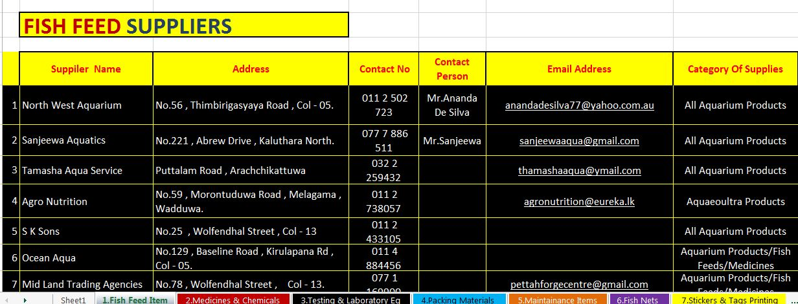

* Find new suppliers / alternative suppliers for every items requesting by farms for the month. ( categorized by Item vise)
* Collect information about new suppliers via browsing and visiting.