**TEKNOWLEDGE SHARED SERVICES-SRI LANKA**

**OPR: DELIVERY RECONCILATION**

|  |  |
| --- | --- |
| SUBJECT | DELIVERY RECONCILATION |
| DEPARTMENT | PRODUCTION PLANNING |
| RECORDER | BUDDIKA MADURANGANA |
| APPROVED BY |  |
| CREATED DATE | 02/01/2015 |
| LAST UPDATED | 03/04/2016 |
| PATH ON NETWORK FOLDER |  |
| NO. OF PAGES INCLUDING THIS PAGE | 2 |

**Objective**

Need to check the delivery status and make sure these POs are shipped by the courier.

Open PO report – Delivery Status

<http://www.cisintl.com/ProductionMatrix/DeliveryStatus193.aspx>

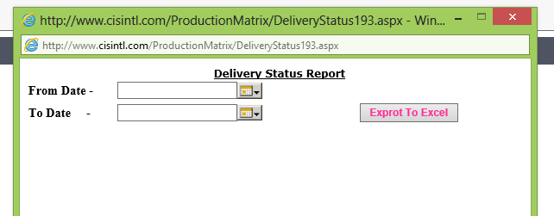

Provide the required date range & Export to Excel.

Get the Excel file and filter for Status “BILLING INFORMATION RECEIVED”

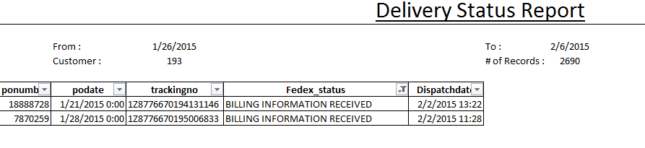

Need to check the Tracking numbers of the POs which are under “BILLING INFORMATION RECEIVED”

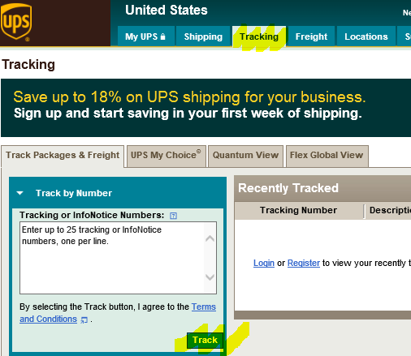

Note: if the PO is under “BILLING INFORMATION RECEIVED” category for more than 2 days, it means the PO has not been picked up by UPS and need to reverse the invoices and assign back to production.

If the PO is picked by UPS, but did not ship due to any reason, Replacement has to be created for the PO and re-ship at the earliest.