**CIS INTERNATIONAL HOLDINGS CORP**

**OPR FOR PACKING RELATED INCIDENTS**

|  |  |
| --- | --- |
| **SUBJECT** | **PACKING RELATED INCIDENT REPORTING** |
| **DEPARTMENT** | **COUSTOMER SERVICE** |
| **RECORDER (Name & Designation)** | **VIKUM MARASINGHE (CSE)** |
| **APPROVEDBY (Name & Designation)** | **PURODHA PERERA (HOD CS)** |
| **CREATED DATE** | **11/30/16** |
| **LAST UPDATED (MM/DD/YY)** |  |
| **PATH ON NETWORK FOLDER** | **N/A** |
| **NO. OF PAGES INCLUDING THIS PAGE** | **3** |

***What are the Packing Related Incidents?***

* DNR – Fish were invoiced as shipped and was not shipped (Packer Error)
* Short Shipped / Wrong quantity sent – Shipped less or more than the original ordered fish quantity
* Wrong Fish Variety shipped
* Heat Pack / Ice Pack – Shipped without or not packed properly.

**Important**: The Packing related incidents can be reported through Customer Service, Petco incident Report (Sent every Tuesday from Petco) and Direct Store Feedback Survey.

***How to report and escalate Packing related incidents***

* Once a Packing related incident is received,
  + Recheck the PO information (Dispatched date / Delivery Dates / SKU’s /Fish Varieties etc.)
  + Call and follow-up with the Store Manager
  + Make a replacement as per the replacement Policy (The PO needs to be open from Store’s end)
* The incident should be entered on the Packing Related Incident report with following details,
  + PO Number
  + Store Number
  + Dispatched Date
  + Delivery Date
  + Packer (Packer who packed the PO / Packing Station)
  + Incident Criteria (Packing)
  + Incident Reported Method (Customer Service/Petco incident Report/Direct Store Feedback Survey)
  + Incident Description (Summary of the incident Reported)
* Escalate all Packing related incidents to the Warehouse Management via email. (Please refer below Screenshot)

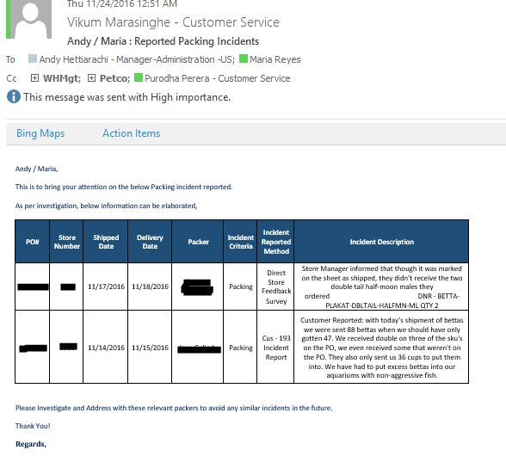

**Important:** The purpose of escalating these Packing Related incidents to the warehouse Management is to identify and prevent recurrence of similar incidents in the Future.