**CIS INTERNATIONAL HOLDINGS CORP**

**OPR FOR PO REPLACEMENT**

|  |  |
| --- | --- |
| **SUBJECT** | **PO REPLACEMENT** |
| **DEPARTMENT** | **COUSTOMER SERVICE** |
| **RECORDER (Name & Designation)** | **VIKUM MARASINGHE (CSE)** |
| **APPROVEDBY (Name & Designation)** | **PURODHA PERERA (HOD CS)** |
| **CREATED DATE** | **06/20/16** |
| **LAST UPDATED (MM/DD/YY)** | **06/20/16** |
| **PATH ON NETWORK FOLDER** | **N/A** |
| **NO. OF PAGES INCLUDING THIS PAGE** | **5** |

**Replacement PO’s**

Purchase order – Replacement functionality is developed to replace/reship an already shipped purchase order due to DOA/ DNR. We could replace/reship the POs with following statuses only,

* PO needs to be shipped before
* PO needs to be invoiced before

**Shipment arrived with fish all dead**

When 100% fish arrive dead the policy is to reship a replacement order in full to the Petco stores.

* This incident is treated as an urgent request and should respond ASAP!
* Log into the ETF website and look up the PO # under “PO Summary Totals Report” on EDI Details and check the PO and its line items very carefully.
* Read the Incident report & the Animal Groups on the Incident Report very carefully and Cross-reference these items with the items on the PO.
* Make the appropriate replacements and inform the stores confirming that the reshipment will be shipped out the next day or same day if possible.
* Afterwards, this information needs to be entered in the Replacement PO Tracker and should to be notified to production planning team to ensure a replacement order is prepared and prioritized to be shipped the same day if possible if not the next day. You need to figure out the ship out date before you notify the store. These orders are treated as emergency orders.
* A summary e-mail should be copied to Warehouse Manager (Andy) with a copy to the two main warehouse supervisors (Joel & Richard) to arrange the emergency replacement orders to be shipped out the same day or the following day.
* Need to follow up on a daily basis with Joel Gonzales at 2:00PM if all emergency orders are completed. If not completed do a second follow up at 3:00PM for a confirmation if the shipment is packed for dispatching (Call or send a text message)
* All emergency PO’s to be shipped out the same day needs to be completed and notified by latest 12:00PM US time, and send an e-mail to Joel Gonzales and Andy (Warehouse manager)
* If the replacement order is to be shipped the next day, notify production and ask them to highlight the replacement orders clearly on the packer breakdowns and follow up with Joel to ensure they are packed by 2:00PM and ready for dispatching. If not second follow up at 3:00PM and call or text
* Once re-shipped get the tracking number from ETF and double check if the PO has been delivered. As a part of providing better customer service, you can also call the store back after the delivery and double check whether the fish arrived in good condition

***Shipment arrived with over 50% of the fish dead***

* If 50% or more fish arrive dead the replacement policy is the same as if 100% of the fish arrived dead. The entire PO needs to be shipped in full.
* Follow the same guidelines as per above when all 100% of the fish arrived dead.

***Fish arrived sick***

* If all fish on the PO arrived sick, a full replacement order needs to be sent. Follow the same guideline for replacement orders.
* If only some varieties of the PO arrived sick, then replace only the sick varieties. There is only a certain amount of space allocated in the store to hold fish and you don’t want to put the store into a situation where they have to over crowd fish in a tank. That is unhealthy for the fish
* If the store does fall into a situation of over crowing then the extra fish will be shipped back and TFI will have to bear the cost

If replacement shipments are not sent on a timely manner the store looses sales for that specific week. This would drastically impact the profitability of the store. Therefore, it is critical that replacement orders are prioritized and shipped out the very next day or if possible, the same day.

***Petco.com Replacement Policy***

Unlike Petco Store replacement policy, we replace all DOA’s fully for the Petco.com reported DOA’s and DNR’s. (DOA percentage is not considered when making replacements)

***How to make a replacement***

**Replacing a PO**

GO to the page Replacement PO --> [http://www.cisintl.com/ProductionMatrix/ReplacemetPO.aspx](http://www.cisintl.com/ProductionMatrix/ReplacemetPO.aspx%20)

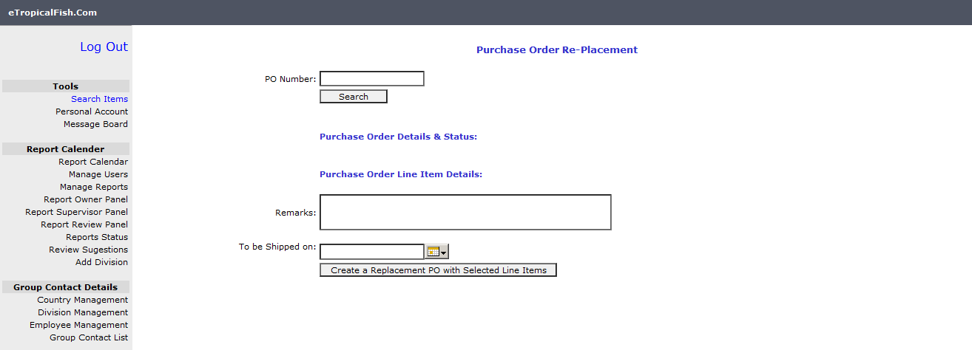

Replacement PO screen

Enter the PO number that should be replaced and click Search button.Line items of the PO will be listed in a grid view. Then the user should

1. Select the line items to be replaced by ticking-off the respective check box
2. Enter the replacement quantity (This should be less than or equal to shipped quantity)
3. User should give remarks for each line item (Reason for replacement etc.)
4. The date to be shipped
5. Click ‘Create replacement PO with selected line items’ button

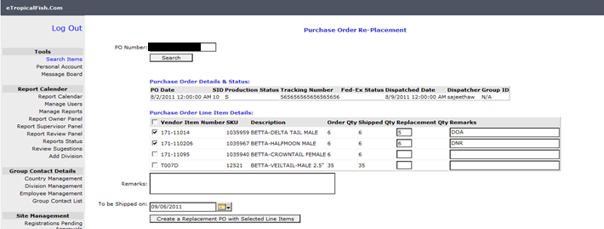

Replacement PO screen

When user clicks ‘Create replacement PO with selected line items’ button the system will display the message ‘The PO# is successfully updated as replacement PO’ when it successfully update the PO as a replacement.

Then the user should handle this PO as same as a regular PO, but only with those replacement line items (E.x: Production Planning, Grouping, Label Printing, Dispatching and etc.).

NOTE: This PO will not be invoiced again, as an original Invoice has already been sent for this PO number.

**Viewing Replacement PO Report**

Go to: [http://www.cisintl.com/ProductionMatrix/ReplacementPOReport.aspx](http://www.cisintl.com/ProductionMatrix/ReplacemetPO.aspx%20)

User should search for the replaced PO, either by a particular PO # or by original PO’s PO date, Then system will display the replacement PO detail; in addition to that if a user wants to see the original PO details they should click on the ‘View’ link button in the ‘View Original PO#’ column.

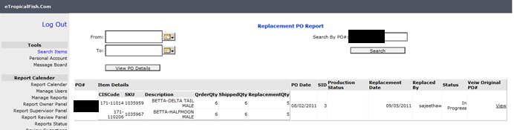

Replacement PO report

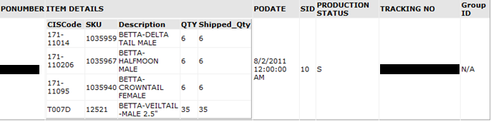

Original PO Detail [Pop-Up screen]

**Modification in EDI Purchase Order Screen:**

*Path*

EDI details 🡪 PO summery total report 🡪 click-on PO #

EDI Purchase Order Screen is modified to show the original PO# as well as the replacement PO# with item details if the PO# is a replaced PO. (Please see the screen shot below)

