**TEKNOWLEDGE SHARED SERVICES (PVT) LTD**

**Purchasing**

|  |  |
| --- | --- |
| **SUBJECT** | Purchasing |
| **Department** | Admin Operation / Administrator |
| **RECORDER (Name Designation)** | Chalani Maduwanthi |
| **APPROVED BY (Name Designation)** |  |
| **CREATED DATE** | 08/11/2016 |
| **NO. OF PAGES INCLUDING THIS PAGE** |  |

**Contents**

1. Quotation
2. Raising Purchase Order (PO)
3. Goods Transfer Notes (GTN)
4. Goods Receive Notes (GRN) / Goods Delivery Note (GDN)
5. Invoices transfer

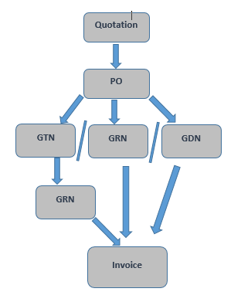

1. Quotation

According to the requirement received by mail Admin Department need to get quotation. There should be 3 quotations per item at least two. If the supplier providing goods for a long time with matching to the quality that we need to have able to continue without getting quotations. Also do not need to have quotation for cash purchase items.

Request quotation by Email with copy to relevant parties

1. Raising Purchase Order (PO)

Once receive the quotation admin department will get the approval from the HOD to approve the quotation and raise a PO to order items.

Sample PO

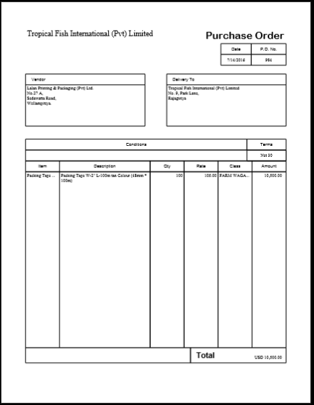

Process to raise a PO from QB

1. Open QB  and connect

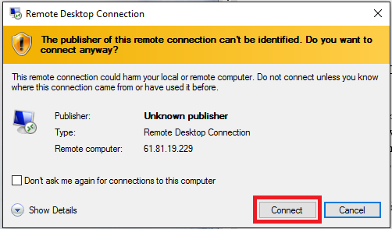

1. Find (Ctrl + F)
2. Select Translation type as Purchase order
3. Vendor – Ex: Pee Bee.
4. Click Find
5. Recent Number – (top one in the list) – Double click
6. Edit – Duplicate purchase order – Msg box OK *
7. Vendor – Date – Delivery Address (PO no need to enter manual in order)
8. Item – add item by selecting drop down box
9. File - Save as PDF
10. Desktop- rename file / save
11. Minimize and check in desk top
12. Save & Close
13. Need to check items and select the correct item & price to description
14. Save & close
15. Close
16. File – Close/company logoff
17. Close
18. Start – log off

*If the vendor is newly entered in to the list need to go to vendor and create purchase order

1. Goods Transfer Notes (GTN)

At the time of goods transferred to any places like farm individual Goods transfer notes (GTN) will be issued by admin department. There are three copies original and the second one will send to farm or where we send goods and third copy will remain in the book for H/O reference. Once it recorded with GRN that to confirm the good received.

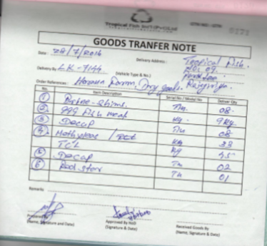

1. Goods Receive note (GRN)/ Goods Deliver notes (GDN)

At the time of goods are delivered to head office goods return note (GRN) should be issued by the administration division. Once the order comes we receive Good receive note (GDN) and we use this as a GRN. GTN original copy will send to H/O with GRN to Admin and admin will submit those record with the invoices to accounts department.

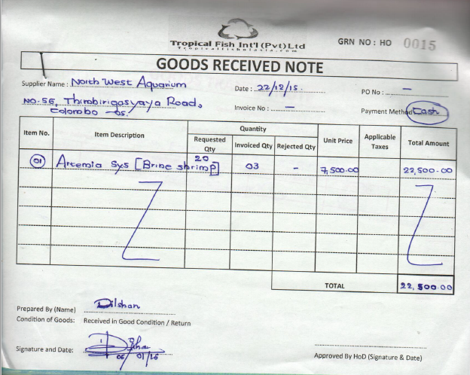

1. Invoice

Transfer the invoice with the relevant documents (GRN / GDN) to Finance department.

1. Dry goods purchase

**Introduction**

Coordinate with farms for their dry good purchasing and other purchasing requirements.

**Content**

1. Dry good requirement of each farm.
2. List of urgent/important dry good items.
3. Price list of dry goods and medicines.
4. List of registered suppliers and contact details.

**Process**

1. Get down the dry good requirement of each farm well in advance.
2. Short list the items list as per the importance and urgency.
3. Calculate the cost of each item and the total cost of the list.
4. Contact suppliers and check the availability of goods.
5. Forward required budget to the finance department to obtain funds.
6. Once funds released, arrange purchasing of each dry good item.
7. Check the possibility of purchasing of items farms itself.
8. If such items available, arrange funds to farms for purchasing such items.
9. When all items are ready, coordinate with the farms for delivering of items to relevant farms.
10. Take all the invoices and return it to the finance department for settling funds.
11. Direct admin assistant to coordinate all works in liaison with farms and finance department.
12. Assist Admin assistant if he requires any assistance to complete the process.

If the items like medicine need to import from US or some machinery parts from Tailand we need to contact admin person in our company which is located in those countries.

Dry goods process well explains with following OPR

OPR for prepare budget for farm dry goods requirements or Maldives requirement

OPR for Obtain approvals

OPR for check on pending procurements and attend / arrange purchases

OPR for Find new suppliers, go out for procurement related work and update "Supplier Register"

OPR for Collect quotations by email and by visit, check samples, coordinate with suppliers, and arrange deliveries.