**TEKNOWLEDGE SHARED SERVICES-SRI LANKA**

**OPR: Daily #193 Production Materials Usage report**

|  |  |
| --- | --- |
| SUBJECT | Daily #193 Production Materials Usage report |
| DEPARTMENT | PRODUCTION PLANNING |
| RECORDER | BUDDIKA MADURANGANA |
| APPROVED BY |  |
| CREATED DATE | 01/11/2016 |
| LAST UPDATED | 03/08/2016 |
| PATH ON NETWORK FOLDER |  |
| NO. OF PAGES INCLUDING THIS PAGE | 4 |

**Objective**

Daily Production Material requirement and the Usage to be recorded for Inventory purpose.

**Report contents**

1. Betta Cups and Lid

After completion of daily Packer/Fish breakdown, required number of betta quantities can be taken. This information to be updated in Betta cups and Lid category.

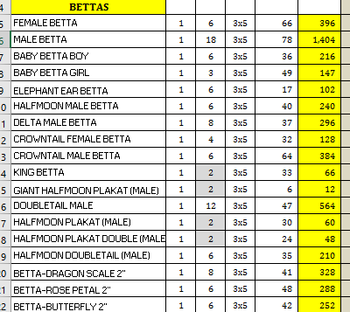

Once the production day is completed, need to get the shipped quantity and update actual usage

EDI details > Shipped quantity report > provide shipping date

#193 Material file updated with Requirement and Usage

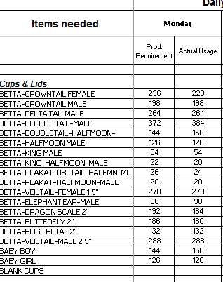

1. If betta Labels (Cups/Lids) issued by WHMgt, they need to inform Prodmgt with all details to update Betta Labels issued for Cups and Betta labels issued for Lid.
2. Bag requirement and usage

After completion of daily Packer/Fish breakdown, required number of bags can be taken from the fish breakdown

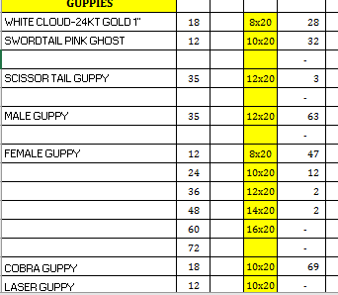

Just filter for each bag size and get the total requirement to update #193 Material file.

Once the production day is completed, need to get the shipped quantity and update actual usage of bags

EDI details > Shipped quantity report > provide shipping date

Get the number of Fish quantities shipped, divide by relevant EOQ to get the number of bags.

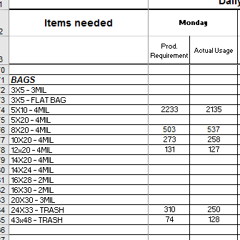

1. Box requirement and Usage

Total number of boxes required can be taken from Packer/Fish breakdown summery, total number of boxes are updated in that and need to have projection of each box types based on the POs which planned for the day. (Size, Group/Ungroup etc.)

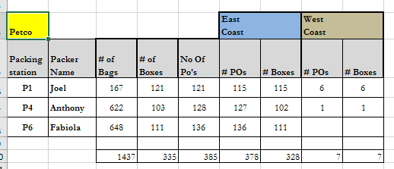

Once the production day is completed, production dash board will show the number of boxes used for the day.

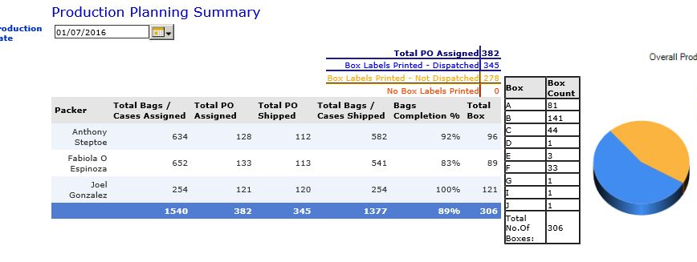

1. Styrofoam requirement and Usage

Styrofoam are required for Box A, B, C & F. therefore Requirement and Usage of aforesaid box sizes are equal to Styrofoam usage.

1. Toad container requirement and Usage

12 Toads will be packed in one container and calculated based on that.

1. Poly Clip requirement and Usage

Total number of bags required/Used are equal to Poly clip usage

1. Trash bag Calculation

For each box of A or B, need one trash bag of 24X33. For each box of C, D, F need 43X48 trash bag.

Apart from that, for Wednesday and Thursday Betta re-bagging to be considered.

Need to use the calculation sheet of the report (Sheet 2)

Wednesday: 50% of total

Thursday: 100% of the total