**TEKNOWLEDGE SHARED SERVICES-SRI LANKA**

**OPR PETCO.COM #651 PLANNING**

|  |  |
| --- | --- |
| SUBJECT | OPR PETCO.COM #651 PLANNING |
| DEPARTMENT | PRODUCTION PLANNING |
| RECORDER | Sivantha Sameera |
| APPROVED BY | Buddika Madurangana |
| CREATED DATE | 11.21.2016 |
| LAST UPDATED |  |
| PATH ON NETWORK FOLDER |  |
| NO. OF PAGES INCLUDING THIS PAGE | 5 |

**Objective**

To provide Open Petco.com PO list with required item list to the Warehouse from Monday to Thursday. This report must be provided before 6.00 am US time.

POs will be considered to the production, which created up to 12.00 mid night previous day and any back POs remaining. If there any replacement request made by CSD also to be included.

**Generate MPOs.**

Path: EDI Details – Purchase Orders

1. Customer – 651 – Petco.com
2. Po Status – Unassigned
3. PO date – last production date, To: today date

Petco.com POs are required to be assigned (Generate MPOs) to ETF from Sunday to Wednesday 12.00 mid night US time. (Monday to Thursday 3.00 PM SL time as per the current time difference) Select the all POs and manual update.

<http://www.cisintl.com/PurchaseOrders.aspx>

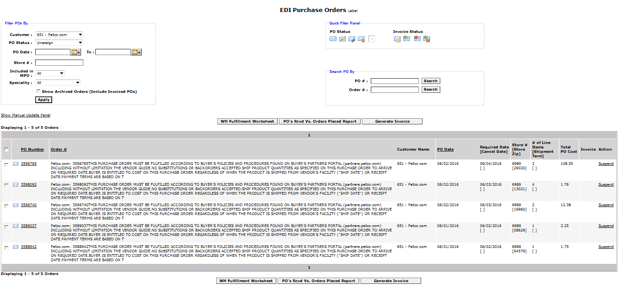 After generate MPOs need to concern following steps to before prepare the plan.

* Check the inventory- Sent By Patrick Lal every weekdays
* Check pending orders with Order Entry.
* If items are not in stock but expected within 24 hours, hold to ship.
* If the items are not in stock and not expected to arrive within 24 hours, zero ship and complete invoice.
* If the items are in stock ask the warehouse for a reason as to why they were not shipped.

**Create Plane**

PO list to be taken from production planning screen as mentioned below.

Path: Production Planning Admin – Production Planning New

<http://www.cisintl.com/ProductionMatrix/ProductionPlanning_NEW.aspx>

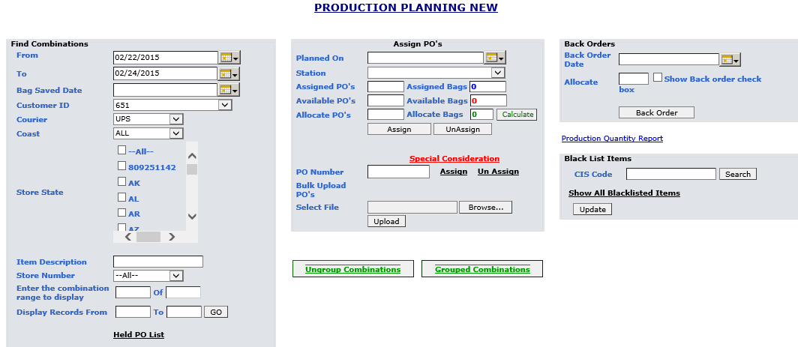

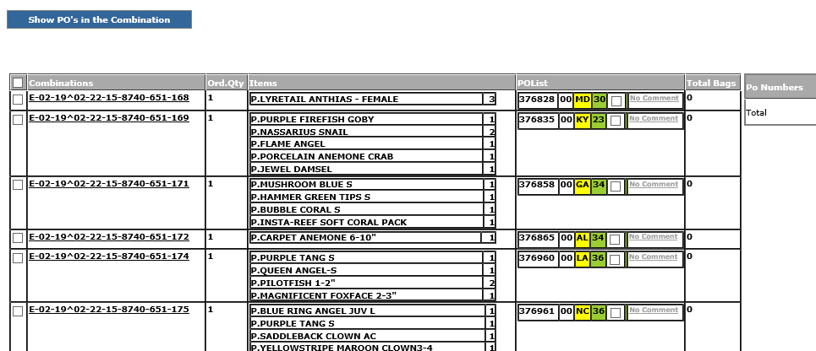

**Ship List**

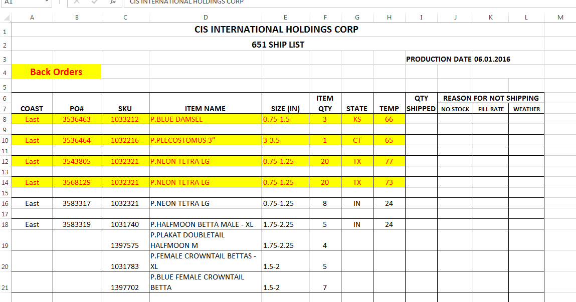

Fill the ship list use the POs list. (Cost, PO#, Item Name, Item QTY, state, Temperature)

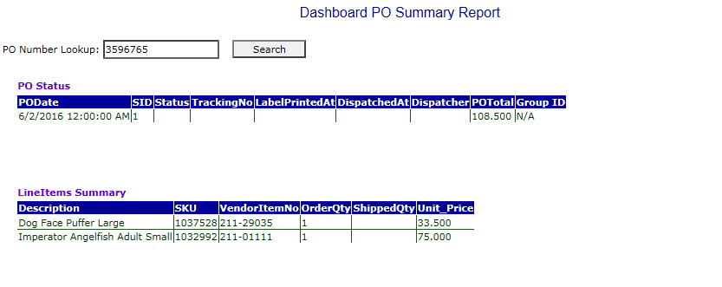Search the Dashboard – PO drill down find the SKU No of the line items.

Using that SKU No find the Item name and Size in Matt’s Inventory Excel file. Then complete the ship list (SKU NO, Item name, Size).

Note: Highlight the Back Order’s.

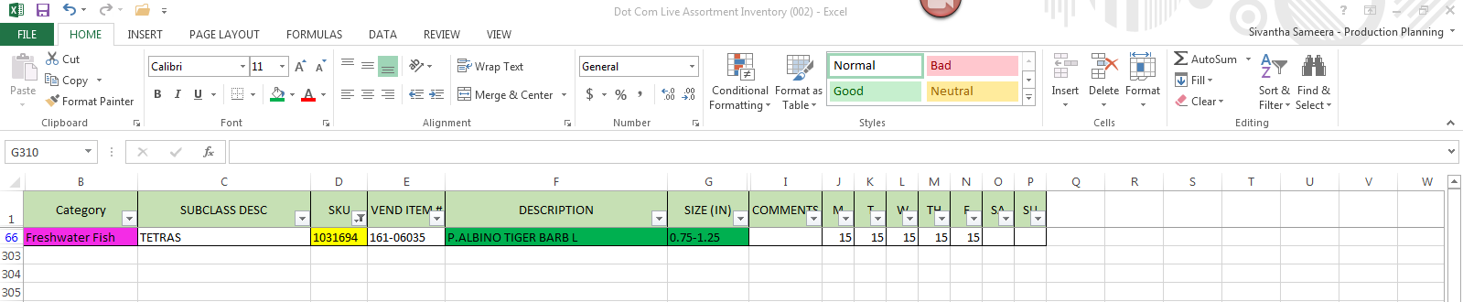

**Pick List**

Using the ship list Item name and size prepare the pick list,

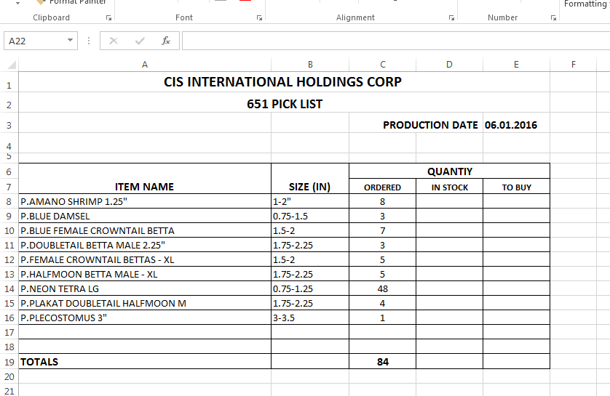

**Summary**

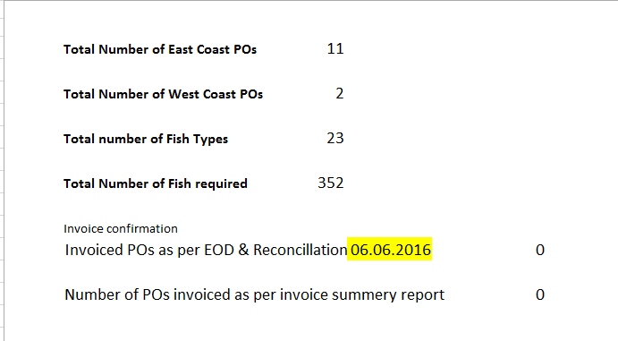

Note: Invoice summery report will provide the Number of invoice POs as per EOD & Reconciliation.