**TEKNOWLEDGE SHARED SERVICES-SRI LANKA**

**OPR FOR DISPATCH REPORT**

|  |  |
| --- | --- |
| SUBJECT | OPR FOR DISPATCH REPORT |
| DEPARTMENT | PRODUCTION PLANNING |
| RECORDER | BUDDIKA MADURANGANA |
| APPROVED BY |  |
| CREATED DATE | 02/06/2015 |
| LAST UPDATED | 03/04/2016 |
| PATH ON NETWORK FOLDER |  |
| NO. OF PAGES INCLUDING THIS PAGE | 2 |

**Objective**

Dispatched PO report to be sent to PETCO on every Friday with below criteria for invoice purpose.

**Date Range**

Date range to be taken from Friday to Thursday (1 week), starting Friday should be two weeks before from the report date.

Example:

Report date Friday 02/06/2015

Date range: Friday 01/23 to Thursday 01/29.

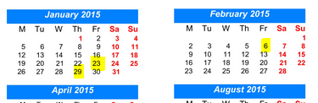

Report Subject: Dispatch report (Date, Time)

**Recipient**s

To: [Carol.Ramos@PETCO.com](mailto:Carol.Ramos@PETCO.com), #193 Dispatch Report [#193DispatchReport@etropicalfish.com](mailto:#193DispatchReport@etropicalfish.com)

Cc: Buddika Maduranga - Production Planing <buddikam@cisintl.com>; genad@petco.com;

**Report Format**

