**TEKNOWLEDGE SHARED SERVICES-SRI LANKA**

**OPR FOR PRODUCTION PLANNING PETCO#193**

|  |  |
| --- | --- |
| SUBJECT | OPR FOR PRODUCTION PLANNING PETCO#193 |
| DEPARTMENT | PRODUCTION PLANNING |
| RECORDER | BUDDIKA MADURANGANA |
| APPROVED BY |  |
| CREATED DATE | 12/04/2015 |
| LAST UPDATED | 11/21/2016 |
| PATH ON NETWORK FOLDER |  |
| NO. OF PAGES INCLUDING THIS PAGE | 7 |

# Objectives

Plan to deliver all received POs for the relevant production week with 100% Fill rate utilizing the available resources effectively such as livestock, Dry good, Manpower etc.

# Analyzing and Forecasting

Following will be consider to prepare the weekly production forecast on every Thursday for coming production week.

1. Analyze the historical data (6 weeks) and coming week projection is made upon that. – PO summery report
2. Coming week betta quantities are already received by Thursday morning and that will be considered. - PO summery report
3. Available quantities of back orders- Back Order report
4. Planned promotions- ETF Promo Calendar
5. Types of livestock- bagging, Prepping activities can be varying from usual and need to consider changes. Ex- Invers can be bagged one day before
6. Live Stock
7. Dry Good
8. Manpower availability- Labor Management checks the availability & skills of employees
9. Shipments
10. Available shipping days

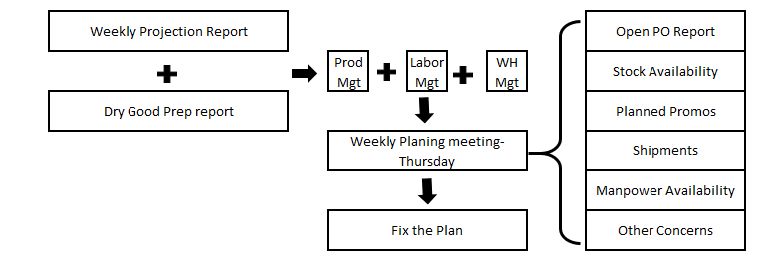

Weekly production forecast is consisting all and submit to WHMGT on Thursday SL time.

Weekly Production Planning meeting is schedule on Thursday 10:00 AM US time to finalize & Fix the plan which provided by the planning & Labor Management

Note: Separate OPR is available for Production Forecast preparation.

# General Item Planning Guide Line

1. Betta should be prioritized in the Plan & need to ship out as early as possible. Keeping betta in stock is labor intensive and all the betta POs must be shipped by Wednesday.
2. Promos to be planned as per the availably of stocks and agreed in the meeting.

|  |  |  |  |  |  |
| --- | --- | --- | --- | --- | --- |
| **Sunday** | **Monday** | **Tuesday** | **Wednesday** | **Thursday** | **Friday** |
| Betta | Regular POs | Regular POs | Regular POs | Regular POs | Wood/Rock Promos |
| Wood/Rock | Wood/Rock | Promos | Promos | Promos |  |
|  | Promos | Plants | Plants |  |  |
|  | Plants |  |  |  |  |
|  |  |  |  |  |  |
| **General bagging Plan for the week** | | |  |  |  |
| **Sunday** | **Monday** | **Tuesday** | **Wednesday** | **Thursday** | **Friday** |
| Betta | All Fish types | All Fish types | All Fish types | All Fish types |  |
| Inverts | Inverts | Inverts | Inverts | Inverts |  |
| Plants | Plants | Plants | Plants | Plants |  |
|  |  |  |  |  |  |
|  |  |  |  |  |  |
| **General Prepping Plan for the week** | | |  |  |  |
| **Sunday** | **Monday** | **Tuesday** | **Wednesday** | **Thursday** | **Friday** |
| Plants | Plants | Plants | Plants | Plants | Plants |
|  |  |  |  |  | Box |
|  |  |  |  |  | Cups |

**PRODUCTION PLANNING PROCESS ON ETF**

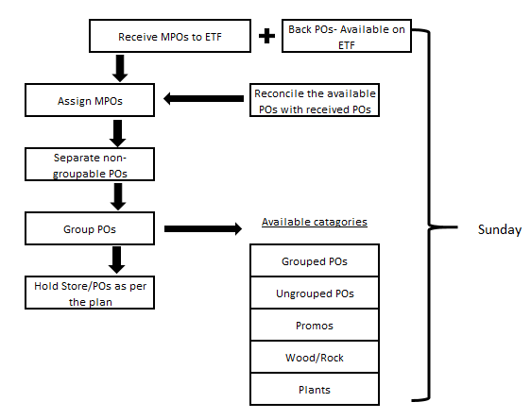

**1. ASSIGN STATIONS ON ETF**

Based on the projected Tracker, number of packers and bagger will be finalized and need to assign Station in ETF. This has to be done on every Sunday before starting the production plan.

Path <http://www.cisintl.com/ProductionMatrix/StationManagement.aspx>

Production Planning Admin-Station assignment

1. Select the station name
2. Select employee name
3. Select supervisor
4. Select Start and End time
5. Select day
6. Save

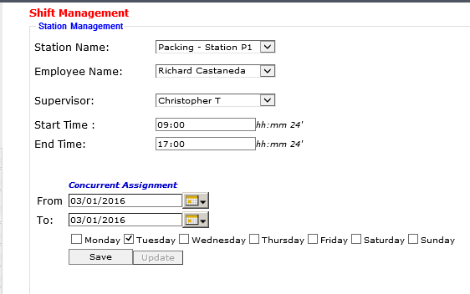

**2. Definition of PO week, Shipping week and Back Orders**

PO Week: PO week start on Sunday and Ends on Saturday

Shipping Week: Shipping Week start on Friday and ends on Thursday

Back Orders: If any PO is open with PO date behind by the current PO week to be consider as back order

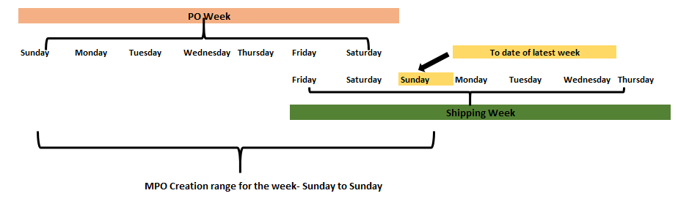

**3. ASSIGN MPOs TO ETF**

New MPOs for the production week to be assigned to ETF on Sunday morning.

1. Date Range: previous Sunday to this Sunday
2. Get the PO list
3. Select All
4. Go to Manual update panel
5. Update

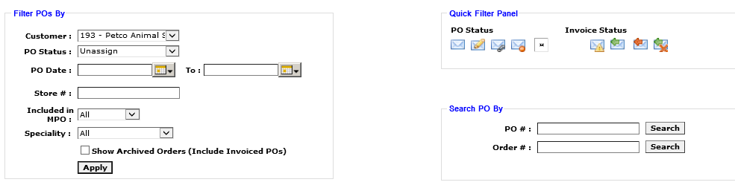

# 4. GROUP POs

POs of the same store to be grouped to minimize the shipping cost. Following instruction to be followed.

1. POs can be grouped only if they are for same store.
2. Maximum 4 POs can be grouped at a time.
3. Wood/Rock /Plant POs to be excluded from the grouping.
4. Promotional POs cannot be grouped with regular POs. if there any requirement to do so, need to get Matts approval.
5. Betta less than six POs must to be grouped with other POs since these POs cannot be shipped alone.
6. Once grouping done, back orders also to be considered.

**How to group**

Production Planning Admin - Purchase Order Grouping

Link: <http://www.cisintl.com/pogrouping.aspx>

Steps

1. Provide the date range
2. Customer: 193-Petco Animal Supplies
3. Find PO
4. Tick the POs which needed to be groped. (tick all option is available and un-tick if any PO that not to be grouped)
5. Group PO

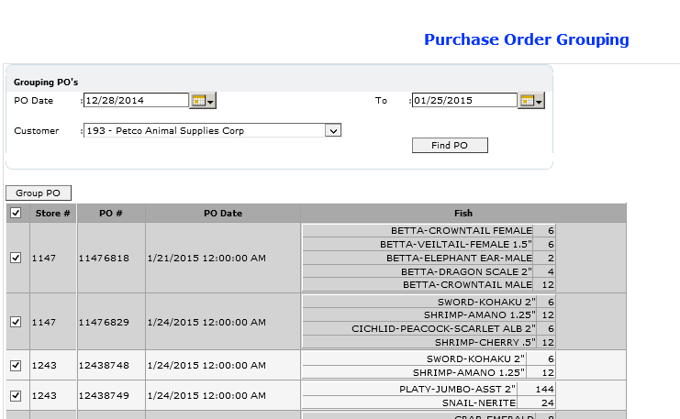

# PO Assignment to the Packer

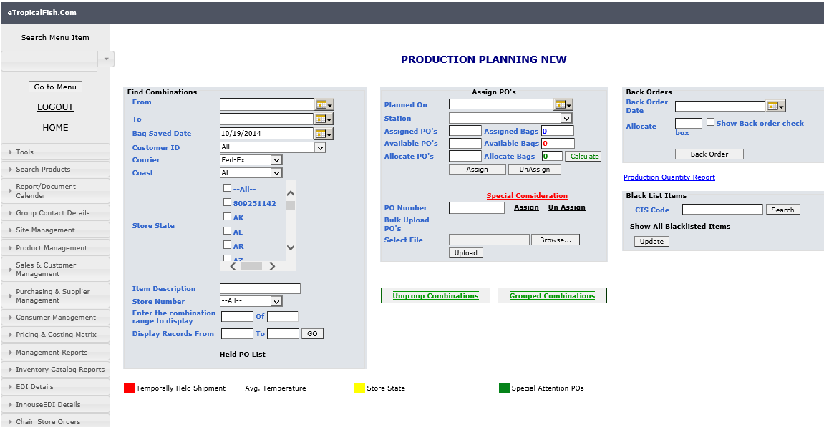

**Production Planning Admin- Production Planing New**

<http://cis.eteknowledge.com/ProductionMatrix/ProductionPlanning_NEW.aspx>

1. Login to ETF & go to **Production Planning Admin ->** Production Planning New
2. Put the date range, From date should be 2-3 week backward from latest Sunday and To date is latest Sunday. Refer the PO/Shipping week definition.
3. Select Customer ID: Customer for whose Orders Planning is being done: Eg. #193, #651, etc
4. Cost can be selected as East or West.
5. POs can be filtered as State wise ticking on the state code.
6. Item description- Using item description option, POs can be filtered as per item availability. Ex: to get Guppy POs, type Guppy in Item description
7. Using the “**Enter the combination range to display” and “Display Records From”** number of combination can be limit to display or can be load give range of combinations.
8. Click on “**View Ungroup Combination”** to view the ungroup combinations Click on “**View Group Combination”** to view the Group combinations
9. Then PO will be listed down in Ungroup & Group sections as per the applied Filters.
10. Once the POs are loaded, if you want to select all click on the first tick box, then all loaded POs will be selected, click on show POs in the combination to get the available POs for assigning

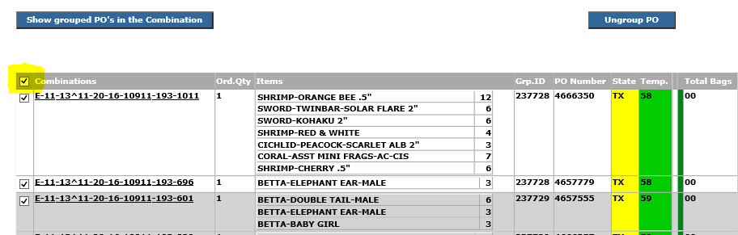

1. Select Packing Station

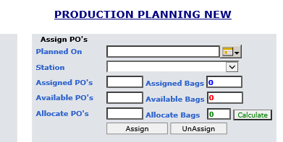

* Select the date which you need to assign POs. let the system to load the date
* Once the date is loaded, click on Station and select the station.
* Available POs shows the number of POs which you have selected before. (Step 1 to 11)
* Put the same number in allocate POs and click on assign. (Note: if you have select group POs, you need to tick on all POs in same group)

1. Special Consideration: If the PO number is available and it is a Open PO, that PO can be assign using this option. Paste the PO number and click on assign. Same way you can removed the assigned PO from a packer. Need select the packer then put PO number and click on un-assign.



**SPECIAL ATTENTION POS & BACK ORDER ASSIGNMENT**

**These special attention POs and Back orders to be prioritize in daily production.**

* As per the customer requirement, some Stores/States to be planned on particular production date.
* Example: Store#596 to be planned on Monday.
* Special attention POs must be assigned in separate breakdown.
* Customer send email request to CSD and daily Petco urgent shipment list is send to planning by CSD. These POs to be planned as special attention in separate breakdown.
* Back orders to be prioritized on Monday and instruction to be given/highlighted to ware house to ship all on Monday to avoid cancellation.

**SAVE BAGS**

Bags to be saved for each packer which assigned for the production.

* Fish Breakdown and Bagger assignment – View Fish breakdown details.
* Provide the date, Production Station and Customer is 193.
* Load Calculated Value should be selected to view the system assigned bag values. Need to check EOQs and Save#bags.

<http://www.cisintl.com/ProductionMatrix/FishBreakDownReport.aspx>

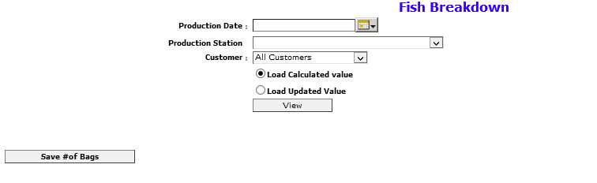

# BAGGER ASSIGNMENT

After the bag saving, need to assign bags to the bagger. This will allow baggers to print the labels for bags.

* Fish Breakdown and Bagger assignment – Bagger Assignment.
* Provide date, Customer#193 & View.
* Select the bagger name which you need to assign & tick the fish types which needed to be assigned for the selected bagger.
* Add
* Assign Bags.

<http://www.cisintl.com/ProductionMatrix/baggerAssignment.aspx>

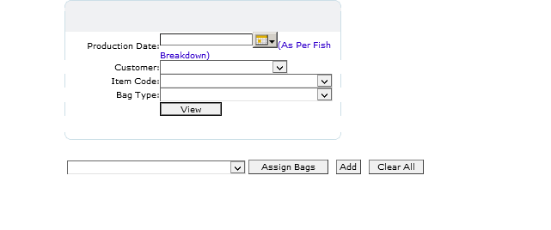

# HOW TO GET PACKER REPORT THRU ETF

Note: This is the old way of preparing Packer breakdown. Please refer the second option currently used for Packer breakdown preparation.

1st Option

1. The go to “Packer breakdown “under “production planning Admin”
2. Put the production date.
3. Select the relevant station.
4. Courier UPS
5. If the POs are assigned as grouped, then need to click on the “Show grouped breakdown”
6. It the POs are assigned as ungrouped, then click on ““Show ungrouped breakdown”.

<http://www.cisintl.com/ProductionMatrix/packerbreakDown_Nw.aspx>

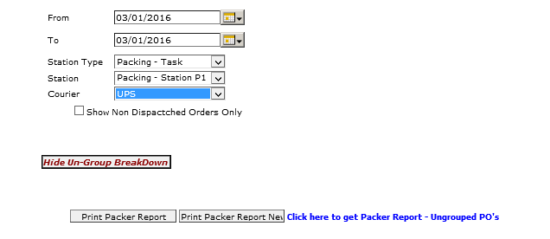

2nd Option- new method

1. Go to Production Planning Admin- Packing Status update

<http://cis.eteknowledge.com/ProductionMatrix/packerInfoUpdate.aspx>

1. Click Start
2. Select the date and allow the system to load the date
3. Select the packing Station
4. Courier must be UPS
5. Tick on “All”
6. Click on Display order

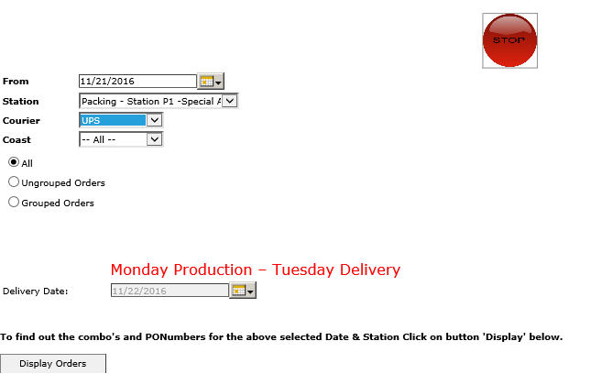

1. Once the POs loaded, Group and Ungroup assigned POs can be downloaded.

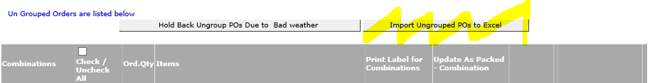

Preparation of Daily Packer/Fish breakdown on Excel

1. Download all the breakdown for the assigned packers and paste on a separate tabs of single Excel file



1. Prepare the individual Packer breakdown summery.
2. Select area of ITEM NAME, CIS & QTY of the report
3. Insert PIVOT Table
4. Select the PIVOT table location at the end of the sheet
5. Create PIVOT table
6. Fields to be reflect in Pivot table are Item Name & Qty (Sum of Qty)
7. Copy data of Pivot table & paste as only data.
8. Remove the Pivot table
9. Assign the EOQs
10. For the multiple EOQ items, Filter the Packer report & assign the EOQs and bags
11. Calculate bags (Qty/EOQ)
12. Assign the packing station to the summery

Select area

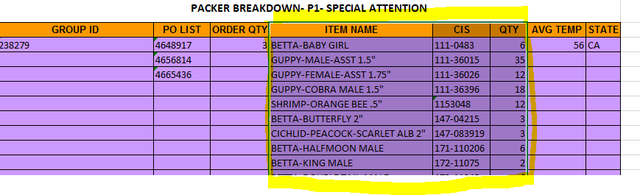

Pivot table

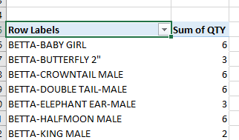

Assign Packing station

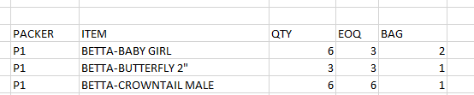

1. Need to do this to all packer breakdowns
2. Once all packer breakdowns are completed, copy the summery to separate tab.

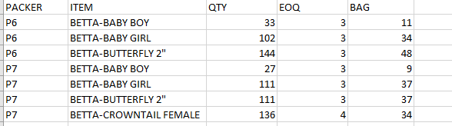

1. Select the summery table & insert Pivot. Fields must be as below snap.

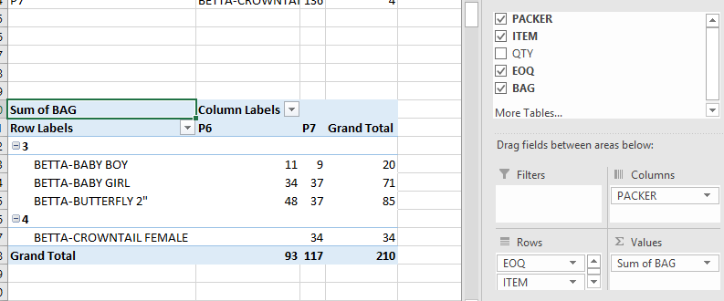

1. Now the Items are sorted as per EOQ
2. Copy data of Pivot to another sheet, insert column in front of items, put the relevant EOQ, then sort all
3. Do the necessary formatting as below and that will be the final Fish breakdown.

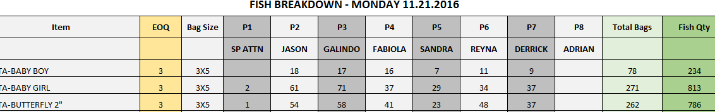

Bagger Distribution & Individual bagger assignment

Bagger Distribution.

As per the Fish breakdown, available bags to be distributed among the baggers

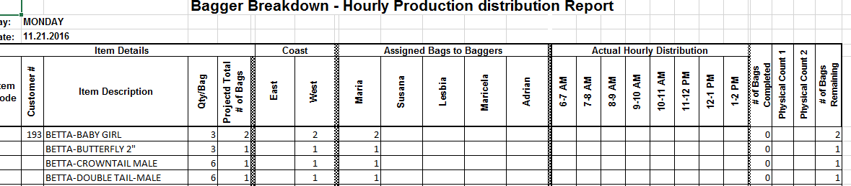

Individual bagger assignment

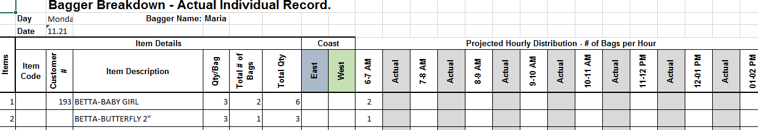

PO assignment Summery

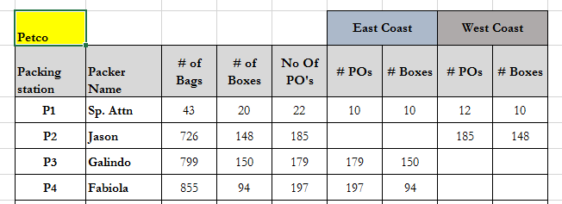

Once the Packer/Fish breakdown completed,

1. Breakdown to be sent to Team Leaders, Supervisors and WHMgt. Cc to ProdMgt, LaborMgt thru the report calendar.
2. IT should be informed with the assigned stations for the day with below format.

