**CIS International Pvt Ltd**

**OPR for Preparation of Petco Incidents Analysis Report**

|  |  |
| --- | --- |
| **SUBJECT** | **OPR for Preparation of Petco Incidents Analysis Report** |
| **DEPARTMENT** | **Audit** |
| **RECORDER (Name and Designation)** | **Sajini Perera, Audit Executive** |
| **APPROVED BY** |  |
| **CREATED DATE** | **09/02/2016** |
| **LAST UPDATED** | **09/02/2016** |
| **PATH ON NETWORK FOLDER** |  |
| **NO OF PAGES INCLUDING THIS PAGE** | **04** |

**Introduction**

This OPR is prepared for the purpose of setting up a proper process that gives guidelines for Preparing “**Petco Incident Analysis Report**”.

**Objective**

The objective of the “**Petco Incident Report**” is to

1. ensure the smooth overall operational performance of the company and CIS warehouse activities,
2. recognize the situations where lack of detective and preventive internal controls exists.
3. recognize the supply chain activities, where company will enable to add value

**Process involved in preparation of Petco Incident Analysis Report**

1. Obtain Weekly Petco Incident Report from Matt.
2. Create a copy of previous week Petco Incident Report and update time periods.
3. Insert Matt’s report in to current week incident report and update working sheet by using information in that report.
4. Trend Analysis of Deceased Quantity

Compare total reported diseased quantity with the total shipped quantity within the reporting week. Further analyse the trend of deceased quantity ratio.

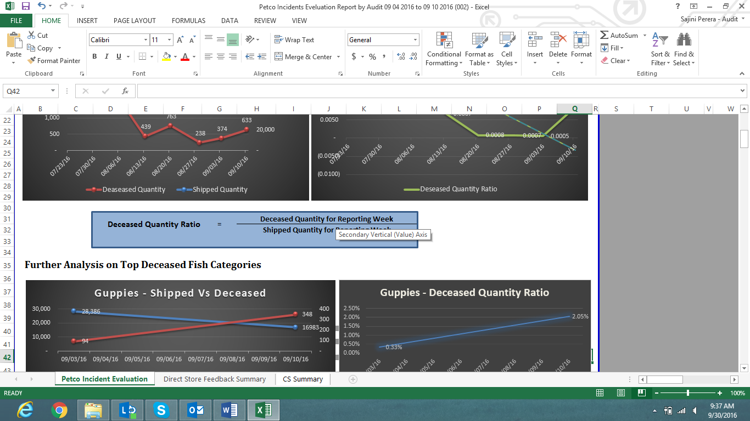

Moving forward, compare the deceased quantity against shipped quantity of top deceased fish varieties of the week. Further, present the hierarchy of deceased percentage.

1. Vender Related Vs Courier Related – Composition Analysis

Compare the total deceased quantity due to CIS issues with deceased quantity due to courier services.

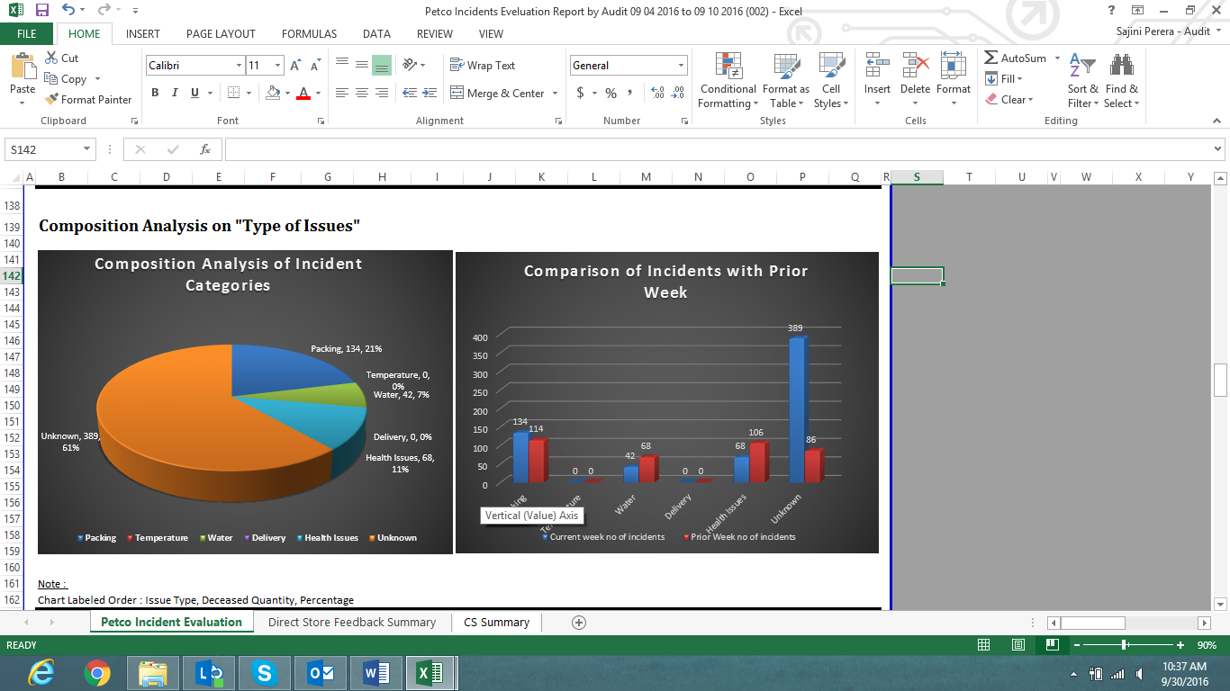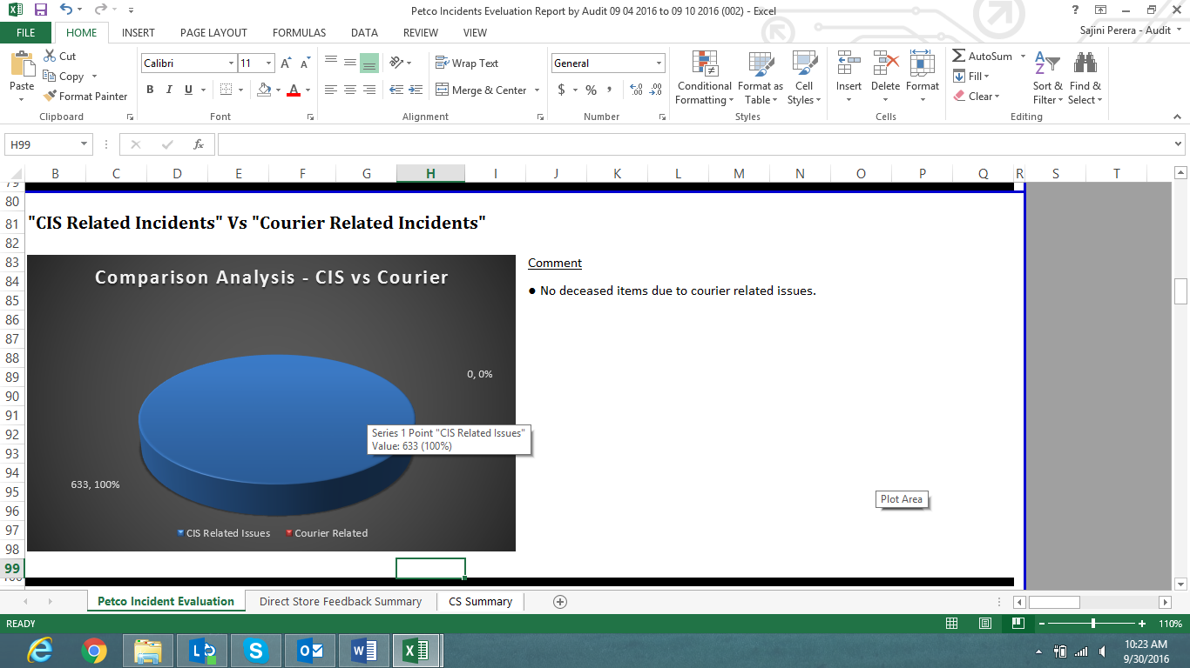

iii) Analysis of Deceased Quantity Based on Item Categories

Analyze deceased quantities based on “**Item Types**”. Moving forward, analyse composition of top deceased category.

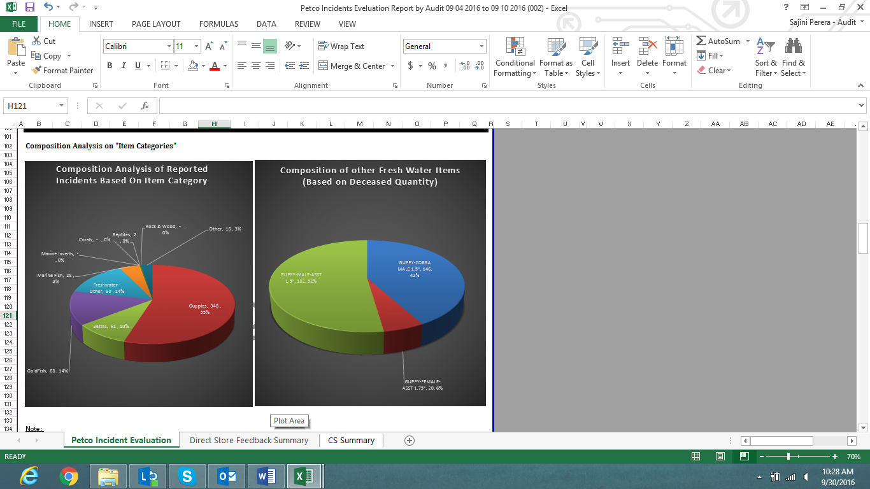

1. Analysis of Deceased Quantity Based on Type of Issues

Analyze deceased quantity based on type of issues (eg: packing, delivery, temperature, water, health issues and unknown. Further, compare deceased quantity under each category with previous week.

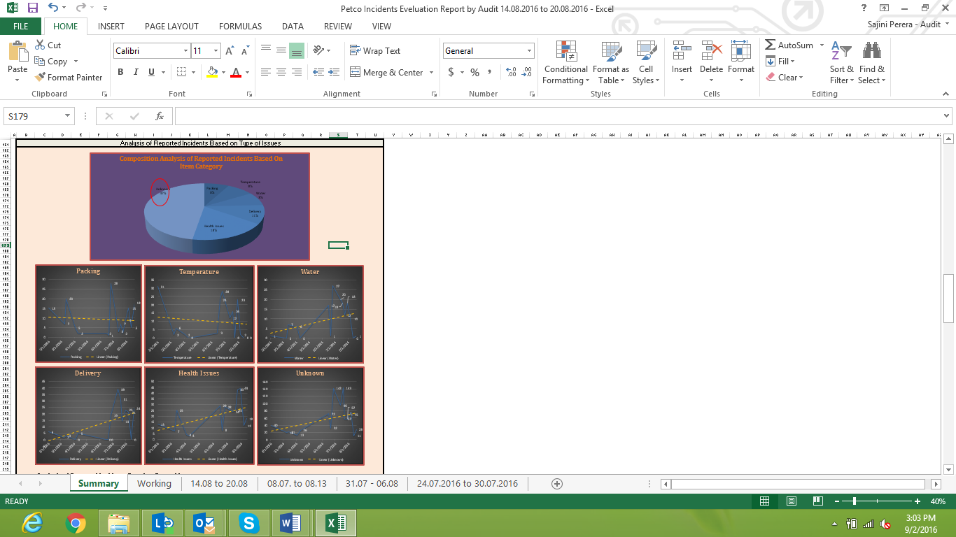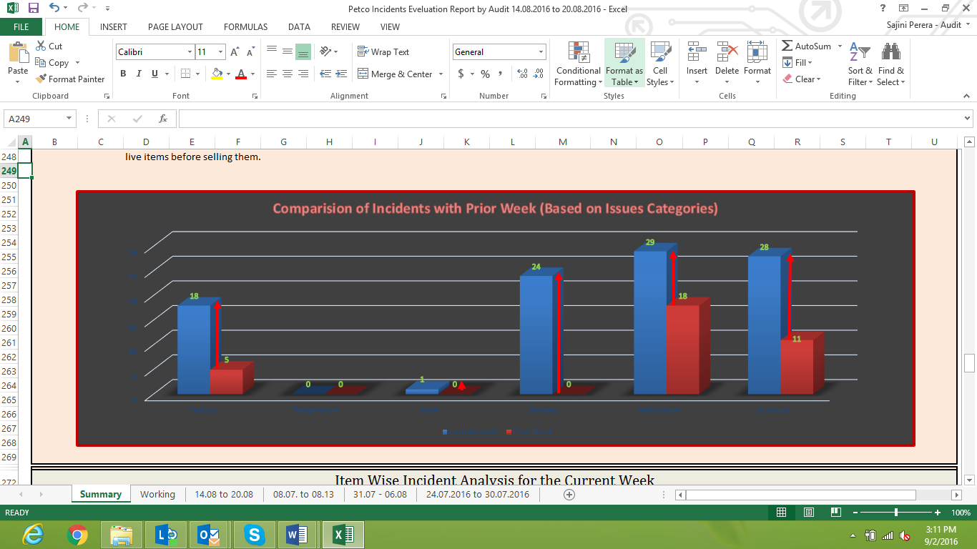

1. Item Wise Incident Analysis.

Carry out individual item wise analysis for incidents comparing number of incidents with prior period. By using this analysis we highlight live items where significant risk is associated with. Further, this need to be linked to the “Item Wise” and “Issue Type” analysis previously carried out.

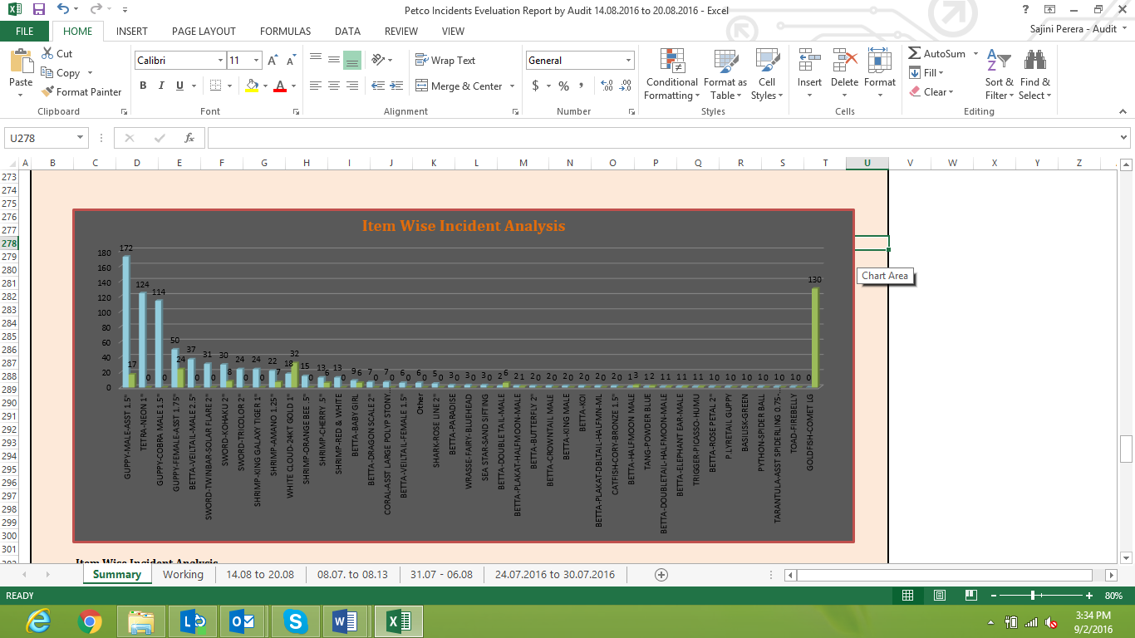

1. Identification of top 5 Regions with significant number of incidents noted.

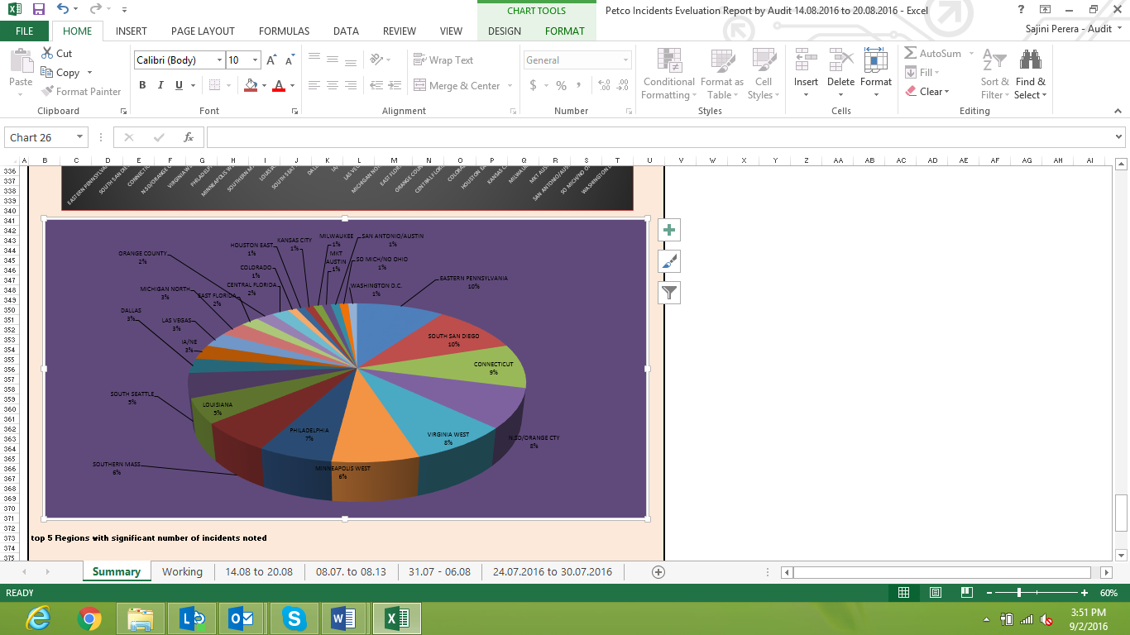By using source document weekly obtain, identify top five regions where more number of incidents recorded and compare this with previous week. Under this incident percentage also need to be considered.