**CIS International Pvt Ltd**

**OPR for Preparation of Weekly Shipment Audit Report – Maldives**

|  |  |
| --- | --- |
| **SUBJECT** | **OPR for Preparation of Weekly Shipment Audit Report – Maldives** |
| **DEPARTMENT** | **Audit** |
| **RECORDER (Name and Designation)** | **Sajini Perera, Audit Executive** |
| **APPROVED BY** |  |
| **CREATED DATE** | **09/05/2016** |
| **LAST UPDATED** | **09/05/2016** |
| **PATH ON NETWORK FOLDER** |  |
| **NO OF PAGES INCLUDING THIS PAGE** | **03** |

**Introduction**

This OPR was prepared for the purpose of setting up a proper process that gives guidelines for Preparing Weekly Shipment Audit Report – Maldives.

**Objective**

The objective of the Weekly Shipment Audit Report is to

1. ensure the smooth operation of Maldives Facility,
2. ensure the continuous supplies from Maldives Facility,
3. identify circumstances where facility employees need training and knowledge
4. identify threats and opportunities associated with facility,
5. assess the efficiency level of the employees’ as well as divers’,

**Process involved in preparation of Weekly Shipment Audit Report – Maldives**

Steps involved in preparing Weekly Shipment Audit Report – Maldives

1. Obtain all “Daily Live Good Inventory Reports (**LGIR**)” from Accounts Executive which are relevant for the reporting week (i.e. from previous week Wednesday to current week Tuesday).
2. Copy all these daily LGIRs to single work book and rename each LGIR report by using relevant date. And also prepare LGIR summary for reporting week.

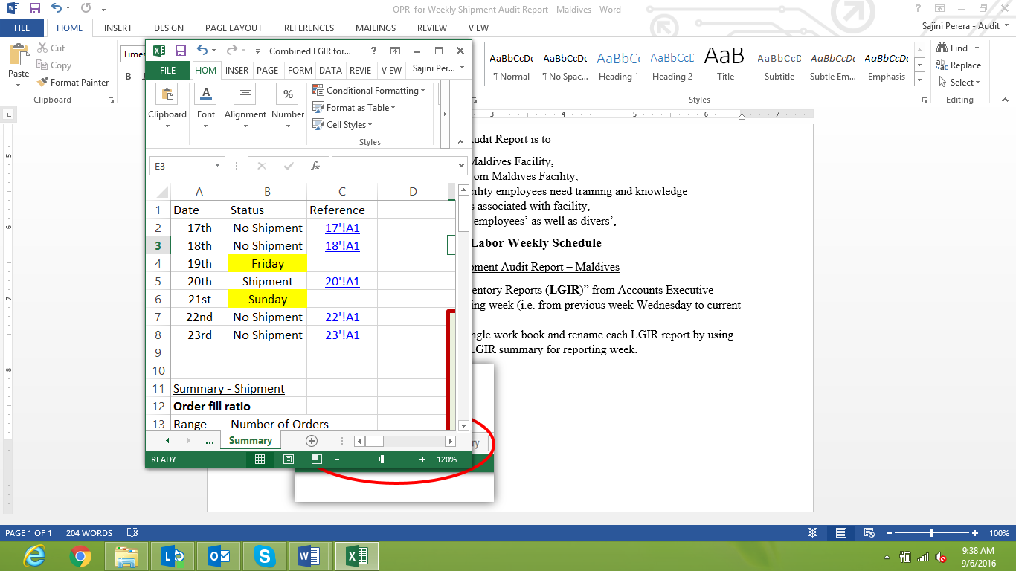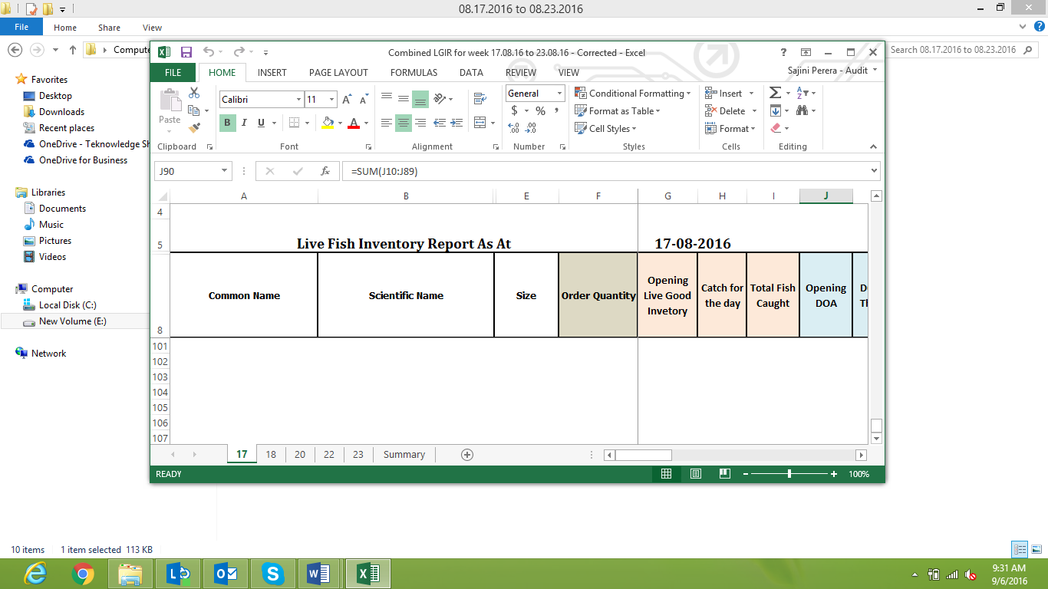

1. By using these daily LGIRs prepare Weekly Shipment Audit Report. Steps are as follows,
2. Fill general information regarding the reporting period and shipment. These general information are;

Report Date:

Reporting Period:

Number of Shipments within Period:

Shipment Dates:

Number of shipment Boxes:

1. Evaluation of Order Fulfilment

Identify items which has 100% order fill ratio (by referring LGIR relevant to shipment date) and copy and paste common names and scientific names of those items to the report.

Calculate percentage of 100% order fulfilment out of total weekly order and document it in the report.

Identify items for which weekly order quantities are over 70% fulfilled and document common names and scientific names of those items.

Calculate percentage of 70% order fulfilment out of total weekly order and document it in the report.

Calculate Overall Order Ratio and identify efficiency and feasibility of the facility.

Total Exported Quantity

X 100%

Overall Order Fill Ratio:

Total Order Quantity

Carry out composition analysis on order fill percentage and also represent number of items relevant for each percentage level and make comments based on analyzed information.

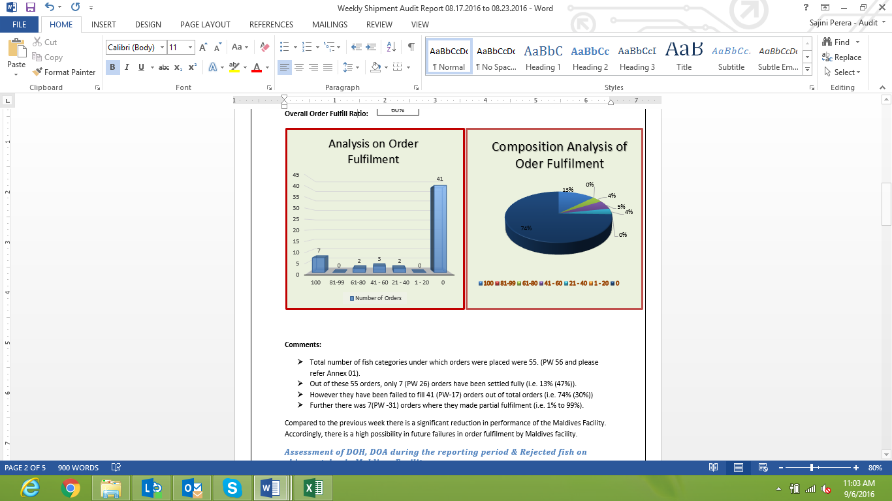

1. Assessment of DOH, DOA during the reporting period and rejected fish on shipment day in Maldives facility.

Identify items of which DOH and DOA percentage is higher than 50% and document common names and scientific names of those items within the report.

Identify no of rejected fish on shipment day and comment on efficiency level and compare efficiency level with previous period.

1. Assessment of Divers’ Efficiency

Analyze number of items relevant to each efficiency percentage level and calculate correlation between divers’ efficiency level and order fill ratio.

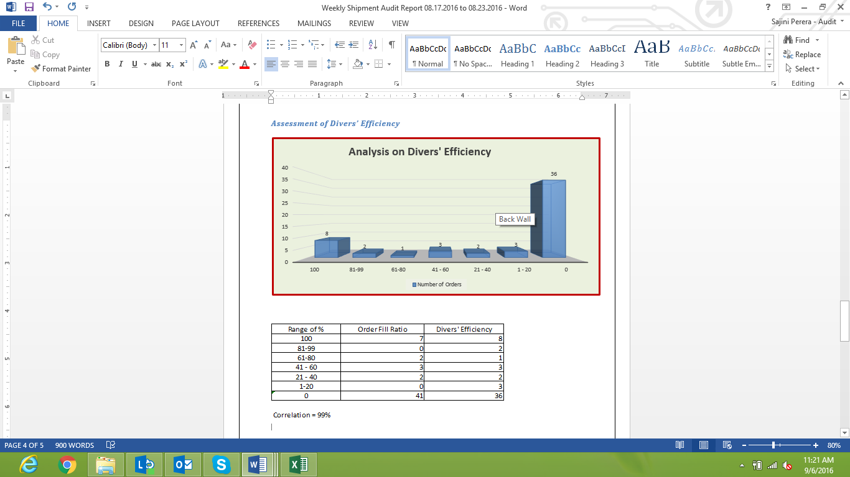

1. Analysis of Fish Condition after the shipment arrived in Sri Lanka (By reviewing Sri Lankan biologists “Shipment Feedback Report”.

Review “shipment Feedback Report” prepared by farm biologist and identify key arrears which gives light of inefficiencies or needy of training programs to the facility workers.

1. Give “Conclusion” on the efficiency level of the facility and shipments and also may suggest preventive and detective controls to be implemented within the business process.

Notes

* Accounts executive does not prepare LGIR for each Friday (Maldives holiday) , Saturday and Sunday (SL holidays).
* Cross check opening balance of inventory at the beginning of the each date with the closing balance of previous date to ensure the accuracy and completeness of the sourcing info.
* Cross check shipped quantity recorded in the LGIR with packing list, invoice and shipment feedback report.