**CIS International Pvt Ltd**

**OPR for Preparation of Supplier Efficiency Ranking Report**

|  |  |
| --- | --- |
| **SUBJECT** | **OPR for Preparation of Supplier Efficiency Ranking Report** |
| **DEPARTMENT** | **Audit** |
| **RECORDER (Name and Designation)** | **Sajini Perera, Audit Executive** |
| **APPROVED BY** |  |
| **CREATED DATE** | **09/20/2016** |
| **LAST UPDATED** | **09/20/2016** |
| **PATH ON NETWORK FOLDER** |  |
| **NO OF PAGES INCLUDING THIS PAGE** | **03** |

**Introduction**

This OPR was prepared for the purpose of setting up a proper process that gives guidelines for Preparing Supplier Efficiency Ranking Report.

**Objective**

The objective of the Supplier Efficiency Ranking Report is to

1. rank the suppliers based on efficiency level.

**Process involved in preparation of Supplier Efficiency Ranking Report**

1. This Report should be Prepared Half Monthly Basis. Reporting period is 1st to 15th and 16th to 30th of each Month.
2. Horana farm shall deliver “Supplier Efficiency Report” to the audit department before every 18th and 3rd of each month following to the 15th and 30th respectively.

Supplier Efficiency Report

* This report incurred by a “**Lead Sheet**” which provides a summary of supplier details and supporting information sheets for each supplier.
* **Individual Supplier Sheets** – this incurred by the following details ;
* Supplier Name
* Fish Varity Names Supplied
* Price Per each Fish
* Total Supply Received During The Period *(A)*
* DOA and DOH *(B & C)*
* Sick Fish / Critical Fish *(D)*
* Fish with Quality issues *(E )*
* TOTAL BAD FISH *(F = B + C + D + E)*
* Balance (Good Healthy Fish) *(G = A –F )*
* Supplier Efficiency *(P = G/A*100)*

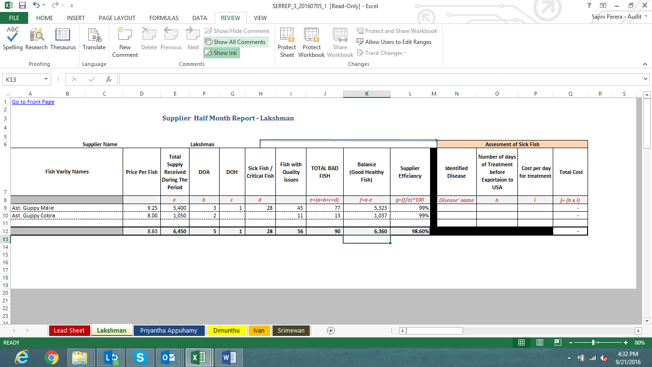

* **Lead Sheet – this incurred by the following details**
* General Information :- Report Prepared Date

Report Covering Period

Preparer’s Name/ Initials

* Summary of supplier information – refer attached screen shot of the summary information table

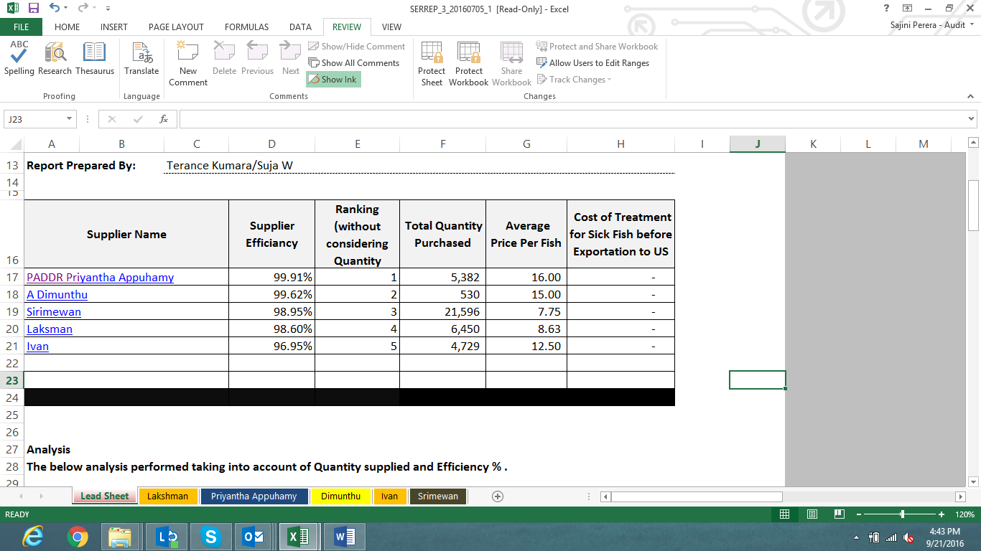

Note: Preparer keeps the “Ranking” column blank and it is filled by the audit department.

1. After receiving the “Supplier Efficiency Report” to the audit department, it ranks the suppliers and prepares the “Supplier Efficiency Ranking Report” by reviewing the information provided. Further, audit department also provides qualitative analysis for the respective reporting period**. *Refer below qualitative analysis provided regarding the above attached summary***

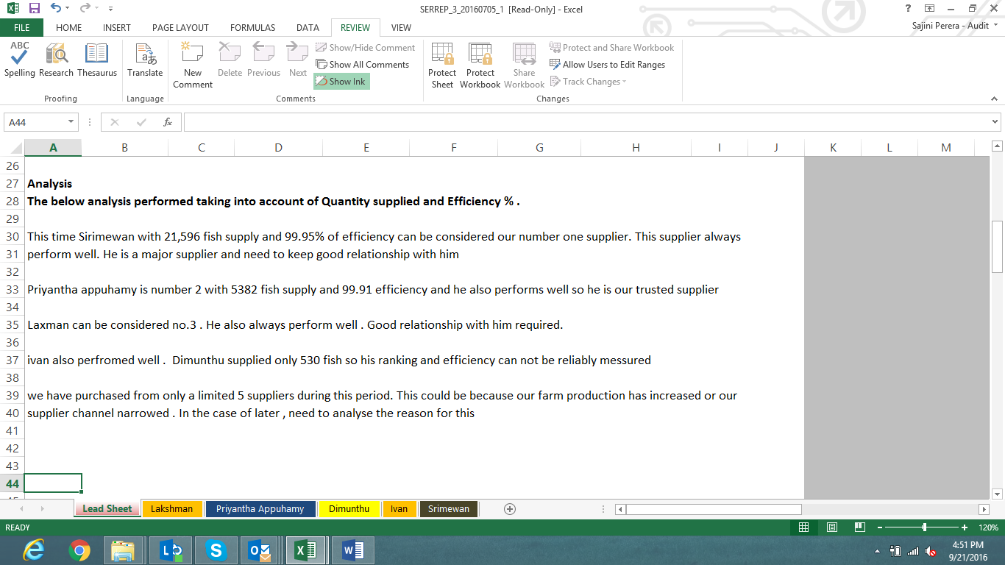

1. This report needs to be updated to the ETF on or before every 18th and 3rd of each month.