**Tropical Fish Intl Ltd**

**OPR for Sending Daily TO DO LIST to CEO**

|  |  |
| --- | --- |
| **SUBJECT** | Sending daily summary / to do list to CEO |
| **DEPARTMENT** | ExecAdmin |
| **RECORDER (Name & Designation)** | Zuhara Careem – Project Coordinator |
| **APPROVEDBY (Name & Designation)** |  |
| **CREATED DATE** | 29-April-2016 |
| **LAST UPDATED** |  |
| **PATH ON NETWORK FOLDER** |  |
| **NO. OF PAGES INCLUDING THIS PAGE** | 2 |

**Objective**: Obtain CEO’s feedback for projects that requires his feedback/approval/review

INTRODUCTION

1. Emails are sent to the CEO requesting his attention, recommendation or views to proceed
2. ExecAdmin must collate these emails and send in one email with the subject heading as below  
   (Pls see image)
3. Apart from sending the summary of emails in one email, the supporting docs, attachments, emails must be uploaded

(OPR for uploading in OD is separately by IT SUPPORT)

1. The docs must be shared for CEO & ExecAdmin access only
2. Based on urgency, the approvals from CEO can be followed up via a text msg, ideally a Viber msg when needed

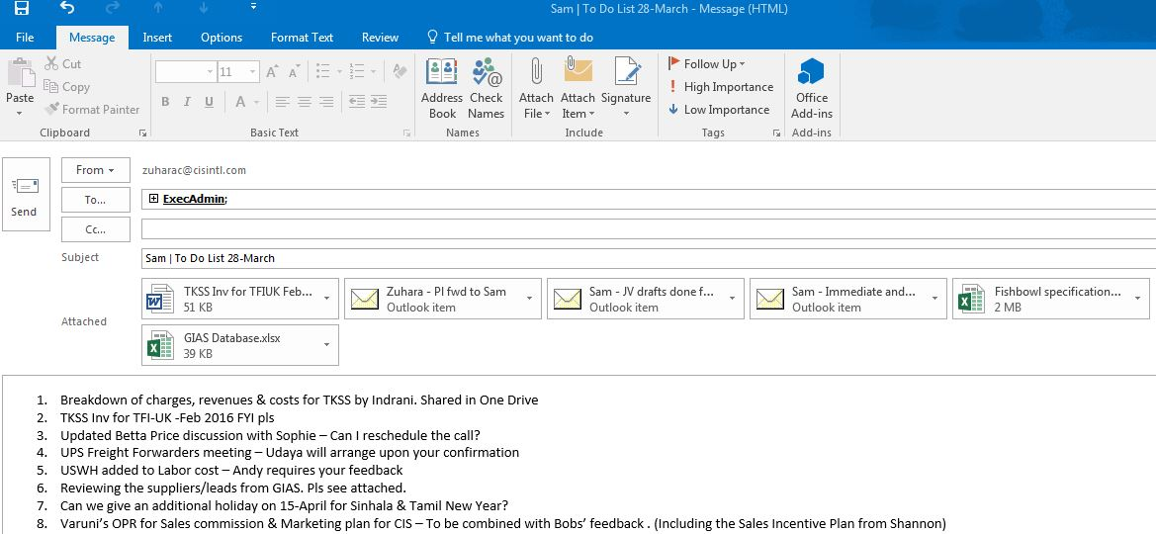

1. When sending text messages, NEVER send multiple messages on the same subject.
2. Number the points
3. See image below of a sample msg sent

