OFFICE PROCESS RECORD

|  |  |
| --- | --- |
| **SUBJECT** | Reconciliation of the intercompany current A/C |
| **RECORDER (Name Designation)** | Chathurangani Ranaweera (Accounts Executive ) |
| **APPROVED BY (Name Designation)** | Stanley Samidas – Senior Accountant |
| **CREATED DATE** | 15/12/2016 |
| **NO. OF PAGES INCLUDING THIS PAGE** | 05 |

**Objective : To ensure all the current accounts balance figures are match**

* **Go to Chart of account and run the Tropical fish intl current A/c.**

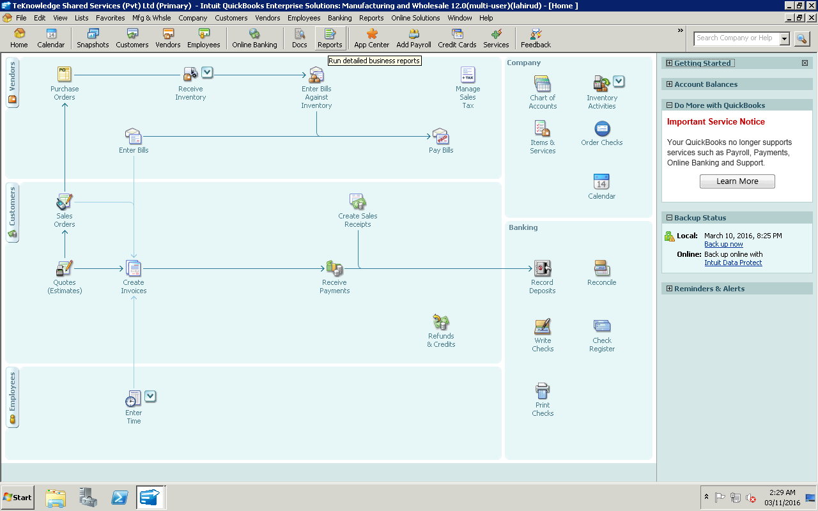

Then Find out the **Tropical fish Intl ACCOUNT** from chart of accounts.

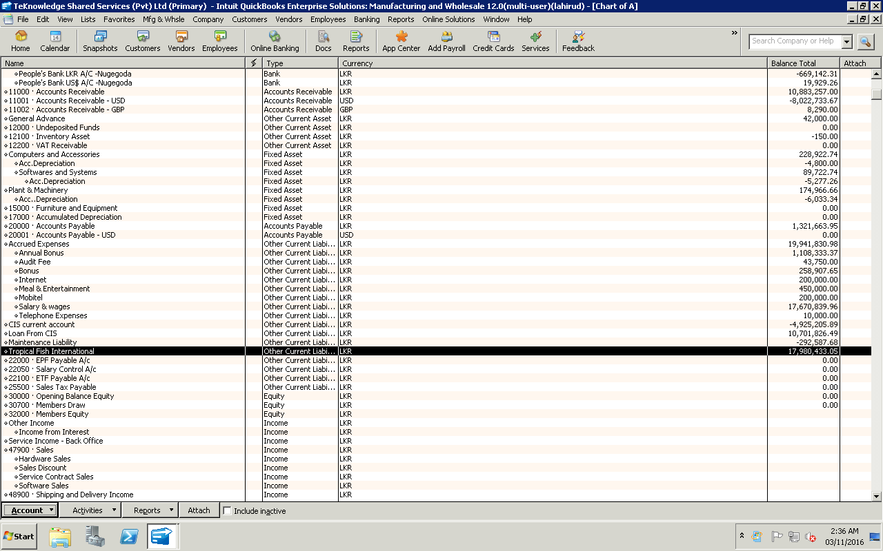

After that run the report for specific time period by selecting the **Quick report**.

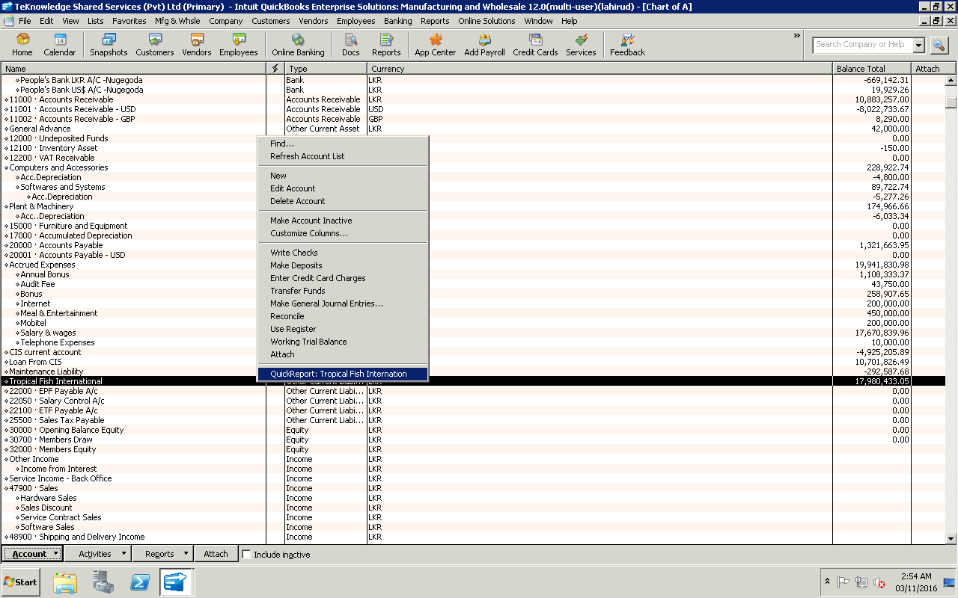

**Quick report interface display as bellow. Select the date range**

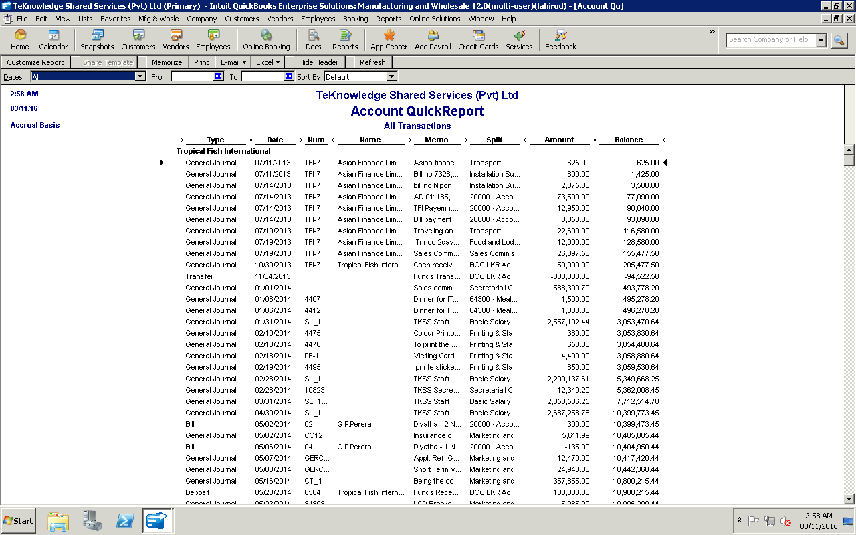

**Then same report need to run in the Tropical Fish International Quick book same procedure as explained in above.**

**And compare the both reports and if there is any mismatch between the balances put a Journal Entry and reconcile both Accounts**

**To put the JOURNAL ENTRY Please follow the Below Procedure**

**Go to Company and Click Make General Journal Entries**

