|  |  |
| --- | --- |
| **SUBJECT** | PMS & ETF – PROJECT MANAGEMENT SYSTEM |
| **RECORDER (Name Designation)** | Chalani Maduwanthi / Assistant Manager System Admin |
| **APPROVED BY (Name Designation)** |  |
| **CREATED DATE** | 03/08/2016 |
| **NO. OF PAGES INCLUDING THIS PAGE** | 16 |

**OPR for PMS & ETF**

**Content**

1. Report Calendar
   1. Report and Document Calendar- summary of reports
   2. Manage Users – add participant by searching
   3. Manage Reports – create, amend reports
   4. Add Division – create division
2. Meeting Calendar
   1. Manage Meetings – create, amend meeting
   2. Add Meeting Minutes – save schedule meeting minutes
   3. Add Participants - add participant
   4. Add Non – Scheduled Meetings – add meeting minutes
   5. Add Divisions - create division
3. Training Calendar
   1. Add Training – record training
   2. Training Log – check training details
   3. Add Participants - add participant
   4. Training Calendar – training calendar summary
4. OPR/User Guides/Process Diagrams
   1. Upload user guides- save OPR, user guide..etc.
   2. Download user guides – download OPR, user guide..etc.

**ETF**

ETF is a system developed for the use of managing meeting and reports for all the staff members of TFI and TEKSS.

It is a place to refer scheduled/ non-scheduled meetings/meeting minutes. It is a place to review /upload reports on monthly/daily basis. All the relevant documents could be uploaded along with where it works as a store also for these two categories.

# Report Calendar

Report calendar is a tool available in ETF system. It is used to review/ upload Reports available for each employee (if reports assigned). Following is the process of uploading a report to the report calendar of ETF

## 1.1 Report and document Calendar

Every ETF user has access to this section and this include all reports uploaded to the system by each report owner and anyone can review these reports after downloading.

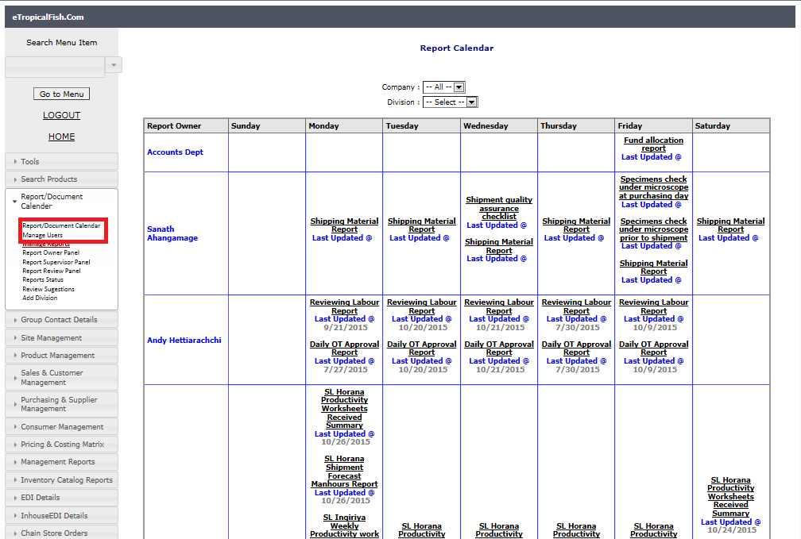

## 1.2 Manage Users

System admin has access to this section to add/update users’ .when there is new employee system admin has to add him/her to report calendar by adding his logging. You can follow the steps given using screen shots.

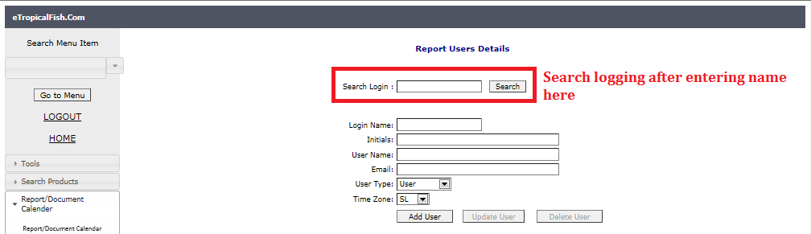

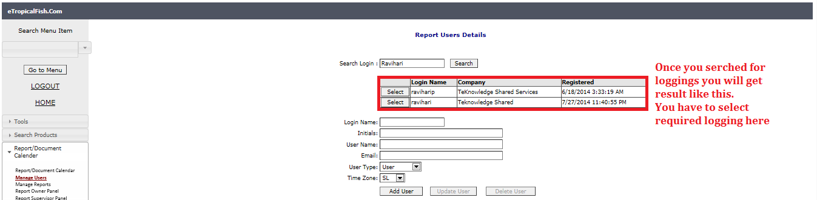

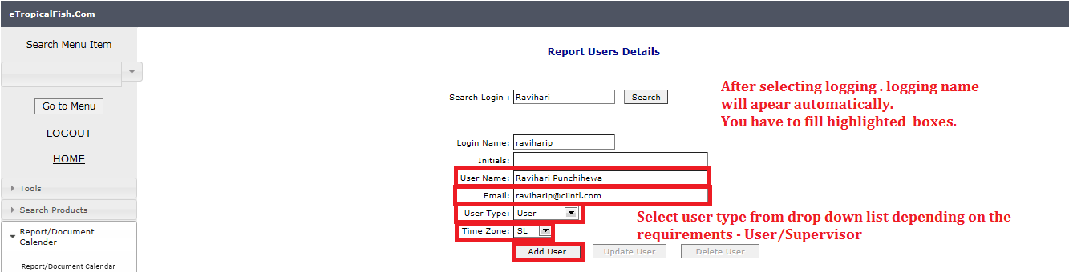

To edit details of existing user, follow steps as in below screen shot.

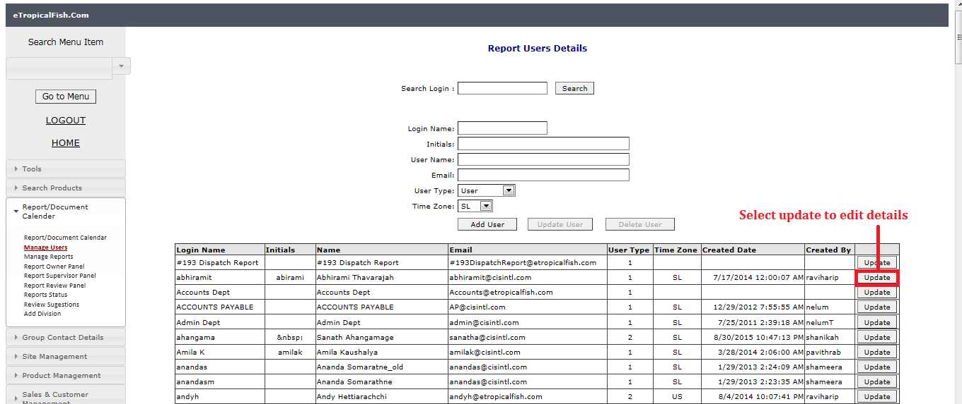

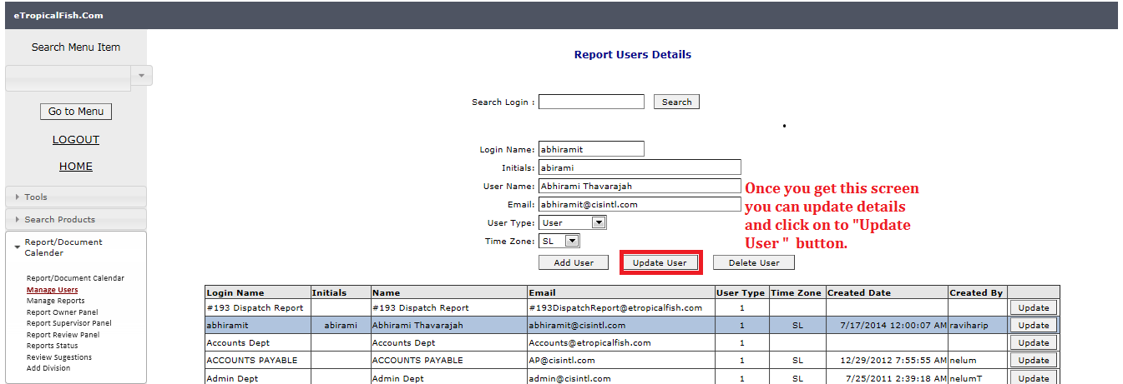

## 1.3 Manage Reports

System admin has access to this section to add new reports and edit existing report details.

To add new reports, follow instructions in below screen shots.

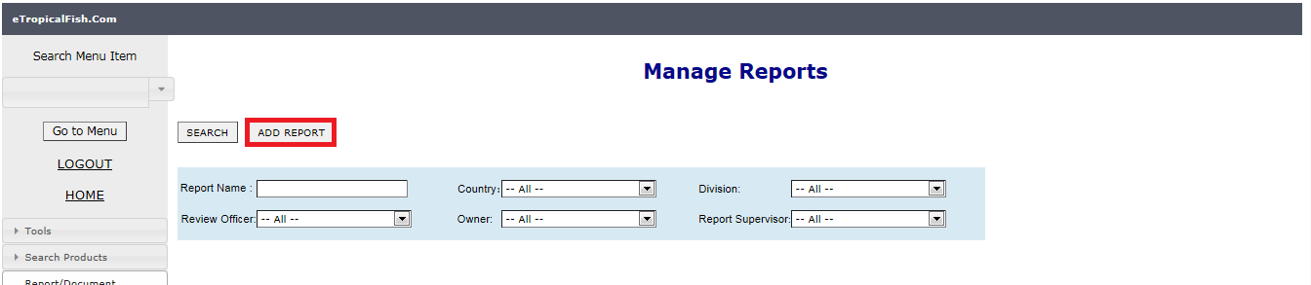

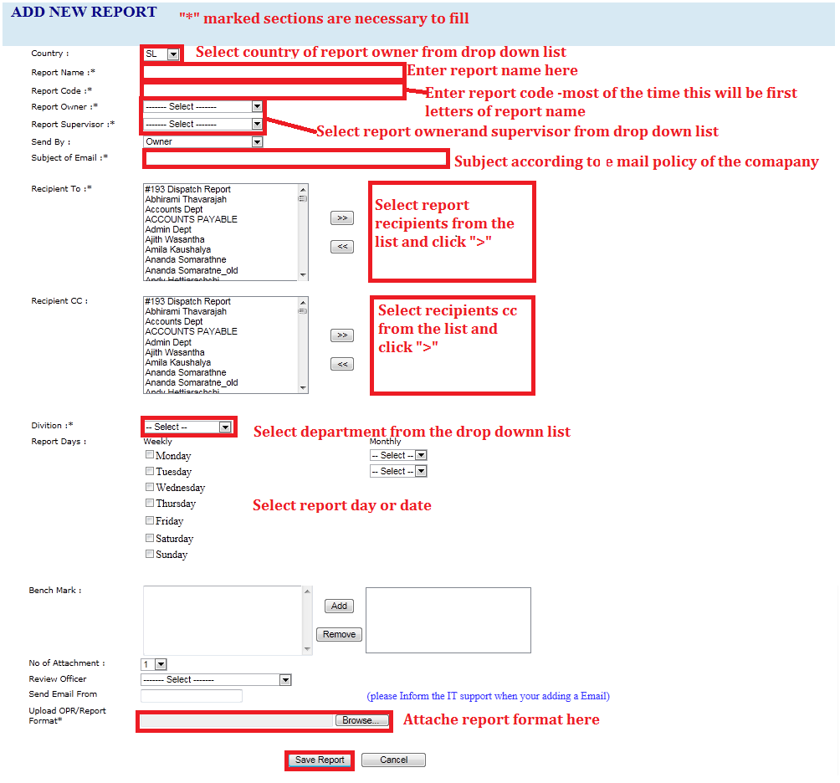

To edit derails of existing report, search for the report using given options.

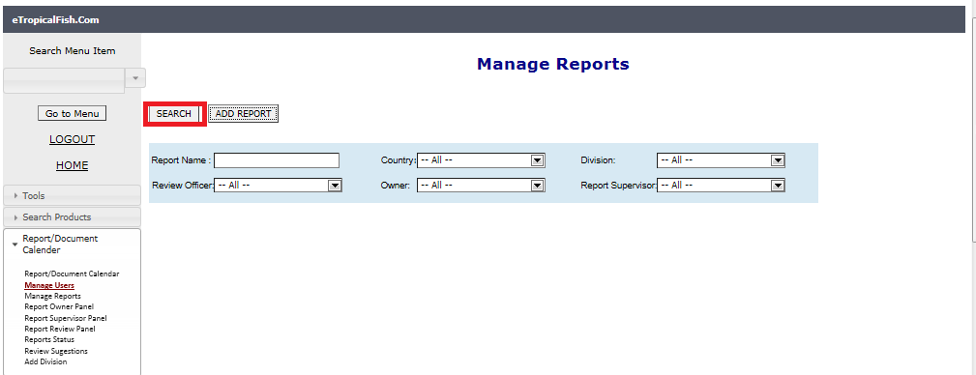

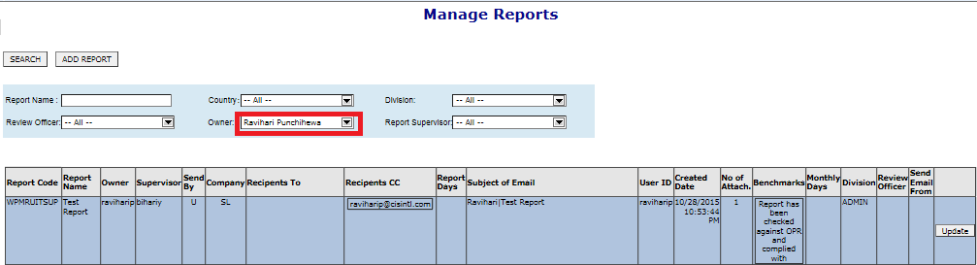

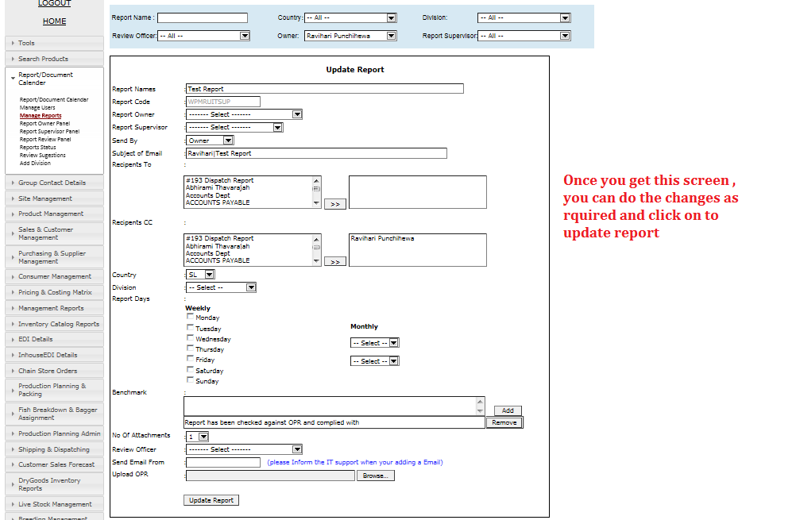

Note : remove the days to deactivate the report or inform IT Dept. to remove the monthly date with approval.

## 1.4 Add Division

System admin can create department using this section

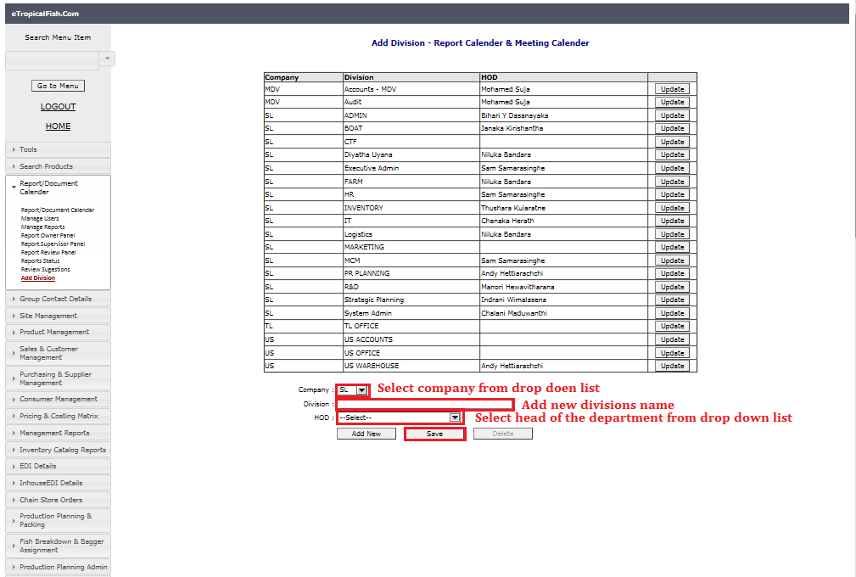

And you can follow same steps after click “update “button to do any changes for existing divisions.

# Meeting Calendar

All schedule weekly and monthly meeting of the company should be listed in this section.

## 2.1 Manage Meetings

System admins can add meetings and edit existing meetings using this section.

To add meetings you can follow below steps as in the screen shot.

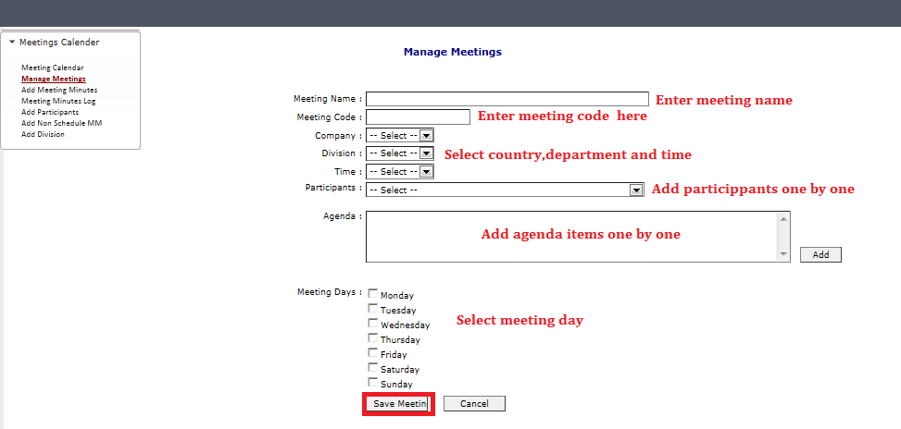

To update existing meetings, select meeting from the list and click “update” button. Meeting details will be appeared in bottom of the page.

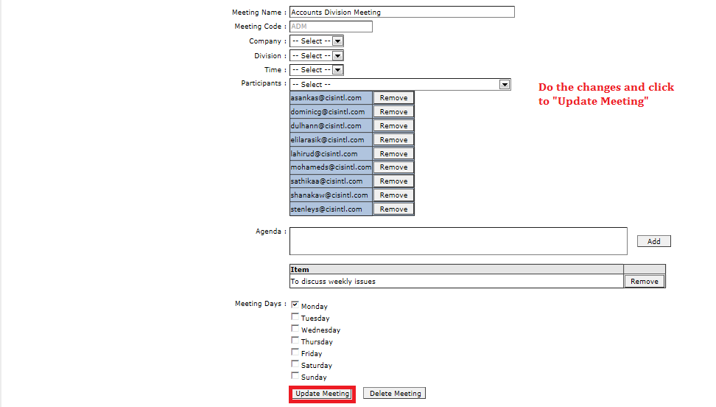

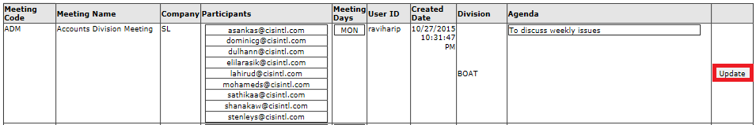

## 2.2 Add Meeting Minutes

After completing the meeting, one of the participants have to upload meeting minutes in to the system. This is not necessary to add by system admins.

To add meeting minutes, you have to “search” for the meeting and “select” the meeting and follow steps as in the screen shots.

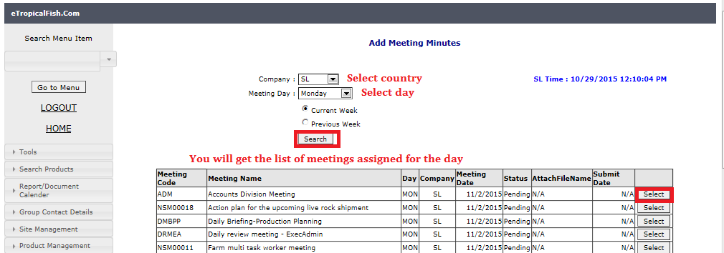

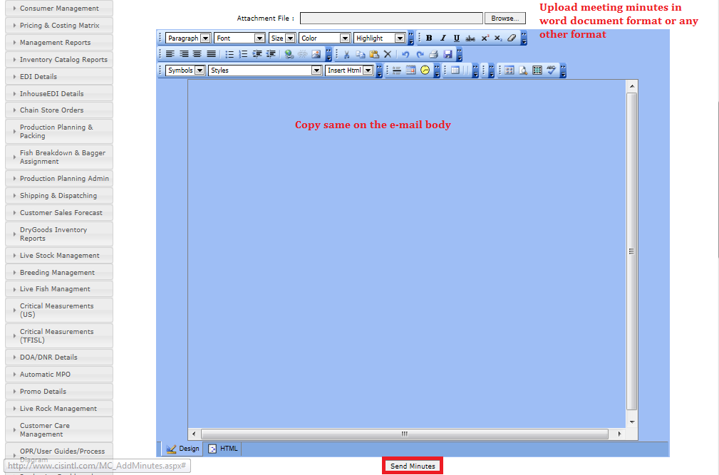

## 2.3 Add Participants

When there is new employee system admin has to add him/her to meeting calendar .This section is common to both Meeting calendar and Training calendar.

You have to add “Name” , “E mail” and select country from the drop down list.



## 2.4 Add Non- Scheduled Meetings

Non-schedule meetings are sudden meetings/ unplanned meetings. You can follow below instructions to add non schedule meeting minutes.

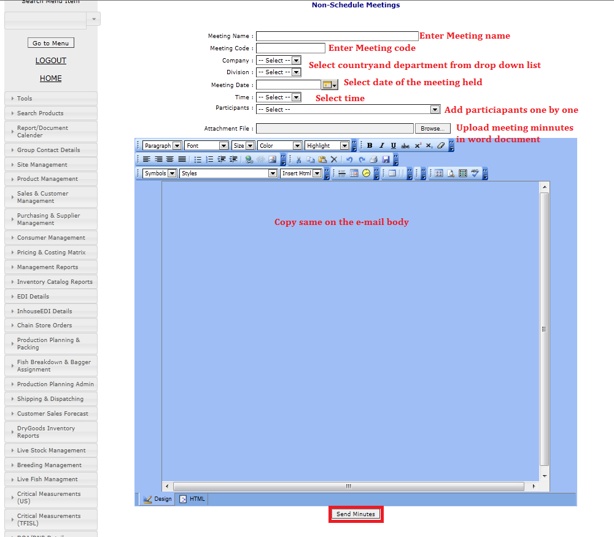

## 2. 5 Add divisions

This section is linked to report calendar Add divisions section

# Training Calendar

All the trainings conducted internally need to record in training calendar.

## 3.1 Add Training

System admin have access to add trainings to training calendar. You can follow steps mentioned in below screen shots.

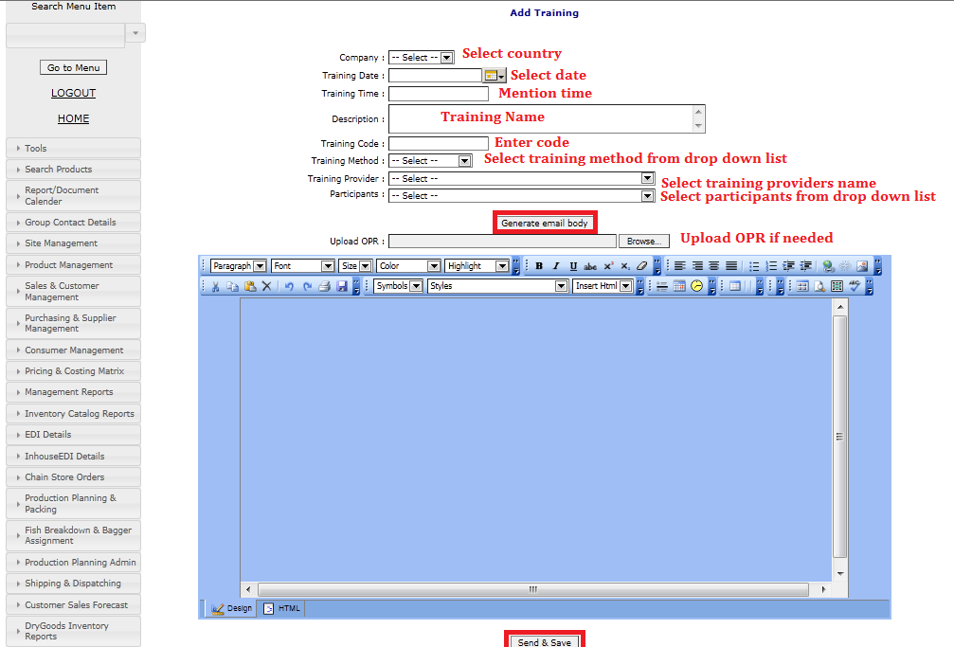

## 3.2 Training log

Once you add trainings to the system, it will appeared in “Training Log” .

You can select country and dates to have summary of trainings which are planned to conduct during the selected time period.

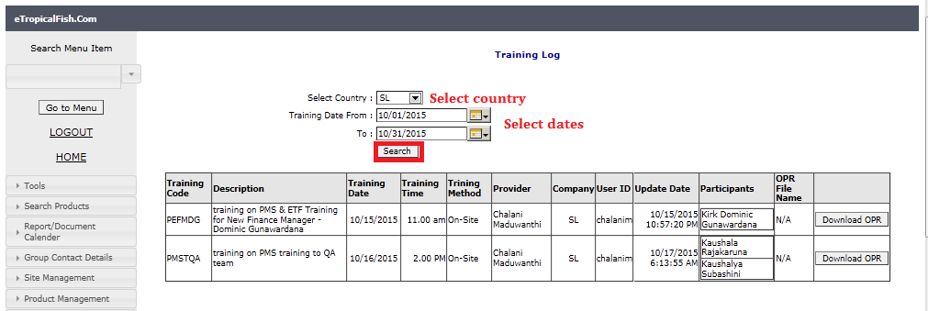

## 3.3 Add participants

This section linked to Meeting Calendar-Add Participants

## Training Calendar

Once you completed with the training, select training from training calendar and click “Complete” button .Training can be completed by training provider or system admins.

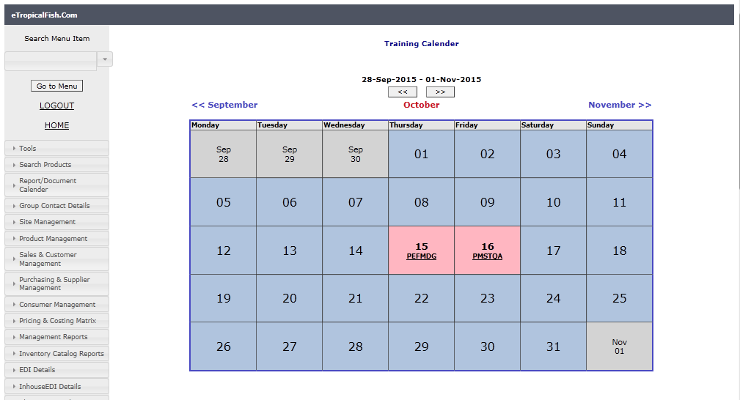

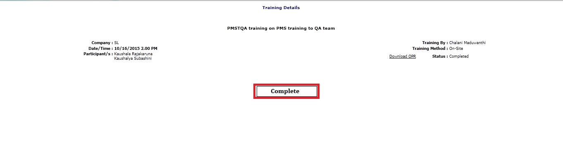

# OPR /User Guides/Process Diagrams

This section includes documented processes of the company which support any staff member to have idea about company processes. Anyone can download uploaded OPRs, User guides and process diagrams. But system admin will responsible for upload these documents in to the system with specific format.

## 4.1 Upload user guides

To upload OPR, user guides, process diagrams you have to fill below details mentioned in the screen shot and select “Upload File”

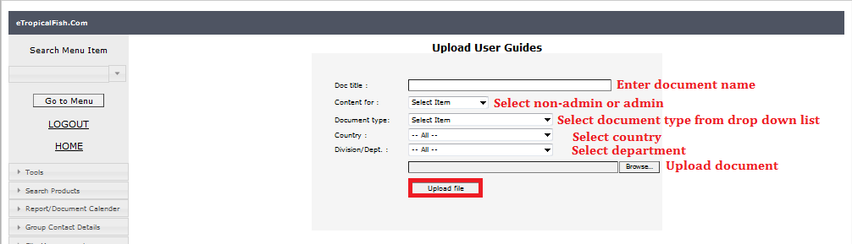

## 4.2 Download user guides

To download or to upload updated OPRs, user guides or process diagrams , you can search for the document, once documents are listed click “ download “ or “ upload” buttons depending on the requirement.

