|  |  |
| --- | --- |
| **SUBJECT** | PMS Tracker / Review meetings |
| **RECORDER (Name Designation)** | Chalani Maduwanthi / Assistant Manager System Admin |
| **APPROVED BY (Name Designation)** |  |
| **CREATED DATE** | 5/11/2016 |
| **NO. OF PAGES INCLUDING THIS PAGE** | 2 |

**OPR for PMS Tracker / Review meetings**

**Project Tracker**

Project Tracker is the tracker where we can summaries all the project by Country / Department / Person. Also this will give several benefits as follows;

1. Summarize projects by project name / project owner / Task owner/ project status … etc.
2. Sort projects by date (oldest to newest) and follow accordingly to the project end date.
3. This will help to monitor and do the follow ups

**Steps to be followed**

**Project wise status and PMS user level view**

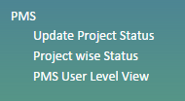

**PMS user level view**

To monitor project individually ( person’s name)

**Project wise status**

Primary responsibility of System Admin is to follow up and conduct PMS review meetings for each department.

Using “Project Wise Status “section system admin can have a report in various categories as below

1. All projects
2. SL projects/US Projects
3. SL department wise projects /US department wise projects
4. Project owner wise report
5. Task owner wise report
6. Projects in specific time period

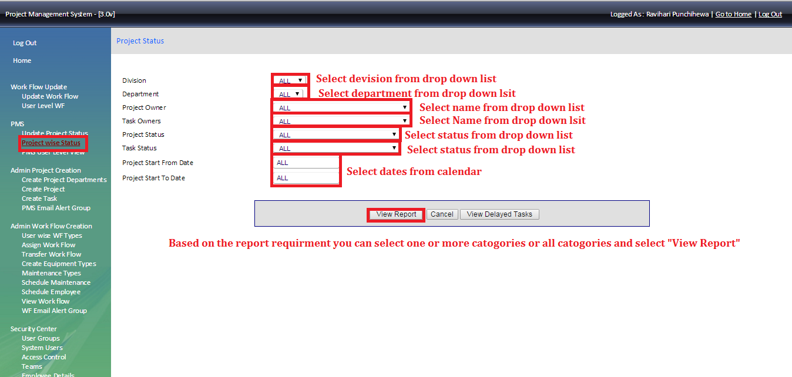

The summary list given by system need to Copy and paste to the Excel sheet and summaries as follows,

The details needed to prepare project tracker

1. Department
2. Project Code
3. Project Name
4. Project owner
5. Task code
6. Task Name
7. Task owners
8. Start Date
9. End Date Project Status

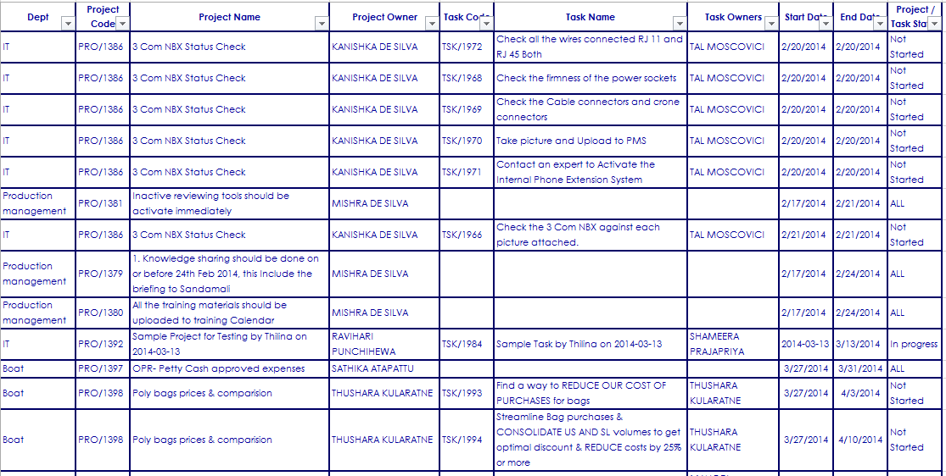

Using Excel tool need to filter and sort end date according to the requirement.