**Tropical Fish Intl Ltd**

**OPR FOR LOGISTIC SHIPMENT CHECK LIST**

|  |  |
| --- | --- |
| **SUBJECT** | **Selection of Agents & Getting Approvals & place the booking confirmation** |
| **DEPARTMENT** | **Logistic Colombo** |
| **RECORDER (Name & Designation)** | **Ranjith Seevaratnam, Priyadhasha, Udaya Perera** |
| **APPROVEDBY (Name & Designation)** | **Udaya Perera** |
| **CREATED DATE** | **11\03\2016** |
| **LAST UPDATED** |  |
| **PATH ON NETWORK FOLDER** | **Z:\Gen Log\OPR** |
| **NO. OF PAGES INCLUDING THIS PAGE** | **1** |

**Selection of Agents & Getting Approvals & place the booking confirmation**

Ensure goods are shipped in line with obligations to the sales contract. Ensure all Import/Export are carried out smoothly by communicating with shipper/consignee/Forwarder. Monitor shipments until reach to destination. Ensure Exports are shipped on time Imports are cleared on time without delays.

Obtain the confirmation from Order Entry for USA & Manchester -UK

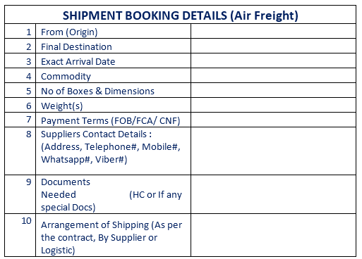

Obtain the confirmation from Order Entry for USA

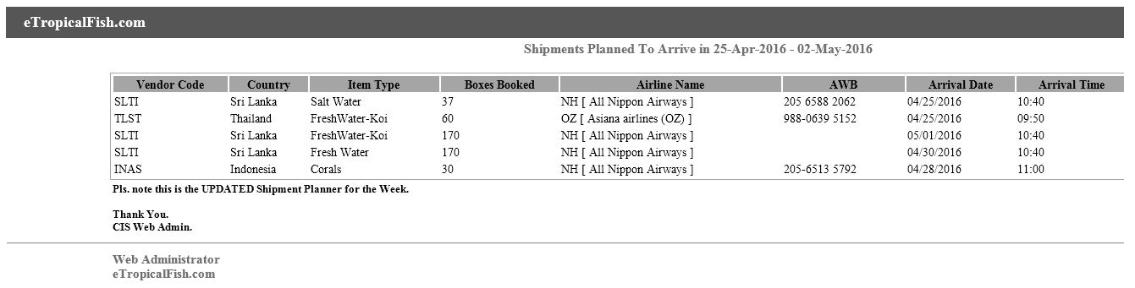

Shipper For UK shipments

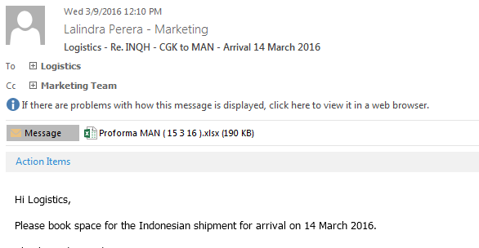

Once we received the shippers details from marketing we will contact shipper for arranging the shipments througha bove email.

Airline confirmation based on the consignees requirements we make the booking.

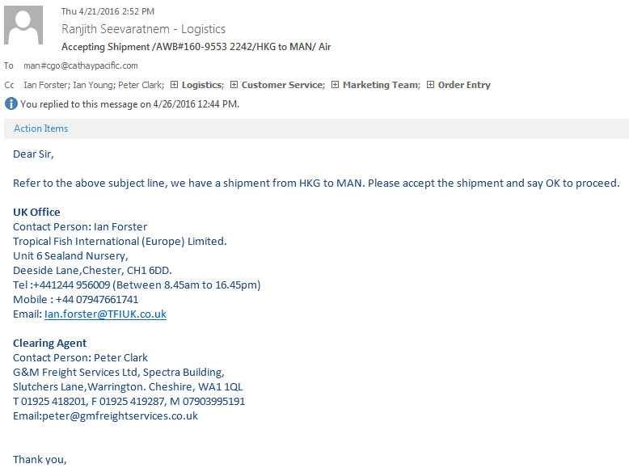

Consignee

Contact consignee and get confirmation on delivary date.

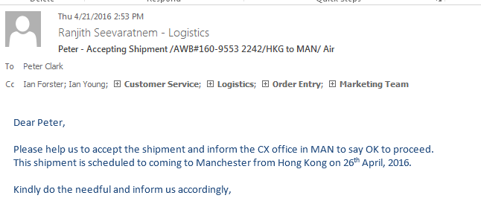

Airline/ Shiping Line confirmation,

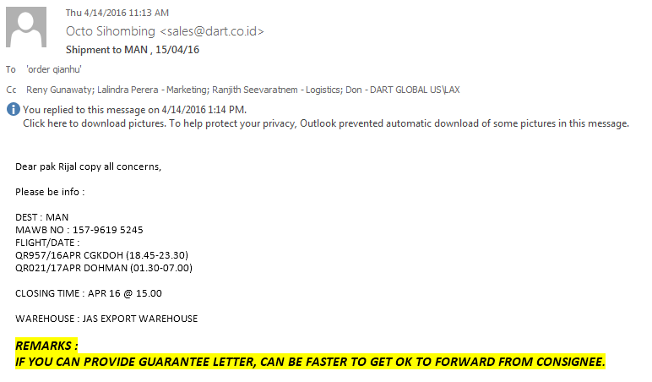

Shipping Confirmation for USA

