**TEKNOWLEDGE SHARED SERVICES-SRI LANKA**

**OPR FOR FARM LABOR PLANNING**

|  |  |
| --- | --- |
| SUBJECT | OPR FOR FARM LABOR PLANNING |
| DEPARTMENT | LABOR PLANNING |
| RECORDER | DILUMI/NILUSHIKA/SANDUNI |
| APPROVED BY | BUDDIKA MADURANGANA |
| CREATED DATE | 03/10/2017 |
| LAST UPDATED |  |
| PATH ON NETWORK FOLDER |  |
| NO. OF PAGES INCLUDING THIS PAGE | 07 |

# Objectives

EFFECTIVELY UTILIZED LABOR AT THE SL FARMS BY FORECASTING THE REQUIRMENT AND ANALYZE THE ACTUAL UTILAIZATION.

# LABOR PLANNING GUIDELINES

**WEEKLY LABOR SCHEDULE-SL FARM**

1. As per the availability and the Farm requirements, weekly labor schedule to be prepared.

Below to be consider,

1. Farm regular activities
2. Outgoing and incoming shipments
3. Labor availability
4. Special requirements
5. OT requirement based on the schedule time
6. Once the coming week schedule prepared, it must be discussed and finalize with Farm Manager.
7. Finalize and send the schedule to Farm on Friday.

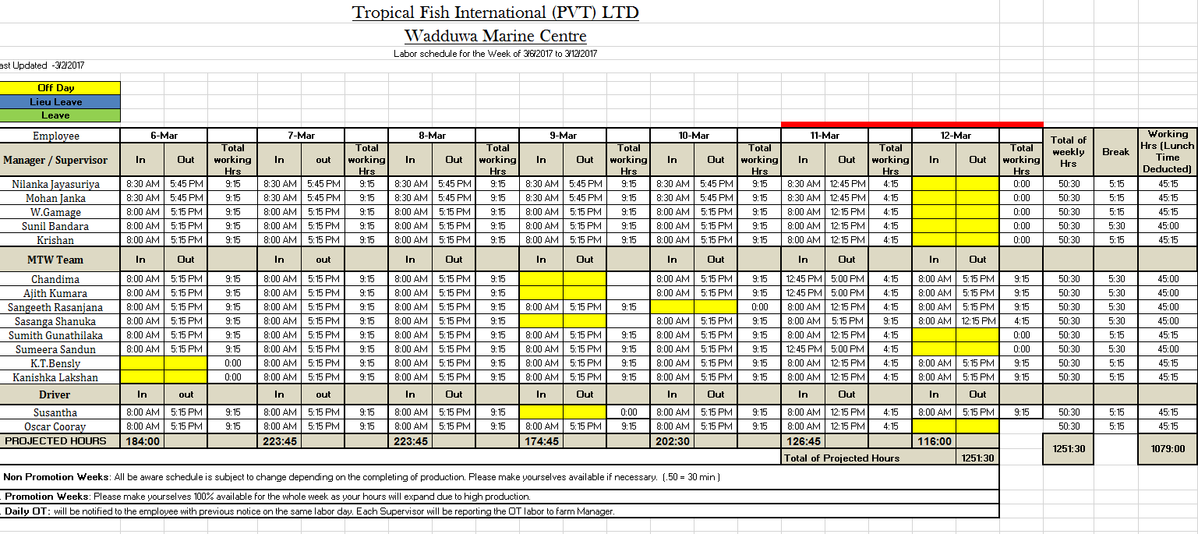

**DAILY MAN-HOUR FORECAST-SL FARM**

Daily man-hour allocation to be prepared and send on the previous day. All the activities to be considered for the day and required man-hours to be calculated.

Daily Man-hour Forecast report

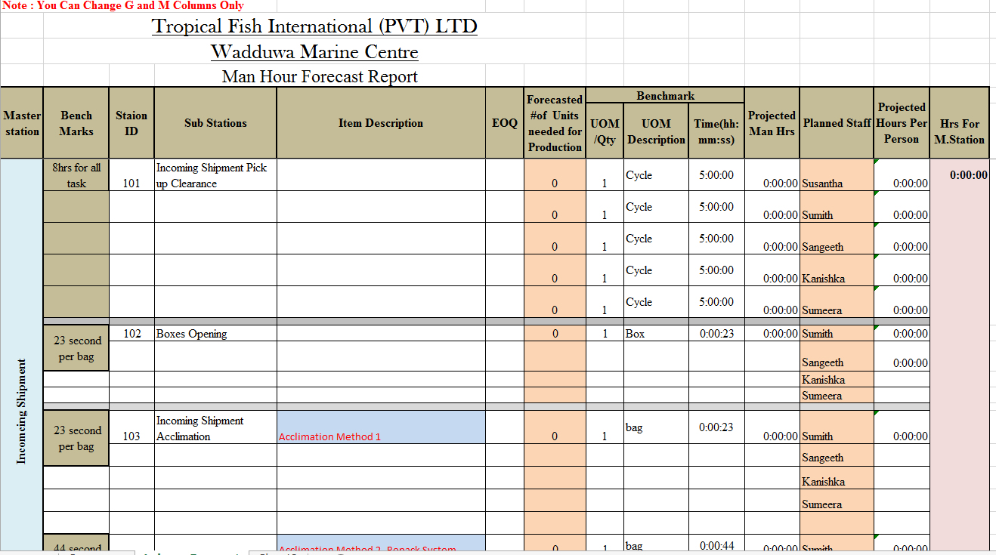

**Daily Man-hour Forecast Summery report**

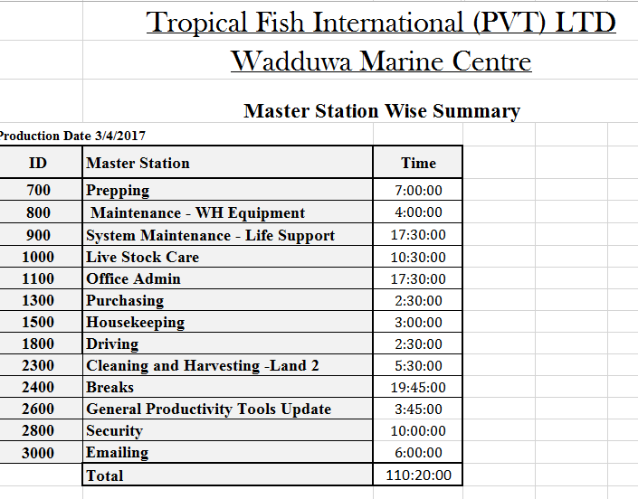

**Productivity Work Sheet-SL FARM**

Pre-defined Productivity sheet to be provided by Labor Management on daily basis. Base on the tasks to be done by the labor, the activity list can be varying from person to person.

Productivity sheet must be filled relevant employee and Farm management has the responsibility to send back (Scan copy) to Labor Management before 10.30AM next day.

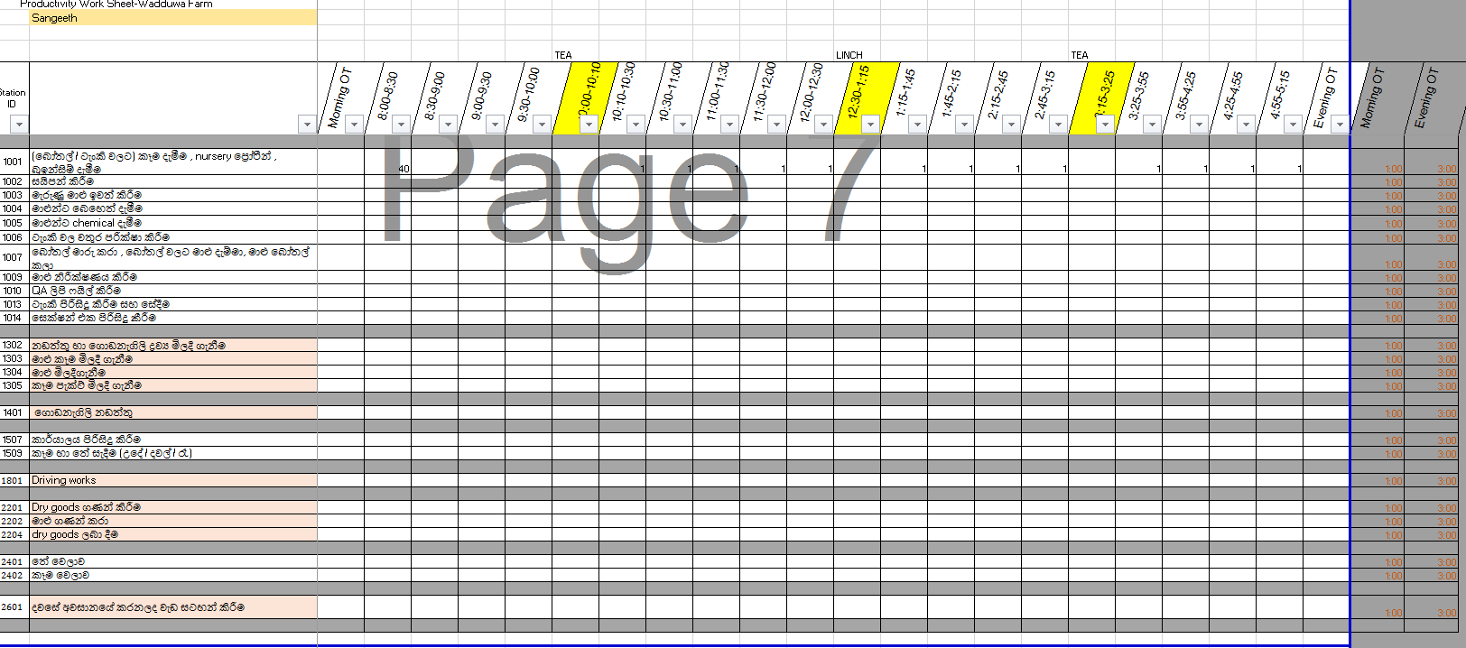

**Productivity Work sheet analysis- SL Farm**

1. Filled Productivity sheets will be analyzed and updated in soft copy.
2. Summery is linked with the individual Productivity sheets and it will be updated once all the PWS are entered.
3. Projection and Actual to be compared and Farm management to be notified for considerable variances.

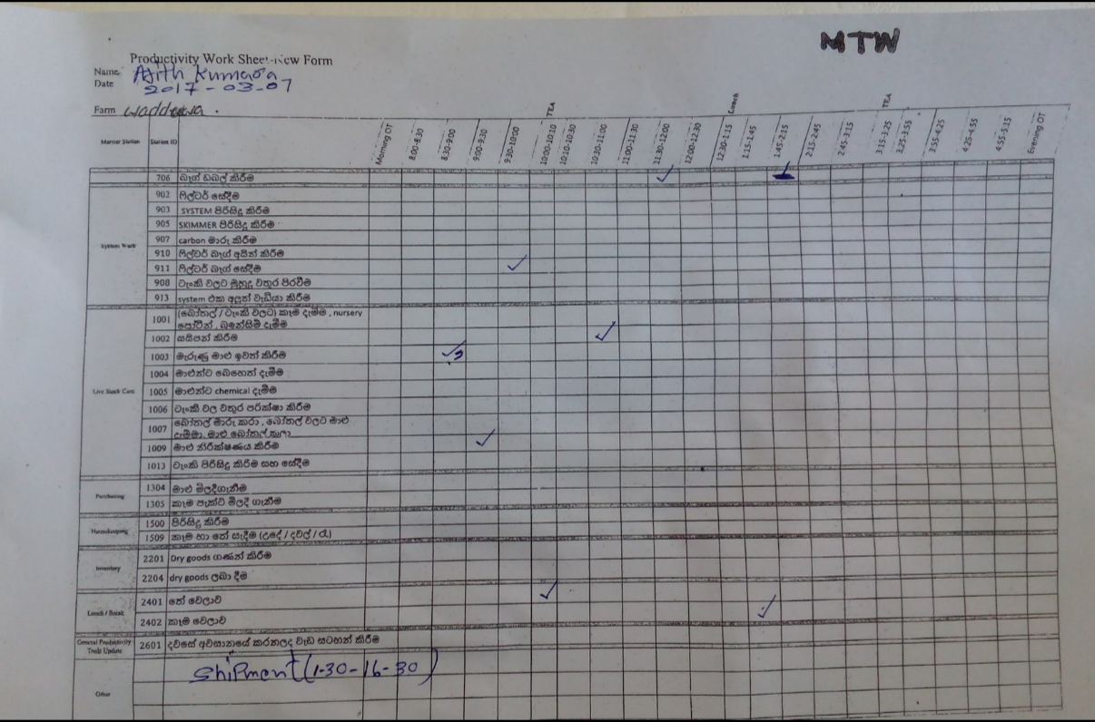

**Productivity Analysis Summery-SL Farm**

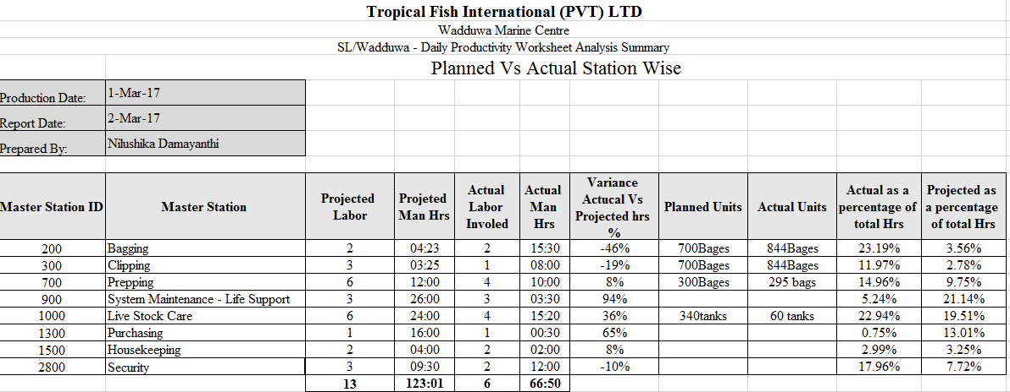

**Productivity Worksheet Error Report-SL Farm**

If the updated PWS is not comply with below, these are counted as Errors and Error report will be prepared base on that.

1. Number of units completed
2. Update total worked duration against the completed task. (no blanks can be available except early depart)
3. Weekly error report for the previous week to be prepared on every Monday based on daily records.

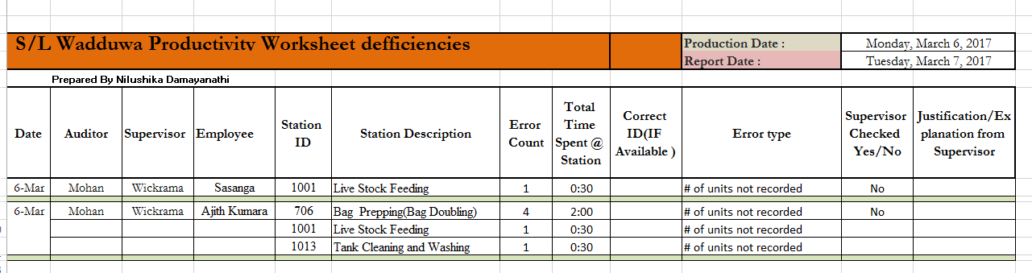

**Productivity Worksheet Received Summery-SL Farm**

1. Get the attendance from the sign out sheet
2. Compare the PWS receiving against each employee
3. Find out the employees who did not provide updated PWS
4. Each employee who did not submit their PWS, Rs 50/= per day will be deducted from their Productivity bonus.

Sign out sheet,

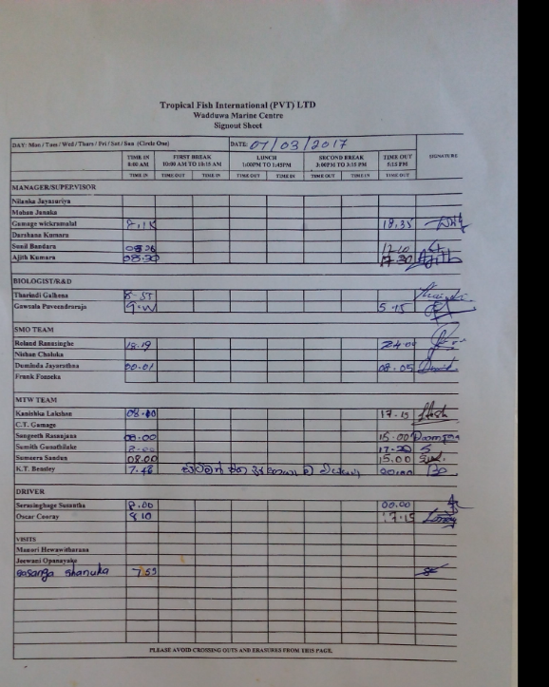

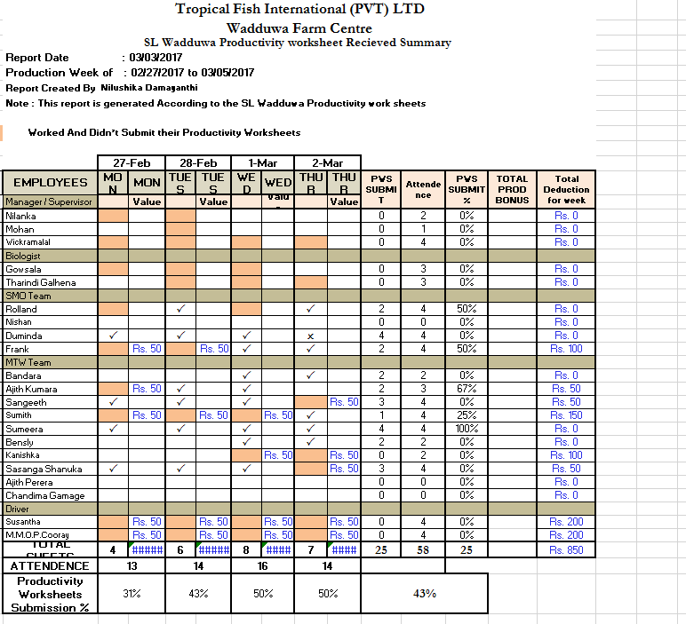

**OT Summary report- SL Farm**

1. Farm Management provide the actual OT utilization details on daily basis.

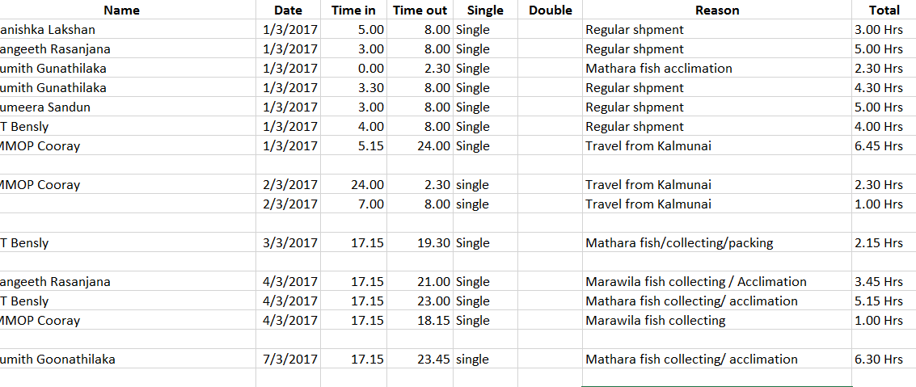

1. Record the daily overtime consumption employee wise by Labor Management

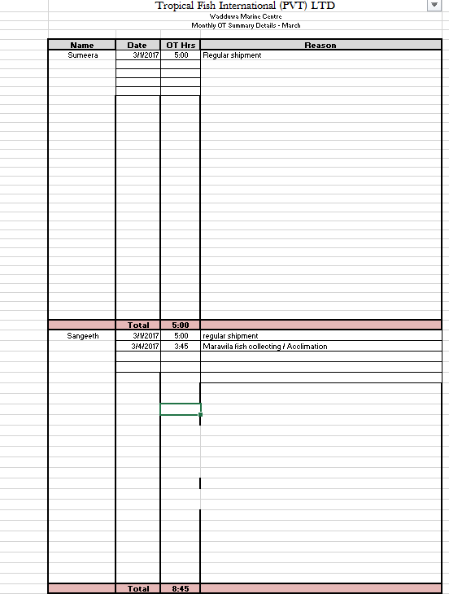

1. 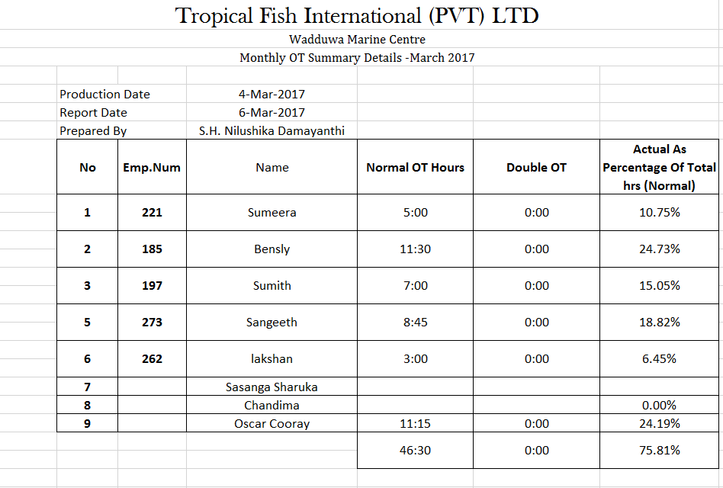Prepare the monthly Overtime utilization and provide to HR at every month end.