**OFFICE PROCESS RECORD**

|  |  |
| --- | --- |
| Subject | How to complete US CIS Daily Labour Hours Forecast Report |
| Department | Labor Management |
| Recorder | Dilan Maduranga |
| Approved by | Suja Wahab |
| Created date | 07/03/2016 |
| Last updated | 24/03/2016 |
| No of pages including in the OPR | 18 |

Note: This OPR for the current Process. Now we are in transition with newly defined Daily Labor Allocation and PWS/MAPs preparation.

The new process OPR is attached at the end of current process.

**LAST UPDATED DATE: 07/03/2016**

**PROCESS:**

**RECORDER: Dilan Maduranga**

**US CIS Daily Labour Hours Forecast Report**

**Introduction**

This OPR was created with a view to grab the required knowledge for any person to carry out the task of preparing Daily Labour Hours Forecast Report following the prevailing process very smoothly and efficient manner. Move over, this OPR gives guidelines when preparing Daily Labor Schedule for the Employees working in the US Warehouse.

**Objectives**

The objectives of the Weekly Labor Schedule is to

1. ensure the smooth operation of US warehouse activities,
2. Use labors in an efficient way that benefit the company and reduce the labor cost
3. Give adequate training and benefits to employees

**Contents**

1. Allocating HRs for Baggers as per benchmark
2. Allocating HRs for Packers as per benchmark
3. Allocating HRs for Clippers as per benchmark
4. Allocating HRs for “Dispatching and Closing” Employee as per benchmark
5. Allocating HRs for QAs as per benchmark
6. Allocating HRs for Labors for Shipment arrivals as per benchmark
7. Allocating HRs for Team Leads as per benchmark
8. Allocating HRs for Labors for Cup prepping and Box Prepping as per benchmark
9. Allocating HRs for labor schedule format as per benchmark

**Process of preparing Daily Labour Hours Forecast Report**

Most importantly, in the beginning of preparing Daily Labour Hours Forecast Report, you are required to collect following supportive documents and need be kept in the spread sheet. It is prudent to keep all supportive documents in one spread sheet using multiple tabs as those are needed to be linked to each other in some occasion.

Supportive documents required to prepare the report

Daily

* Hourly Bagging distribution Report – Sent by Prod. planning
* Summary Report – sent by Prod. Planning
* Daily fish Breakdown Report – sent prod. planning
* Weekly Labour Forecast report – prepared by CIS Labour planning person.
* Prepping tracker – sent by prod. Planning which is useful only on Friday and Saturday
* Betta Inventory tracker – Sent by US warehouse on Thursday which is useful only on Saturday for Betta re-bagging and sealing.
* Shipment planner – generated by system every day.
* Weekly project and maintenance Labour schedule – sent by US warehouse on Thursday.
* Weekly Employee Availability Schedule

Weekly

* Prepping tracker – sent by prod. Planning which is useful only on Friday and Saturday
* Betta Inventory tracker – Sent by US warehouse on Thursday which is useful only on Saturday for Betta re-bagging and sealing.
* Prepping tracker (remaining quantity at the end of the prepping)– Sent by US warehouse on each Saturday.

**Steps of Data entering / Allocating Labour Hrs. for employees in US WH pertaining to benchmark**

**Step** 1: Every station should be set up allocating Labour as per daily production plan sent by Production Planning Dept. and skill chart.

Figure 1.1

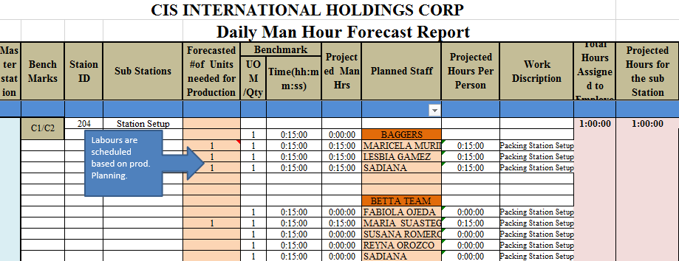

**Step 2**: Setting up time for each substation following the benchmark that is calculated according to the number of units projected in Prod. Plan for the respective day.

Total of bags Column< Fish breakdown < Prod. Plan

**a).** allocating Hrs for bagging and counting saltwater/ freshwater.

Figure 2.1

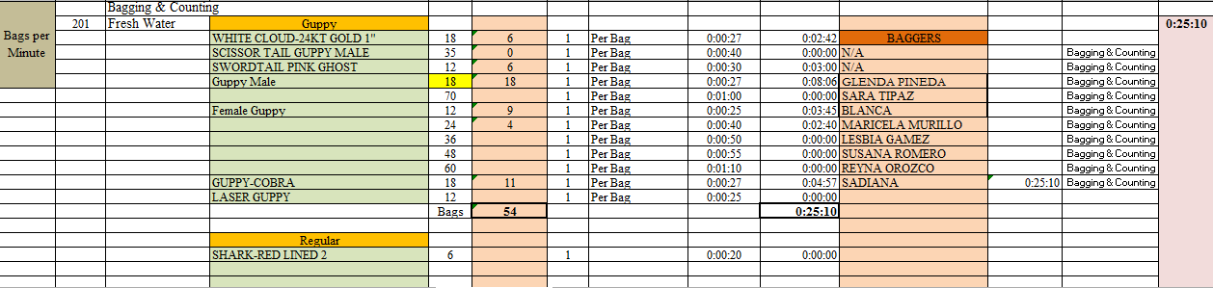

Total of bags Column< Fish breakdown < Prod. Plan

**b)** Allocating Hrs for betta counting.

Figure 2.2

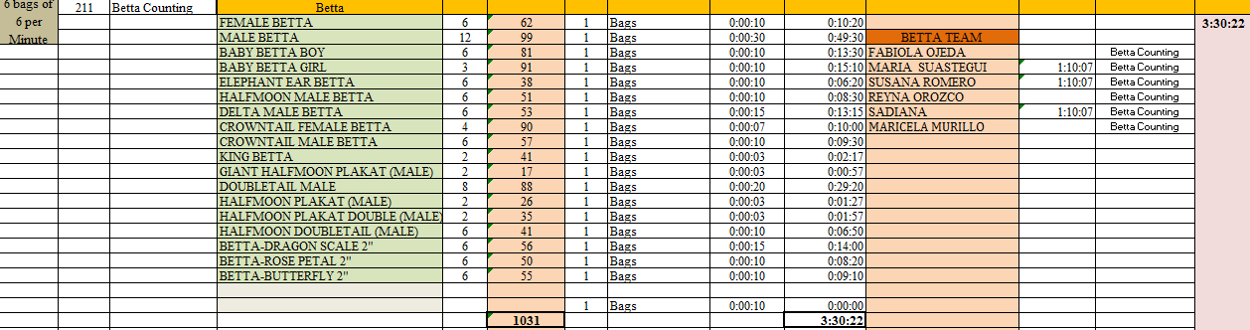

**c)** Opening leftover bags: **Production and Labour tracker > Labour input > station ID 205**

**d)** Betta sorting: having entered data as shown in figure 2.2, total no of fish can be entered for betta sorting.

**e)** Betta washing is done as follows. In order to identify the betta quantity to be washed livestock inventory list sent by US WH every day is used.

Monday 10%

Tuesday 15%

Wednesday 25 %

Thursday 30%

Saturday entire remaining quantity.

**f)** Betta sealing and re-bagging are usually done only on Saturday. Betta inventory list sent by Fabiola on each Thursday is taken into consideration when allocating Hrs as per benchmark.

Quantity/ No of bags can be taken from fresh/salt water bagging and counting station or fish breakdown

**g)** Allocating Hrs. for clipping.

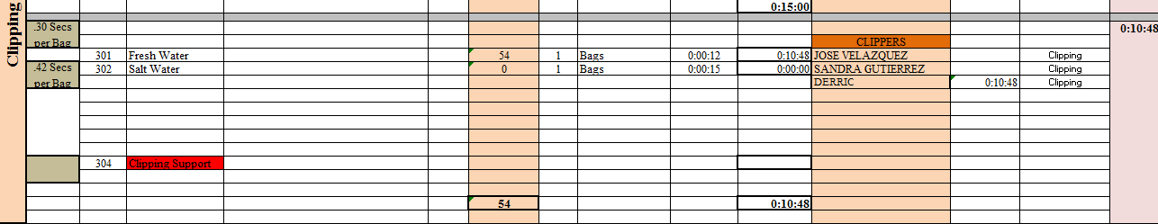

Remarks: 1. Clipping is done only for Fresh water and salt water.

2. 15 minutes given for station set up for each employee.

3. Whenever freshwater/salt water bagging is done, Clipper’s presence is mandatory.

As per summery report in the Prod. Planning details are taken.

h) Allocating Hrs. for packing.

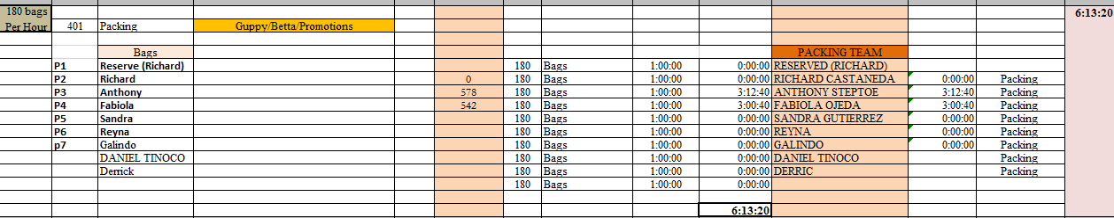

Remarks:

1. Supervisors can only be scheduled for maximum 8 hrs.
2. If any unexpected changes occur, due to changes in schedules, lack of Fish or Shipment Delay etc. - the Management reserves the right, to make changes to the Daily schedule.
3. Dispatching/ Closing/ Loading: information should be taken form summery in prod. Planning report.

Special Note: when allocating hrs. for closing and dispatching on Monday, pls make sure to get both Sunday’s and Monday’s boxes into account. (Those details can be taken form summery sent by Prod. Dept. on Monday and Sunday)

J) Labour Hrs. allocation for cups prepping/boxes prepping

Details for cups prepping and boxes prepping are taken form Projected Weekly Dry Good Prep Assignment Report sent by prod. Planning dept.

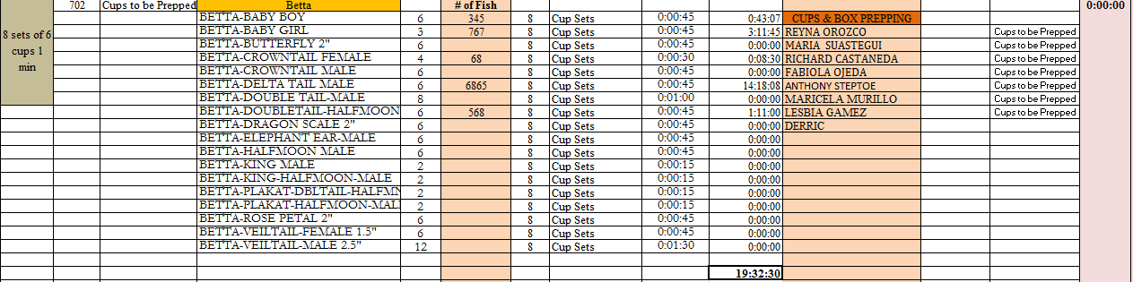

1. **Hrs. allocation for Prepping Heat pack/Ice pack**

|  |  |
| --- | --- |
| Ice/Heat pack | Time |
| 260 PCs | 60 Mins |

**Calculation =** Bench mark * Number of Ice/Heat packs

Benchmark =

**J) Live Stock Care**

**Activity 1**: Live Stock Feeding

**Calculation =** Bench mark * Number of systems

|  |  |
| --- | --- |
| **System** | **Time (Minute)** |
| 1 | 10 min |

**Bench Mark** =

**Activity 2** : Live Stock Siphoning

**Calculation =** Bench mark * Number of systems

|  |  |
| --- | --- |
| **System** | **Time (Minute)** |
| 1 | 15 min |

**Bench Mark** =

**Activity 3** : Live Stock Dead Removal

**Calculation =** Bench mark * Number of systems

**Bench Mark** =

|  |  |
| --- | --- |
| **System** | **Time (Minute)** |
| 1 | 10 min |

**Activity 4** : Live Stock Medication

**Calculation =** Bench mark * Number of systems

|  |  |
| --- | --- |
| **System** | **Time (Minute)** |
| 1 | 10 min |

Bench Mark =

**Activity 5** : Live Stock Chemical Addition

**Calculation =** Bench mark * Number of systems

|  |  |
| --- | --- |
| **System** | **Time (Minute)** |
| 1 | 10 min |

Bench Mark =

**Activity 6** : Live Stock Water Testing

**Calculation =** Bench mark * Number of systems

|  |  |
| --- | --- |
| **System** | **Time (Minute)** |
| 1 | 10 min |

Bench Mark =

**Activity 7** : Live Stock Transfer

**Calculation =** Bench mark * Number of systems

|  |  |
| --- | --- |
| **System** | **Time (Minute)** |
| 1 | 10 min |

Bench Mark =

**Activity 8** : Live Stock - Hospital system

**Calculation =** Bench mark * Number of systems

|  |  |
| --- | --- |
| **System** | **Time (Minute)** |
| 1 | 15 min |

Bench Mark =

**Activity 9** : Live Stock Observation

**Calculation =** Bench mark * Number of systems

|  |  |
| --- | --- |
| **System** | **Time (Minute)** |
| 1 | 10 min |

Bench Mark

**K) Labor Hrs. Allocation for System Maintenance – life Support**

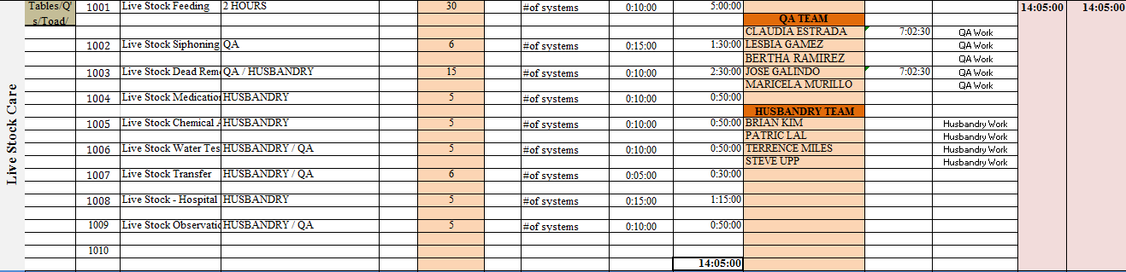

**Table Prepping**

**Calculation =** Bench mark * Number of tables

|  |  |
| --- | --- |
| **tables** | **Time (Minute)** |
| 1 | 45 min |

Bench Mark

**Filter Washing-including filter**

Calculation  **=** Bench mark * Number of filters

|  |  |
| --- | --- |
| **Filter** | **Time (Minute)** |
| 1 | 15 min |

Bench Mark =

**System Clean up - Scheduled**

Calculation  **=** Bench mark * Number of systems

|  |  |
| --- | --- |
| **System** | **Time (Minute)** |
| 1 | 45 min |

Bench Mark =

**System Clean up - Not Scheduled**

Calculation  **=** Bench mark * Number of system

|  |  |
| --- | --- |
| **System** | **Time (Minute)** |
| 1 | 45 min |

Bench Mark

=

**Skimmer Clean Up**

Calculation  **=** Bench mark * No of Skimmers

|  |  |
| --- | --- |
| **Skimmer** | **Time (Minute)** |
| 1 | 60 min |

Bench Mark =

**System - Critical Measurements**

**Calculation =** Bench mark * Number of systems

|  |  |
| --- | --- |
| **System** | **Time (Minute)** |
| 1 | 10 min |

Bench Mark =

**Live Stock - Hospital system**

**Calculation =** Bench mark * Number of systems

|  |  |
| --- | --- |
| **System** | **Time (Minute)** |
| 1 | 15 min |

Bench Mark =

**Live Stock Observation**

**Calculation =** Bench mark * Number of systems

|  |  |
| --- | --- |
| **System** | **Time (Minute)** |
| 1 | 15 min |

Bench Mark =

**L ) Labour Hrs allocation for other sub-stations**

1**. Construction**: External Employees are assigned, should be allocated 8 hours for each employee when forecasting.

1. **Housekeeping**: Assign 1 hour for one employee daily and rotate them. Make sure not to give 2 days for same employee within the week.
2. **Miscellaneous:** Assign fixed 2 and half hours on Weekdays from Mon to Thursday and 30 minutes on each Friday, Saturday and Sunday.
3. **Driving:** Employee and Dry goods Pickups, Drop offs and Transfer. Benchmark is based on the Distance and Cycles of the trip.
4. **Training and Development:** Plan According to the Training Calendar, benchmark are created according to the training type/no of participants.

Eg: Training on Productivity Worksheets Completion -10 minutes per trainee

1. **Away from Work Station:** Forecasted When Company emergencies or no Production due to live Stock issues etc.
2. **Research and Development:** Forecasted according to the research type and the required hrs. From Employee.
3. **Inventory :**Assign 1 hour per Employee on Wednesday for count available live stock
4. **Storage/Put away :** Forecasted According to the Stock we are going to store and the required details from US warehouse
5. **Maintenance - WH Equipment:** Currently External Labor Assigned so normally Added 8 hrs. daily for Maintenance

**General Productivity Tools Update**

**Calculation =** Bench mark * Number of employees

|  |  |
| --- | --- |
| **System** | **Time (Minute)** |
| 1 | 15 min |

**Bench Mark** =

**Labour Hrs allocation for Incoming Shipment**

Incoming Shipments – Check Shipment Arrival time and the Number of Boxes/Bags –Shipment Planner

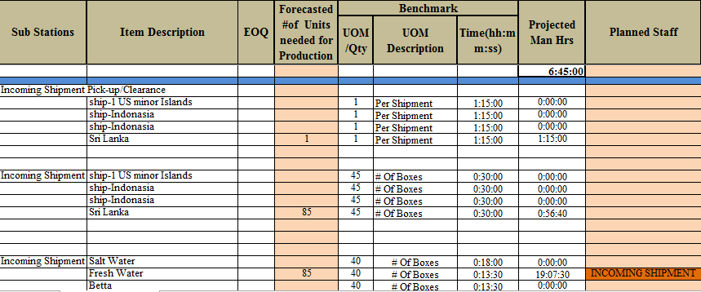

Following the shipment planner no of Shipments, No of boxes should be entered.

**Benchmark Calculation for Incoming shipment,**

|  |  |  |
| --- | --- | --- |
|  | | |
| **Item** | **No of Boxes** | **Time (Min)** |
| Salt Water | 40 | 18 |
| Fresh Water | 40 | 13:30 |
| Betta | 40 | 10 |
| Plants | 10 | 10 |

**Extract of Incoiming shipment Planner ,**

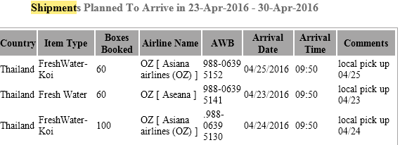

**Office Admin**

Office – Emailing

**Calculation =** Bench mark * Number of Admins

|  |  |
| --- | --- |
| **Admin** | **Time (Minute)** |
| 1 | 60 min |

Bench Mark =

Office - Document File

**Calculation =** Bench mark * Number of Admins

|  |  |
| --- | --- |
| **Admin** | **Time (Minute)** |
| 1 | 45 min |

Bench Mark =

Office - W/F Updates

**Calculation =** Bench mark * Number of Admins

|  |  |
| --- | --- |
| **Admin** | **Time (Minute)** |
| 1 | 60 min |

Bench Mark =

Office - PMS Updates

**Calculation =** Bench mark * Number of Admins

|  |  |
| --- | --- |
| **Admin** | **Time (Minute)** |
| 1 | 30 min |

Bench Mark =

Office Dry Goods Receiving

**Calculation =** Bench mark * Number of Admins

|  |  |
| --- | --- |
| **Admin** | **Time (Minute)** |
| 1 | 90 min |

Bench Mark

Office Admin Tasks

**Calculation =** Bench mark * Number of Admins

|  |  |
| --- | --- |
| **Admin** | **Time (Minute)** |
| 1 | 90 min |

Bench Mark =

New Process

**TEKNOWLEDGE SHARED SERVICES-SRI LANKA**

**OPR DAILY LABOR ALLOCATION-US WAREHOUSE**

|  |  |
| --- | --- |
| SUBJECT | OPR DAILY LABOR ALLOCATION-US WAREHOUSE |
| DEPARTMENT | PRODUCTION & LABOR PLANNING |
| RECORDER | BUDDIKA MADURANGANA |
| APPROVED BY |  |
| CREATED DATE | 02/20/2017 |
| LAST UPDATED |  |
| PATH ON NETWORK FOLDER |  |
| NO. OF PAGES INCLUDING THIS PAGE | 6 |

Required documents

Weekly Labor Schedule

Prepping tracker

Daily Production Plan

Shipment Planner

Maintenance plan

Betta Inventory

Frag Production Plan

Discussion point in daily planning Meeting

Note: Only need to fill the Green Colored Cells.

1. How to allocate people
2. Select and assign the labor under each category as per the above-mentioned documents.

Note: depend on the daily requirements, pre-assigned task may need to change.

1. All the labor required sections are available on Main page and this will allow to assign labor without error.
2. For the Packing, Bagging and Clipping, need to assign the in time along with the name.
3. Production date is mandatory to update.
4. Petco.com Packing assignment to be done under Packing, Packer#10.

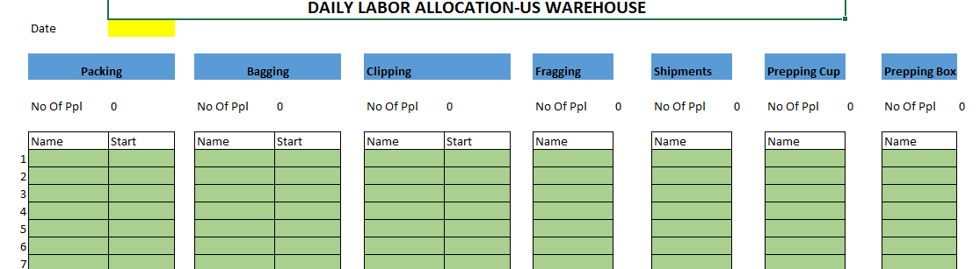

1. How to assign individual tasks

Packing

1. All assigned Packer names will be available on Packing page
2. Need to update individual bag, PO and Box assignment for each packer (Source Doc-Daily Production Plan)
3. Petco.com to be assigned under #10.

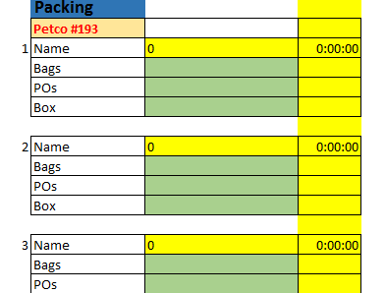

Bagging/Bagging related and Clipping

1. All assigned bagger names will be available on bagging sheet.
2. Need to assign the item Name, EOQ & Number of bags of each individual. (Source Doc-Daily Production Plan)
3. Need to select the fish category (item type) and sheet will calculate the correct bench mark. This must be selected for the first item of each category. If the bagger is assigned with betta and Fresh water, first item of the set of betta must be selected as Betta and then the first item of Fresh water has to be selected as FW.

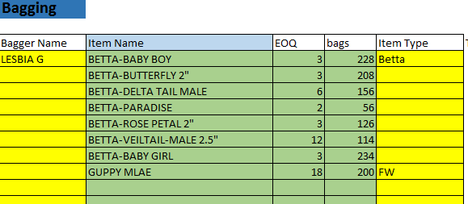

1. Bag distribution, Bagging support, Label printing labor allocations are required to do on this. Related man hours based on bench marks are available.
2. Betta Processing (Opening, Re-bagging, Sealing, Bag as per EOQ) to be planned depend on the daily requirement (Source Doc-Betta inventory)
3. Clipping- Required hours will be calculated by the sheet and need to assign Labor accordingly.

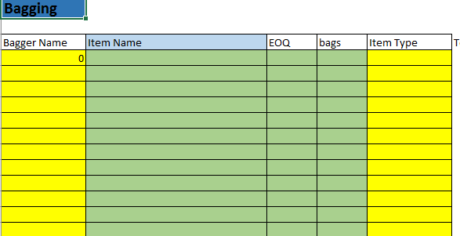

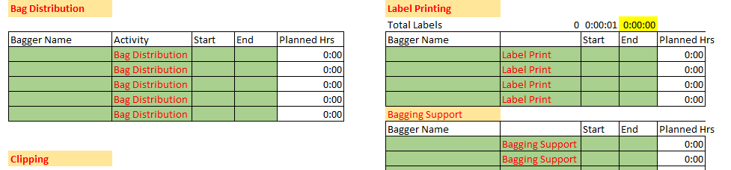

Fragging & Plants

1. Number of Colonies to Frag, Number of Frags to pull out and any weekly dipping quantities to be updated (Source Doc-Weekly Frag Production Summery)
2. Required hours will be calculated by the sheet and need to allocate people as that.

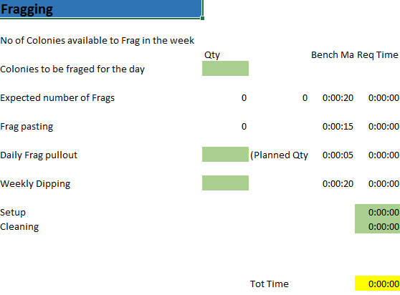

1. If Plant Prepping is planned, quantities to be assigned as per the verities
2. As per the labor requirement calculated by the sheet, Labor to be assigned with in and Out time.

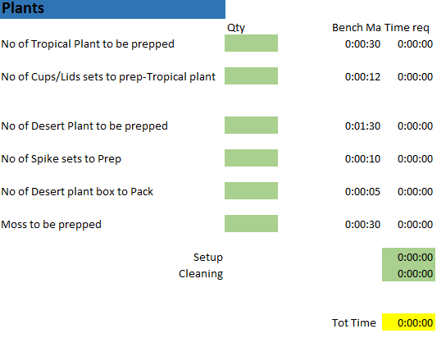

Shipments

1. All the required details in the green colored cells to be provided from Shipment planner.
2. Shipment Matrix is also available to calculate the Labor for each shipment.
3. Driver/Acclimator persons are to be assigned as per the required times and shipment arrivals. (Source document- Shipment planner)

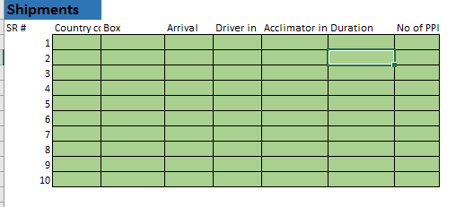

Prepping

1. Prepping requirement for the day to be updated in the sheet and it will calculate the required labor.
2. People to be assigned as that (Source Doc-Prepping Tracker)

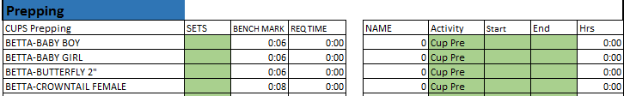

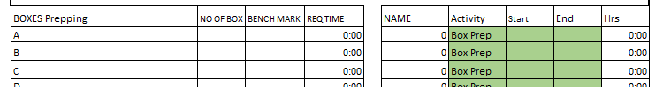

Other Activities

1. People to be allocated for below tasks as per weekly Labor schedule.
2. QA and Husbandry
3. Whole Sale
4. Construction
5. House Keeping
6. Closing and Dispatching
7. Other Task

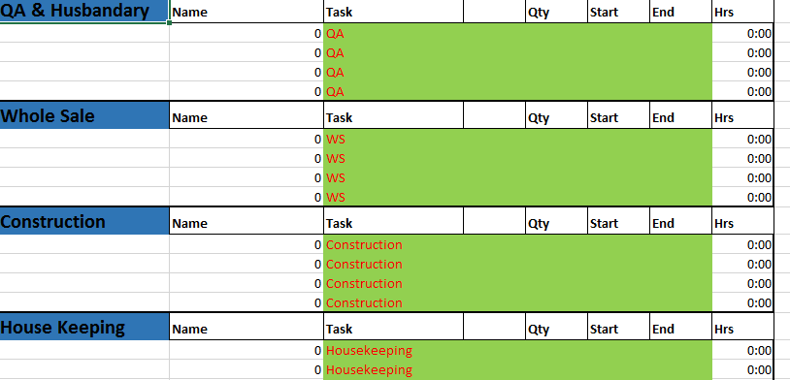

1. Summaries the labor assignment
2. Once all the labor requirement is updated, go to Calculate page and click on the Format tab.
3. This will summarize the labor assignment and provide a list of employees with their activities.
4. Filter the data range remove the zeros from Name & Item/Activity/PO column to get actual data.
5. Copy the data to daily summery page.
6. Productivity Work Sheets cum Work Allocation Map

Now the all productivity Work sheets/Station Maps are updated for everyone with all assigned activities on PWS Update sheet.

Check for any error and if the data are accurate, copy entire sheet and paste data only to remove formulas.

Check the sequence of activities and correct the sequence if required.

Remove the blank rows.

Update the work location of individual as per the work assignment and export the PWS to PDF format.

Print the PWS on US machine