**Tropical Fish Intl Ltd**

**OPR FOR LOGISTIC SHIPMENT CHECK LIST**

|  |  |
| --- | --- |
| **SUBJECT** | **Follow-up with Broker/Agent to assist in shipment clearance** |
| **DEPARTMENT** | **Logistic Colombo** |
| **RECORDER (Name & Designation)** | **Ranjith Seevaratnam, Priyadhasha, Udaya Perera** |
| **APPROVEDBY (Name & Designation)** | **Udaya Perera** |
| **CREATED DATE** | **28/04/2016** |
| **LAST UPDATED** |  |
| **PATH ON NETWORK FOLDER** | **Z:\Gen Log\OPR** |
| **NO. OF PAGES INCLUDING THIS PAGE** | 3 |

**Follow-up with Broker/Agent to assist in shipment clearance**

Follow-up with Broker/Agent to assist in shipment clearance

**For USA shipements – Air Freight to LA**

**Broker – Air Freight**

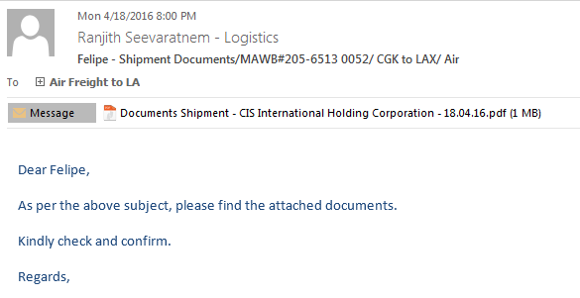

**Confirmation**

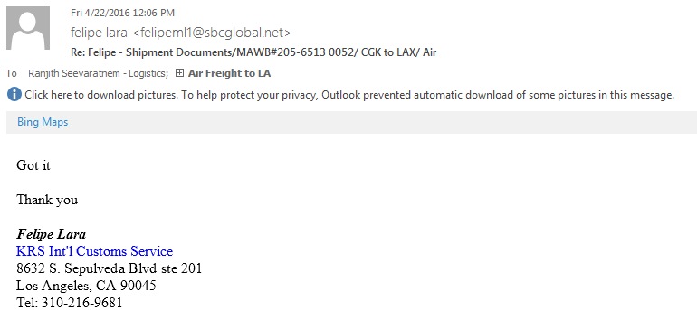

**Broker – Sea Freight – Broker Sea Freight**

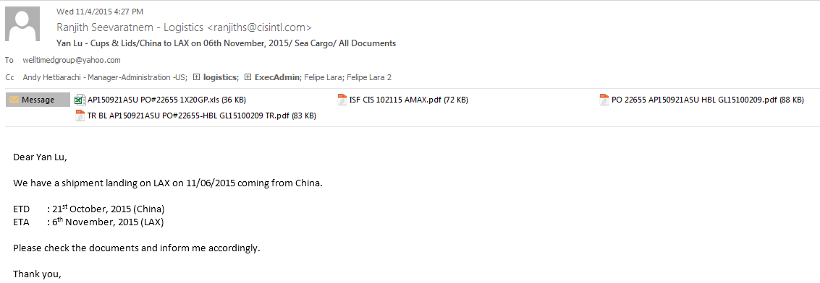

**Confirmation**

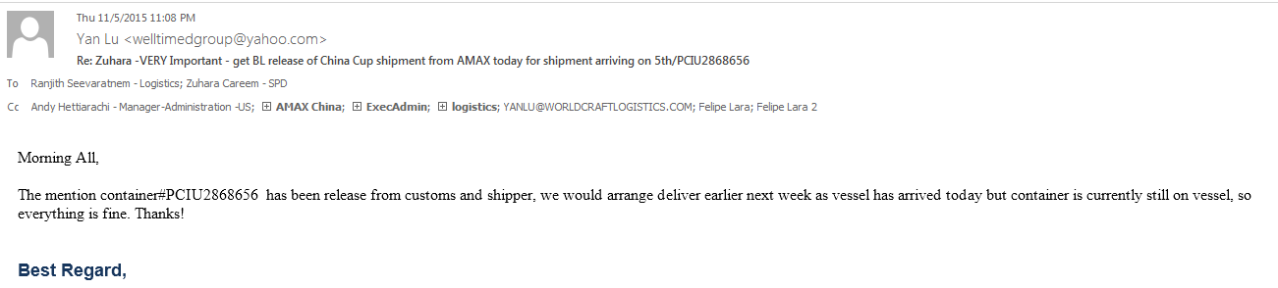

**For UK shipements – Through email – UK shipment**

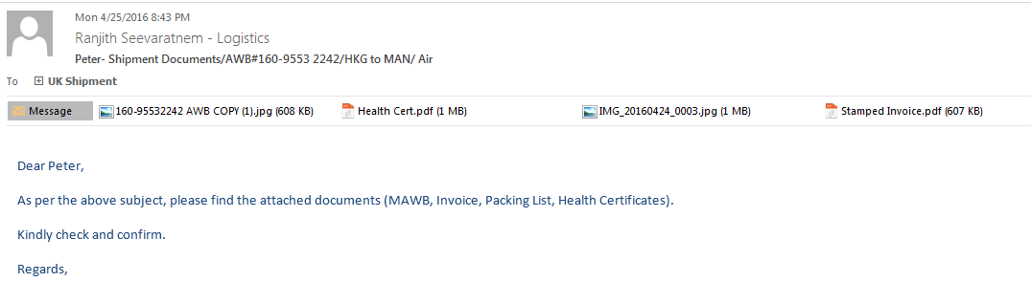

Confirmation

