

**CIS International (Pvt) Ltd**

# 27 / 6A ,

Park Lane,

Rajagiriya.

Sri Lanka.

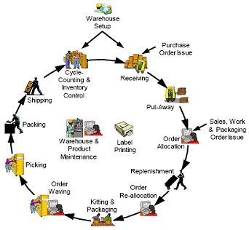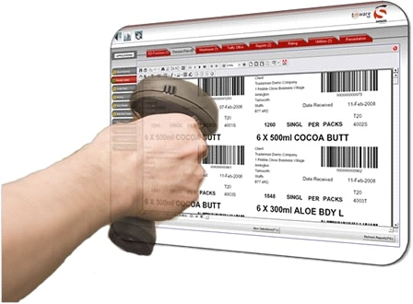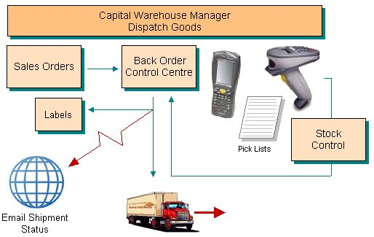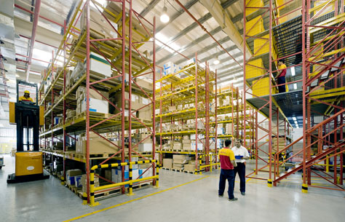

WIMS – Warehouse Inventory Management System

**PROJECT PROPOSAL FOR DEVELOP& INSTALLATION OF**

**To :**

**Mr. RsikaWickremesinghe**

IMPRA USA LLC

12440 Firestone Blvd Suite 309

Norwalk, CA 90650 USA



CIS International (Pvt) Ltd

# 27 / 6A ,

Park Lane,

Rajagiriya.

Sri Lanka.

22/09/2011

Dear Sir,

#### PROPOSAL FOR DEVELOP& INSTALLATION OF WAREHOUSE INVENTORY MANAGEMENT SYSTEM– IMPRA TEA : USA

We are pleased to submit our proposal for the above for your kind perusal. Service has been and will be our utmost priority and keeping with that business philosophy in practice, we at **CIS International (Pvt) Ltd.**, provides its customers with excellent services & support to their entire satisfaction.

We are system integrators in information and communications technology (ICT) based solutions. We bring advanced cutting edge technology to the market using the best tools and Methodologies available in the industry. The company’s commitment to quality, efficiency, security, ease of use, speed of deployment and low cost of ownership is backed by its reliable comprehensive warranties and technical support / services.

In the event of confirmation of our offer, our organization with all required resources and technical expertise shall undertake the task of supply, installation & commissioning of the system to your entire satisfaction.

Should you need any further clarifications / details on our solutions you may contact **MsNelumWijayasundara, Assistant Manager: Projectson 011 7 685 785 : EXT 319**

Thank you,

Sincerely,

**CIS International (Pvt) Ltd**

.............................................

Indika Gunawardena

Assistant General Manager Admin - IT

EXECUTIVE SUMMARY

The purpose of this document is to set out a Warehouse Inventory Management solution for **IMPRA TEA USA**.

**IMPRA TEA** is herein after referred to as **IMP**.

WIMS comes with a SIX Months Warranty during which time any defect identified by either party will be attended to immediately. **CIS** would also provide services under a maintenance agreement to support **IMP** in its routine operations and enhancements to the application.

PROJECT SCOPE AND APPROACH

## Solution

The solution given by us is a package that will handle the Inventory Management functionality of the IMP US office and also extends to cover the tracking and dispatching from IMP SL Office.This package enables the user to handle operations in a computerized environment whereby the user would benefit through easy and user-friendly, quick access to the functions and output. This solution is based on the Web platform and will use Microsoft SQL Server 2005 as the database engine.

**Feature List**

* Totally computerized InventoryManagement system
* Web Based online real-time info
* Use of Latest Technology in Software Development
* E-Mail Notifications
* Tracking of Dispatched Cartons from **IMPRA TEA SL** Office
* Update Stocks on Receipt @ **IMPRA TEA USA**
* Discrepancy Reports on shipments received
* Online tracking of inventory with references to Virtual Store location
* On demand PO entry
* PO Processing and Stock assignments based on FIFO
* Stock Reports , Age Analysis Reports , Etc.

**WIMS System Functionality**

1. **Dispatching Cartons to USA Warehouse**.

Print a Label to Each and Every carton to identify the Item Details,

**Bar Codewill include [Additional information could be included and Captured] ,**

**Contract Number – Expiry Date – Item Code**

434534-20092011-7867

**Process Diagram for Dispatching Cartons to USA from SL**

*1. Select items*

*2. Update Quantity/Price*

*3. Data Validations*

Item

Details

[Sri Lanka]

DISPATCH

NOTE

[SRI LANKA]

Print Label

For the

Packages

Goods Issue

Note

Stock

Details

[Sri Lanka]

Bar Code

Scanning

*Scan Labels on Cartons for the Goods Issue*

*Reduce Dispatch Stock Details from Sri Lanka*

1. **Receive shipment In the USA Warehouse.**
   1. **DNR** - DID NOT RECEIVE
   2. **DOA** - DAMAGE ON ARRIVAL

Details Captured,

1. Store Locations. ( Virtual Rack/location Numbering System)
2. Inventory type / Item code / Description
3. DOA
4. DNR
5. Other Data as specified by IMP

**Process Diagram Of Stock In**

Good Issue

[Sri Lanka]

Bar Code

Scanning

*Match with Goods Issue*

*From Sri Lanka*

DGRN

[USA]

Discrepancy Report

Stock Details

[USA]

Virtual Rack

DOA / DNR

[USA]

1. **Dispatching of Orders to USA Customer from USA Ware House.**

*Check Availability of Items in the Stock*

Item

Details

[USA]

Stock

Details

[USA]

Purchase

Order

[USA]

*Reduce Dispatch Stock Details from Sri Lanka*

Print Dispatch

Note with StoreLocation

**Using FIFO**

DISPATCH

NOTE

[USA]

Dispatch

Bar Code

Scanning

**Alert Generation System , Generates ;**

* + 1. Re-Order Level Notifications
    2. Dispatch E-Mail Alerts
    3. Store Space Alerts
    4. Expiry Alerts

**Reports**

1. Age Analysis
2. Stock Reports
3. Fast Moving Items
4. Non-Moving Items
5. Item Expiry Reports
6. Re-Order Level Report
7. Other reports as specified by IMP

Financial Consideration forWIMS

|  |  |
| --- | --- |
| **Module** | **Price (Rs.)** |
| Warehouse Information Management System | **500, 000.00**  20% Discount (100,000)  **400,000.00** |

**GENERAL TERMS & CONDITIONS**

**OF OUR OFFER**

**VALIDITY OF OFFER:** This offer is valid for 30 days.

**ACCEPTANCE OF**

**OUR OFFER : CIS International (Pvt) Ltd ,**would make arrangements to deliver the system under the agreed schedules receipt of written confirmation.

**INSTALLATION :** Installation / configuration & commissioning of the entire project will be free of charge done by Certified & Experienced Engineering & Technical staff of CIS.**All Hardware equipment needs to be provided by IMP**

**PAYMENT :** 50% on confirmation and the balance on deliveryand acceptance of the system.

**WARRANTY :** **06months comprehensive warranty**,

**POST WARRANTY** : The customer has the option of entering into a service contract after the expiry of the warranty.

Services /Maintenance and attending to breakdown calls will be done at customer location. This agreement does not cover any Hardware equipment purchased by the Customer outside CIS. Travelling to outside of Colombo a nominal transport fee of Rs 25. A backup Unit will be provided when necessary. The maintenance agreement is **18%** of the purchase price.

**PERIOD OF SERVICE**

**AVAILABLE** **we provide On-site services WITH IN Sri Lanka and Remote Services via Remote Access tools 365 Days on 24 Hours**.

**SITE PREPARATION**:

Site preparation for the proposed computer system will be the responsibility of the customer. Although a 10% -20% power fluctuations can be handled by the computer system, we recommend a usage of an on-line U.P.S. which is equipped with a surge suppressor.

**INSURANCE:**

An insurance cover to protect to both the System and the Related Hardware is recommended to be obtained by the customer in order to protect against natural disaster, Fire & Theft.

**CUSTOMER COMPLAINS**

CIS has established a complain management to understand and quickly resolve the challenges faced by the customer. Please contact **Ms. Nelum Wijayasundaraon 011 7 685 785 EXT 319**CISprovides its customers with great service & support, consistently, to be able to be ahead of the competition. This commitment to service & support adds value to our offer and in turn reduces the cost of ownership.

TRAINING & IMPLEMENTATION

It is envisaged that the IT and non-IT staff of **IMP** would benefit from training on the use of the software

Training from CIS will be categorized into three levels. They are as follows,

1. Management training

Training on system security features, verification and authorizing of documents will also be provided.

1. Hands on user training

This level will be given a training on traversing the system and entering the captured data adhering to standards.

1. Technical staff training.

This level is responsible for keeping the systems functioning smoothly so that other users could carry out their day-to-day activities. Therefore this category of people would be given a technical training to handle the database and to overcome day-to-day system issues. They will be assigned the responsibility of training new users introduced to the system.

**Training**

Training will be provided to the identified personnel on the proposed software free of charge for a stipulated period of time, which would be decided by CIS depending on the number of users. The customer should nominate the officers to be trained in each module in writing and make them available to attend the training session on the agreed schedule. In the event of customer failing to provide the above, the cost incurred due to delay in implementation would have to be borne by the customer.

It is recommended that at least two (2) officials to be trained on WMIS and an official be in charge of the entire project as it will be helpful for both parties in implementing the software.

**Work Commencement and Development Plan**

The development of the software will commence after confirmation of the order, and after a detailed study of the requirements. A revised schedule will be submitted after the detail study which will specify the work commencement date, the development plan and training of the proposed software in modular form or altogether.

**Implementation**

CIS International (Pvt) Ltd. will help the customer to commission the software to their maximum capacity. It would be the customer’s responsibility to provide all necessary details and personnel during the implementation, training stage and for data entry (if required). CIS International (Pvt) Ltd. will not be responsible for delays in implementation due to reasons arising from the customer's side.

**Maintaining Data Backups**

Maintenance of data backups is the total responsibility of the customer. Failure to take regular backups may cause difficulties for continuous operation of the system. CIS International (Pvt) Ltd. will not undertake any responsibilities in such cases. However, if the customer requests for any assistance, CIS may provide services the doctor.

**Data Changes**

CIS International (Pvt) Ltd is **NOT** responsible for and data entry mistakes. It is advisable to roll back the database using previous data backup(s).

CIS will notify the period of parallel run/User Testing. If the customer fails to use the system after implementation,

**Warranty**

CIS International (Pvt) Ltd. provides a comprehensive warranty of **Six (06) months** for the integrated Hardware. CIS International (Pvt) Ltd. will make necessary modifications, corrections of any faults that may appear in the software during the period of warranty, provided that the faults are actually inherent in the software and not as a result of hardware error or a new requirement to the software.

In the event of the customer requesting for any modifications during the period of implementation, CIS International (Pvt) Ltd., will undertake to do the modifications free of charge depending on the complexity and its scope within the system specifications.

All required modifications should be notified to CIS International (Pvt) Ltd., in writing and it should be after in depth study of the system implemented.

**Data Corruption, Losses and Incorrect Data**

CIS International (Pvt) Ltd. will not be responsible for any incorrect data, data corruption or data losses due to data entry errors, virus attacks or hardware failure. It is recommended the system be used in an air-conditioned environment with protection for virus attacks power fluctuations or failures.

The customer should maintain backups of data on a frequent basis. If backups are maintained frequently even if a hardware failure occurs data can be recovered up to the last backup date.