**Tropical Fish International (Pvt) Ltd**

COMPLETE LABOR REPORT

|  |  |
| --- | --- |
| **SUBJECT** | COMPLETE LABOR REPORT |
| **DEPARTMENT** | HR – Payroll US |
| **RECORDER (Name Designation)** | Saroad Gunarathne : Payroll Executive |
| **APPROVED BY (Name Designation)** |  |
| **CREATED UPDATE** | 29/03/2016 |
| **LAST UPDATE** | 29/03/2016 |
| **PATH ON NETWORK FOLDER** |  |
| **NO. OF PAGES INCLUDING THIS**  **PAGE** | 08 |

**Objective : Analyze Labor Cost and hours comparing with Sales**

**Labor Report preparation**

1. **Labor summary**
2. **Daily summary**
3. **Projected Labor**
4. **Labor summary details**
5. **Graph**
6. **Labor Summary**
   1. Labor Report daily Calculate For the period of Friday To Thursday

Total Projected Sales Dollars details received from PO summary report of EDI details in ETF for the production week Sunday to Saturday.

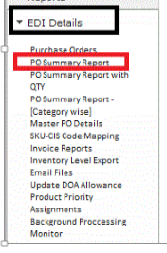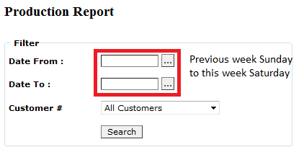

* 1. Get the grand total from the selected period of 5/28/2016 to 6/4/2016 (Sunday to Saturday) and record in labor summary in labor report.

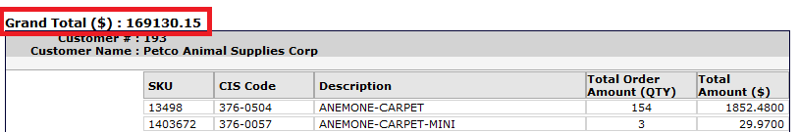

**Labor summary tab in excel – Labor Report**

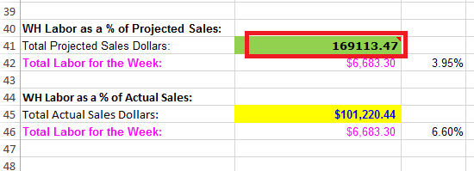

1. **Daily Summary –**
   1. Login in to Uattend and select report- summary, select date range as selected in red.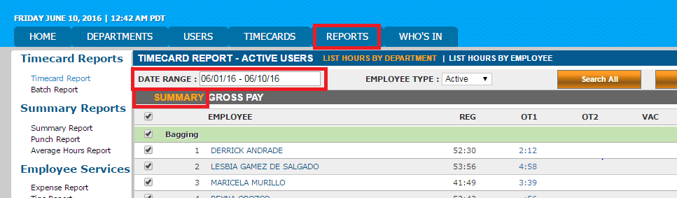
   2. Select report- gross pay as selected in red.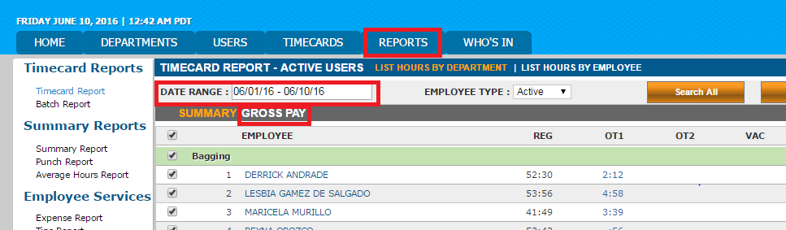
   3. The details appear from summary and gross pay as bellow according to the given date range paste the copy of the details to the Excel sheet (new tab called daily summary) in Labor Report.

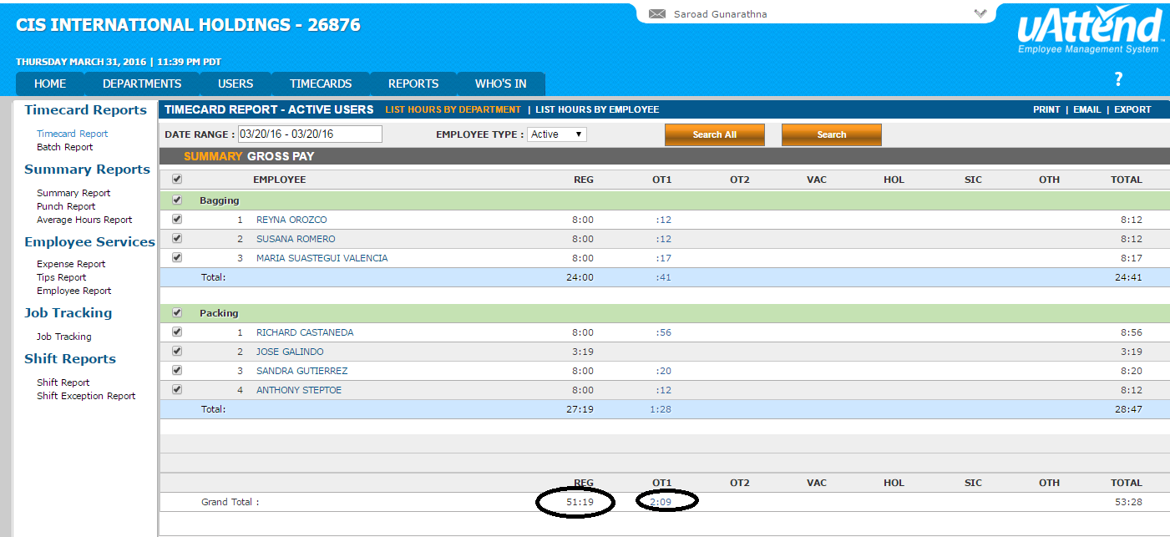

* 1. Record both the summaries as below,

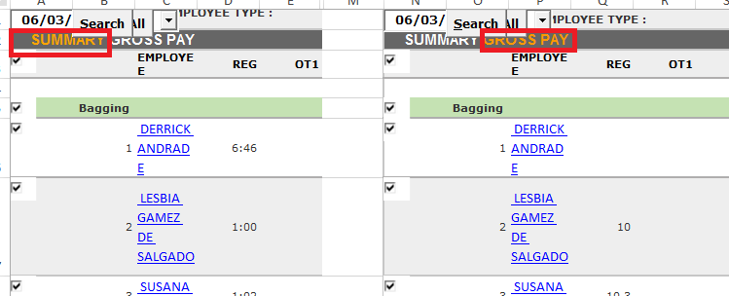

1. **Projected Labor**
   1. Get The Update Labor schedule Report & paste It to labor report (schedule tab), then get the day to day projected Hrs. From This Report, it updates daily

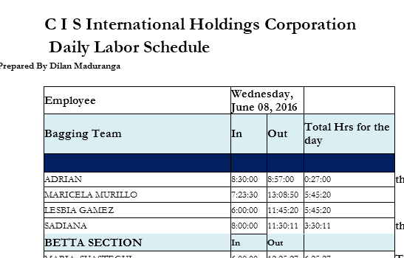

* 1. Prepare a following table including projected labor hours and multiple from the hourly rate that each employee gets to prepare projected labor cost.

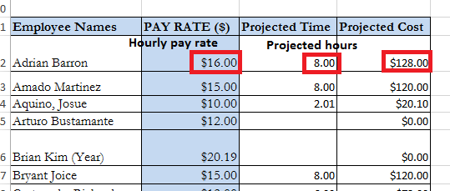

Record seven days in the same tab in labor report.

1. **Labor summary details** 
   1. Add details for the day as mentioned below (Ex: details under Wednesday) then automatically calculated the total hours for the seven days.

Daily projected production hours – Projected labor tab – projected hours

Actual Regular hrs. – Uattend – Summary – total regular hours (Ref 2.3)

Actual OT hrs. - Uattend – Summary – total OT (Ref 2.3)

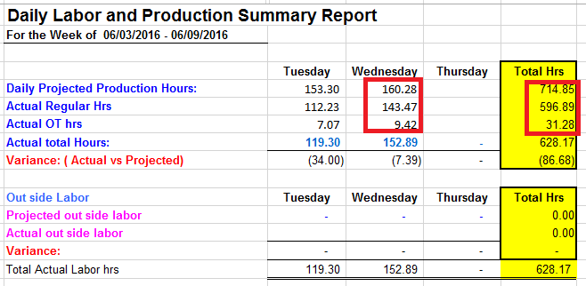

4.2 Get the sales from the invoice summary report from EDI in ETF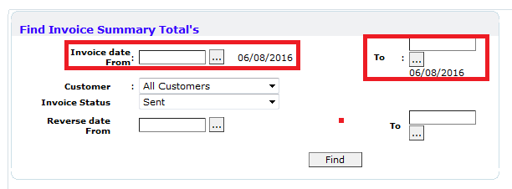Select the date range then click find. 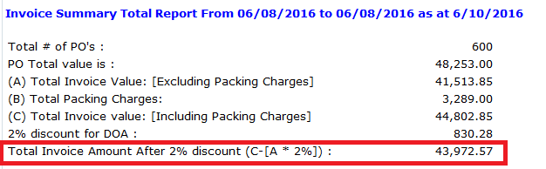

Daily Sales – Toral invoice amount after 2% discount

Total projected labor dollars by day - Total projected labor cost from projected labor tab

Tota actual labor dollars bu day – Uattend – Grosspay – total regual cost (daily summary -Ref 2.3)

Daily overtime: - Uattend – Grosspay – toral OT cost (daily summary - Ref 2.3)

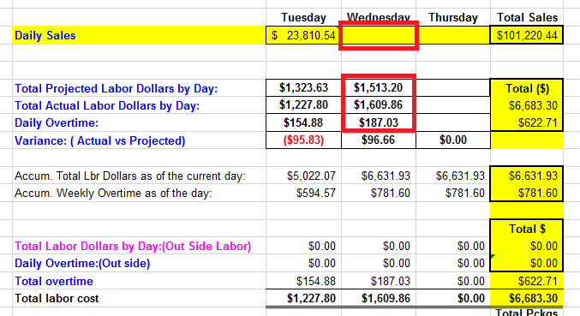

* 1. Get the Total number of packages shipped from Dispatch Report from Shipping and dispatching in ETF.

Select the date range to get the details,

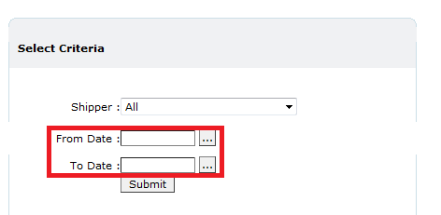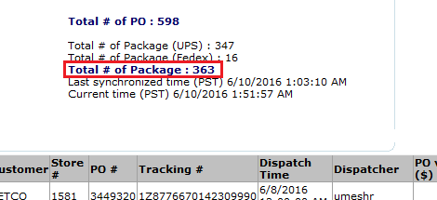

Enter the no of packeage for the day.

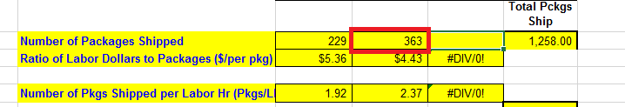

1. **Graph -** Graphs that display for the given details

