**Download Time Cards in UAttend**

|  |  |
| --- | --- |
| **SUBJECT** | Download Time Cards in UAttend |
| **DEPARTMENT** | Finance – US Payroll |
| **RECORDER (Name Designation)** | Nipuna Madumal: Payroll Executive |
| **APPROVED BY (Name Designation)** |  |
| **LAST UPDATE** | 17/08/2017 |
| **PATH ON NETWORK FOLDER** |  |
| **NO. OF PAGES INCLUDING THIS**  **PAGE** | 02 |

Introduction

Objective of this Download time card reports is check and confirm employee worked times are correct or not. Every Monday need to download the last week time cards of all the US employees and send them to HR Admin – US.

* First log in to the UAttend site by using user name and password.
* Click the “Timecards” tab in the UAttend.

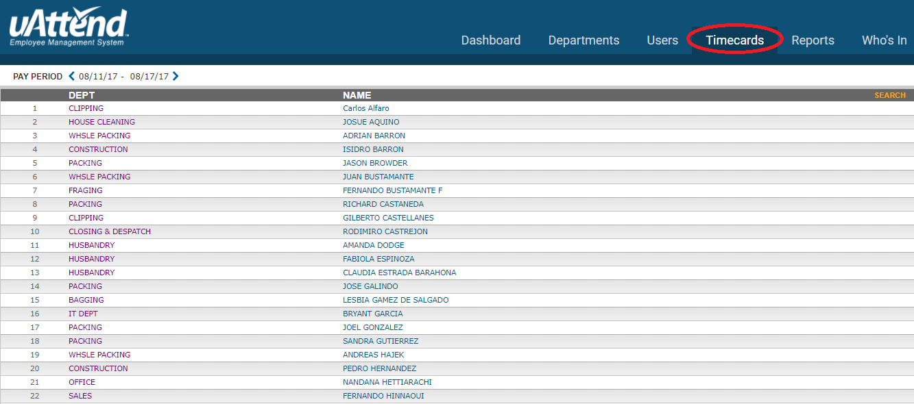

* Select the correct pay period



* Click the employees name and you can see the summary of time they have worked in the week.
* Go to bottom of the page and click the download for download the time card of particular employee.



* After download all the time card reports of employees finally send to HR Admin-US.

Please click below link for get sample time card reports

[Click here for sample time card reports](https://cisintlcom-my.sharepoint.com/personal/nipunam_cisintl_com/_layouts/15/guestaccess.aspx?folderid=0fee2b8754cbc446187fc7ed02583abd0&authkey=AQNEFColo9RkT2auTb2oZvU&expiration=2018-02-13T08%3a00%3a17.000Z)